Windows Opensimulator Grid Server



**Outworldz, LLC, © AGPL 3.0**

Contents

Startup - Starting up the System the First Time 9

Setup Your Viewer: 10

Running the Grid manually 12

Settings 13

Enable Diva Panel APACHE Webserver 14

Content Management System 19

Enable Other: 19

Setting Up WordPress with DreamGrid 20

Installing and Running Joomla and jOpensim 23

Restore data 27

Backup jOpensim 31

Update: 31

jOpensim Money 32

References: 32

Backups: 33

Jopensim Wiki 33

JOpensim Bugs 33

Backup Settings 34

CheckBoxes 34

Backup Strategies 35

Region Level OAR 35

Grid level IAR 35

Grid level SQL 35

UUID: 35

Backup - Autobackup 36

SQL Backup 37

Ban List 38

Copybot Viewers 39

Bird Module 40

BirdsChatChannel 43

aches-Cache Control 44

Cache Deletion 44

Flotsam Cache Settings 45

Flotsam asset cache 46

General principles 46

Database Settings 47

FSAssets Server 48

Clear Region List 49

Running MySQL as a Service 49

Starting Over with a Blank Database 51

Hypergrid and Domain Name Setup 51

Running on the LAN only 52

FIREWALL 56

FSAssets Settings 63

Data Folder 64

SpoolDirectory Folder 64

Migration 64

Grid Type (or server type) 65

Icecast & Shoutcast 70

WINAMP 73

Icecast Control Panel 76

MIXXX 79

Running Mixxx 79

Mixx Setup 81

License Agreement: 82

DNS 83

Anonymous data 83

Logging Menu 84

Load Free DreamGrid OARs Menu 84

Options: 86

Load Local IARs Menu 88

Load Free Avatar Inventory Menu 88

Troubleshooting Manually 91

Try This First: 91

Try This Next 91

Password Reset 92

Troubleshooting the Network. 92

Flaky Teleports 94

The URL I use to Test port forwards: 95

Test Private Loopback: 95

Test Public Loopback 95

How to Get on The Hypergrid 97

UPnP Not Working? 97

Firewall 97

Updater: 98

Help with Opensim Crashes: 98

My database still did not start. 98

Starting Over with A Blank Database 99

Ports 99

Port 8001: 99

Port 8002: 99

Port 8003: 100

Port 8004 and upwards: 100

Running Manually 100

Run as A Service 101

How to Compile DreamGrid 102

Maps 103

Manual regeneration 104

Permissions 105

Allow Level-based gods 105

Allow Region owner gods: 105

Region Manager is God: 105

Prim Limits: 106

Clouds: 106

Export Permission: 106

Physics Engine 107

Port Settings and UPnP (Region Ports/Network Ports) 108

Port Forwards 108

UPnP Enabled 108

Troubleshooting Ports 109

IceCast/Shoutcast 110

Loopback: 110

Firewall Issues: 111

More information about Opensim Ports 111

Diagnostics port 8001: 111

HTTP Port 8002: 112

Private Port 8003: 112

Region Port Start # (Port 8004 and upwards): 112

Highest used: 112

XMLRPC Port Start # 113

External HostName For Region Servers 113

Links: 113

Port Testing: Open Port Check Tool -- Verify Port Forwarding on Your Router 113

Loopback: https://www.outworldz.com/Outworldz_installer/Loopback.htm 113

Publish Grid 114

Photos 114

Publish Items Marked for Search 114

How it works 114

Region Add or Edit Panel 116

Rules: 119

Options 120

Nonphysical Prim Size: 120

Physical Prim Max Size: 120

Clamp Prim Size: 121

MaxAgents 121

Max Number of Prims in a Parcel 121

Max number of Avatars + NPCs 121

Script Timer Rate (0.0909) This is 1/11 of a second. This is the fastest rate a timer can run. You can lower this at the cost of some performance. 121

Frame Rate (0.0909) 121

This is 1/11 of a second. Our Frame Rate is 11 FPS. This is the fastest rate Opensim events can happen. You can lower this at the cost of some performance. Second Life runs 5X faster, or 55 FPS 121

Overrides 121

Publish Items Marked for Search: 123

Permissions: 123

Allow Gods: 123

Physics Engine: 123

Maps: 125

Rules for INI files 125

More Rules: 126

Modules 127

Enable the Tides 127

Teleporter Sign Enable 127

Region List 127

Refresh button 128

Add Regions 128

Run All Button 129

Stop All Button 129

Restart Button 129

Import Button 129

Region Stats 129

Restart Robust 131

Details view: 132

Icons view: 132

Map view: 133

The third view only appears if Maps are enabled before the stem boots. It has zoomable map images by the scroll wheel. 133

Avatars view 133

Import 133

Regions 134

Default region for visitors: 134

New User Home X, Y, Z: 134

Add a Region: 134

Normalize Regions: 134

Edit Region: 134

Configure All Regions: 135

Auto Restart and Startup Settings 135

Automatic Startup 135

Restart Periodically 135

Auto Restart Interval in Minutes: 136

Start Regions Sequentially: 136

Enable One-Click Start: 136

If a region crashes, the region will be restarted (automatically?) 136

REVISIONS FOR DREAMGRID 136

Save IAR 174

-------------------------------- 175

Save IAR via Region console 175

Switches 175

Script Settings 177

X Engine 177

Allow LSL to contact the server 177

Robust and Server Type 177

Grid Server with Robust 178

Region Server 178

OsGrid Region Server 179

Hypergrid.org Region Server 179

Streaming MP3 Sound files for Opensim 179

Streaming MOVIE files in Opensim 183

Tides Module 188

Enable 189

Broadcast Tide Info 189

High Water Level 189

Low Water Level 189

Tide Info Channel 189

Tide Hi/Lo Channel 189

Send Debug Info to console 189

Buoy 189

Tide script 190

TOS Service 191

Troubleshooting Manually 192

Network Diagnostics 192

Try This First 193

Try This Next 193

Password Reset 194

Troubleshooting the Network 194

Flaky Teleports 196

How to Get on The Hypergrid 197

**UPnP Not Working** 198

Free UPnP (Universal Plug and Play) Tool for Windows 198

Firewall 198

Updater: 198

Help with Opensim Crashes: 199

My database still did not start. 199

Starting Over with A Blank Database 199

Ports 200

Port 8001 200

Port 8002 200

Port 8003 201

Port 8004 and upwards 201

Running Manually 201

Run as A Service 202

How to Compile DreamGrid 203

Vivox Voice Settings 203

Setting Up WordPress with DreamGrid 203

# Startup - Starting up the System the First Time

You can install DreamGrid by saving ”InstallDreamGrid.exe” in an empty folder and running it.

Or you can install DreamGrid by unzipping the zip file into a new, blank folder

Then locate and click “Start.exe”. You may get a popup warning. All my binary code is digitally signed and is cryptographically verified to protect you and to assure you that the code you get is what is originally authored. It is virus-free and has no ads. It should say "Verified Publisher: Outworldz, LLC”.

Click [Start] in the top left of the menu:



This box will appear for you to claim ownership of thje Grid.

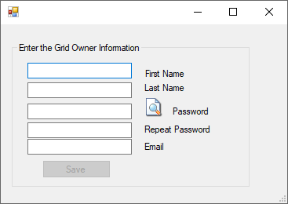  
  
Use a unique, new long password as this is the avatar that owns the grid.

Another DOS box will appear. This will be your first region. The region is named "Welcome".  You can change this name later. The system will ask you for an estate name.  You can just press enter to name it “My Estate”, or type in a new name.

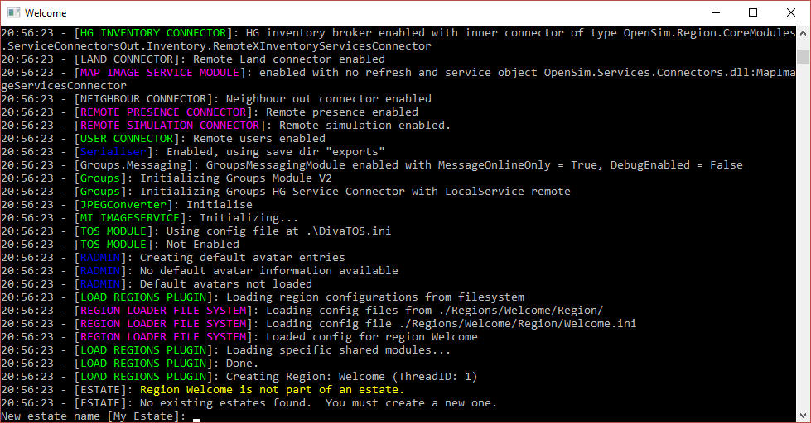

It will then ask you for the owner’s name of this region.   **Use the same name that you first entered.**

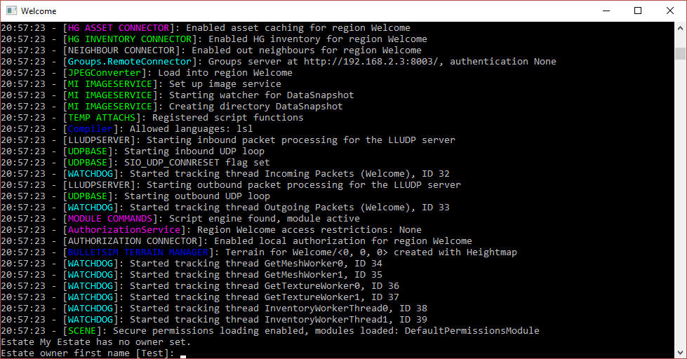

The system will eventually tell you "INITIALIZATION COMPLETE FOR Welcome - LOGINS ENABLED"

Setup Your Viewer:

Click the first item in the Help menu - Show Hypergrid address. It may print a name, or an IP address.

If it is an IP Address, your system will only run on your local area network at this time. The Hypergrid will not be available until you set up the router. See the help section at the bottom of this article on Ports and Loopback.



The system will print the address.

Download the Firestorm viewer for Opensim. You can get it from <https://www.firestormviewer.org/>

Launch the viewer and go to the Viewer Preferences menu (Ctrl-P).

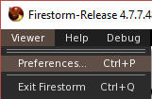

Go to the Opensim Grid manager screen:

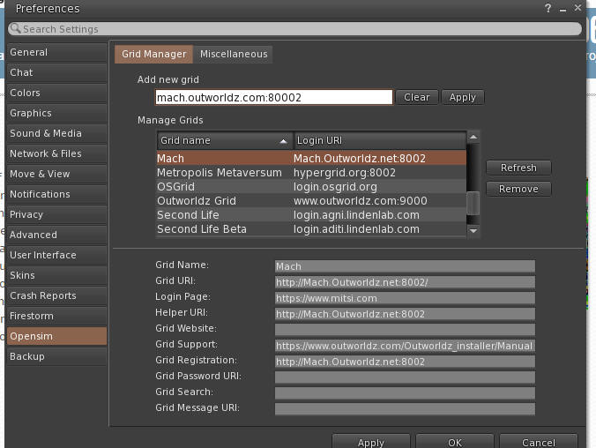

Add the IP address to the Firestorm or other viewers "Add new Grid" field and click "Apply".

You should now be able to select your new DreamGrid in the pulldown login screen and log in with the same First and Last Name and password you originally entered. You should then appear in an empty sim on a small round island.

If this does not work, please use the troubleshooting link at the bottom of this help file.

Running the Grid manually

After the first run, you do not need DreamGrid at all. The batch file **Go.bat** starts a command prompt with an instance of Opensim in it (an instance is a set of sims). The batch file launches Opensim with the settings it needs for the INI files and the Log file.  
See Outworldzfiles\mysql\bin\StartManually.bat which will start MySQL. Also, a StopMysql.bat is in there. It is a clever idea to run (as an Administrator) InstallAsAService.bat so you do not need to start/stop MySQL.

InstallAsAService.bat

 See Outworldzfiles\Opensim\RunRobust.bat which starts Robust

RunRobust.bat

 See Outworldzfiles\Opensim\go.bat, which starts any region by Instance (Dos Box) Name. This is the batch file "StartManually.bat" which does them in sequence:

@remarkable batch file to start DreamGrid manually.  
cd mysql\bin   
start startmanually.bat   
cd opensim   
call runrobust.bat   
call go Welcome   
call go AnotherRegion  
add more region names here

# Settings

You can make changes to DreamGrid in the Ctrl-S (Settings) menu.  
  


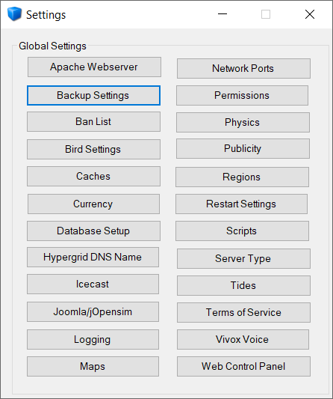

Each section of this manual is in Alphabetical order according to the above menu.

# Enable Diva Panel APACHE Webserver

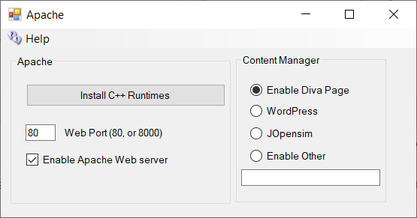

You may optionally set up an Apache Web server with PHP7, Wordpress, Joomla/Jopensim, or other Content Management (CMS) systems. The default purpose of Apache/PHP is to serve a detailed map, object search and other useful functions. It is optional and may be disabled and still run Opensimulator. If you do not need the additional maps or Jopensim, then you can leave Apache & PHP disabled.

Install C++Runtimes

If your system tells you the msvcr100.dll is missing, install both the 64 bit and 32-bit update by clicking the [Install C++ Runtime] button. This will install all necessary runtimes.

Web Port

Defaults to 80. If your ISP blocks port 80, try 8000. You may need to open this port in your PC’s firewall.

Enable Apache Web Server

The checkbox for [Enable Apache Web Server] must be set so the web server and PHP will work.

When enabled a map will appear at your URL on port 80. You can hover on any square and see its size, location, name, and other details. Apache will then start when your PC is booted. No DOS boxes will appear. The advantage is less clutter and 24-hour operation of the web server. But if you run from another folder, the server will still attempt to run from the original folder.

Manually disable Apache as a Service:

Type this in your Windows Search: **cmd**

Right click the Command Prompt App and select "Run as Administrator".

Now type this in the command prompt:

sc delete ApacheHTTPServer<enter>

 Change to the folder for OutworldzFiles\Apache\bin.

Type this in the same admin-level prompt.

httpd -k install<enter>

net start ApacheHTTPServer<enter>

That should get it all going again.

Apache & Search setup

In each of the respective OpenSim viewers available, such as; Firestorm, Singularity, etc... You have a Search feature, that might look like this inside each respective viewer:

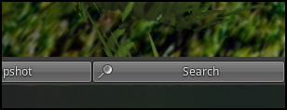

This brings up the following dialog with the respective search categories:

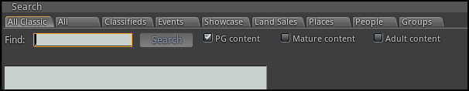

Enable Search

If enabled, any regions or prims marked in the viewer for *Show In Search* will be registered and indexed by the <https://hyperica.com> server, and is thus available for anyone to look at. Turning off your system will remove it from search, as will unchecking this box.

Events

By just clicking on the Search button without specifying a search term you will see all events that are up and coming

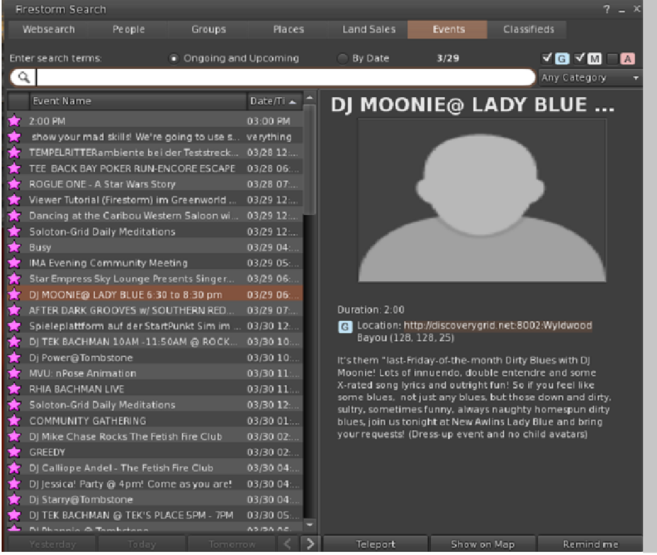

Search for Objects

This viewer screen lets you search for objects marked as “Show in Search”. There is a search button ‘magnifying glass’ at lower left to refine your search. You can select 100, 250, or 500 rows. You can sort by any column header by clicking the title.

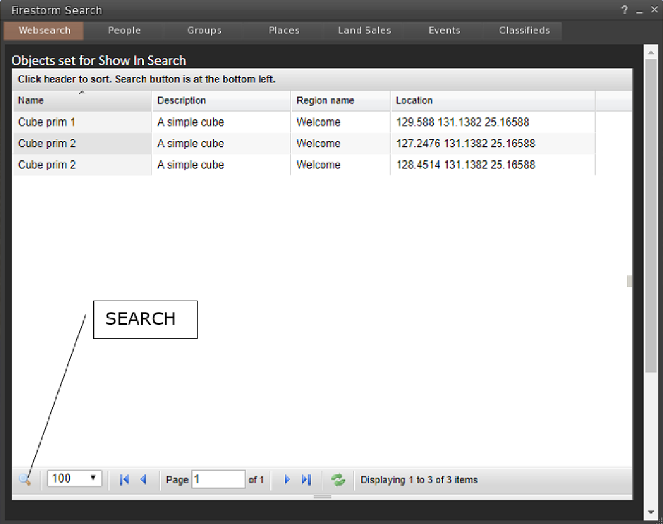

Places search:

Any parcel marked as “Show in Search” can be located in this viewer screen.

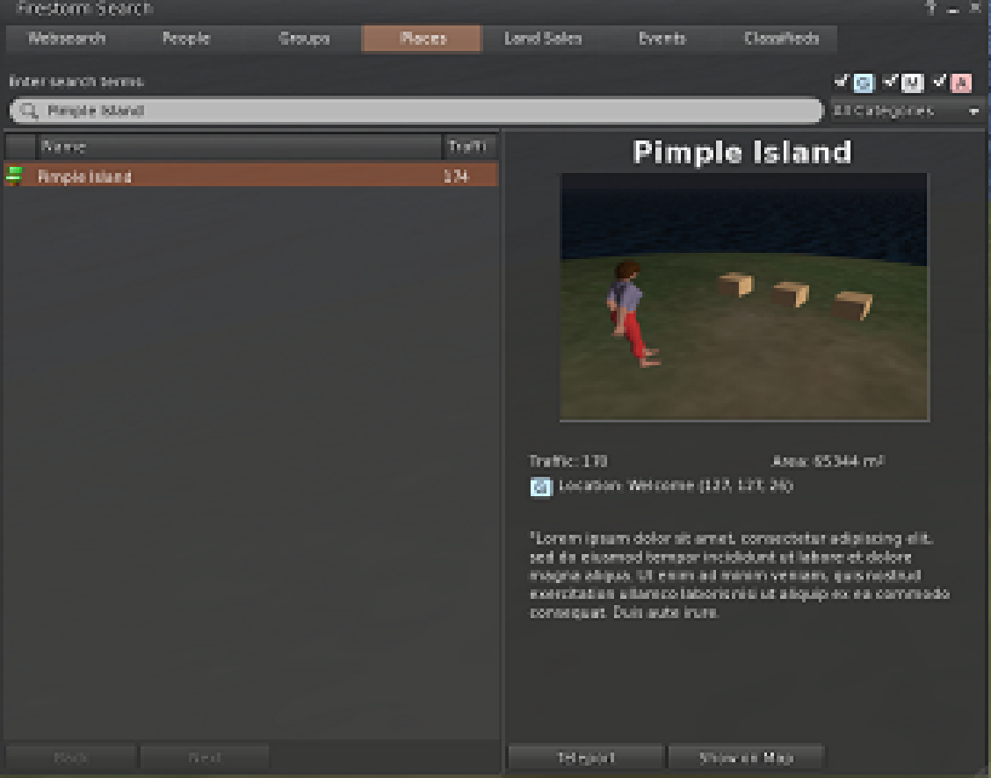

Land Sales:

Parcels marked for-sale and “Show in Search” can be located in this screen:

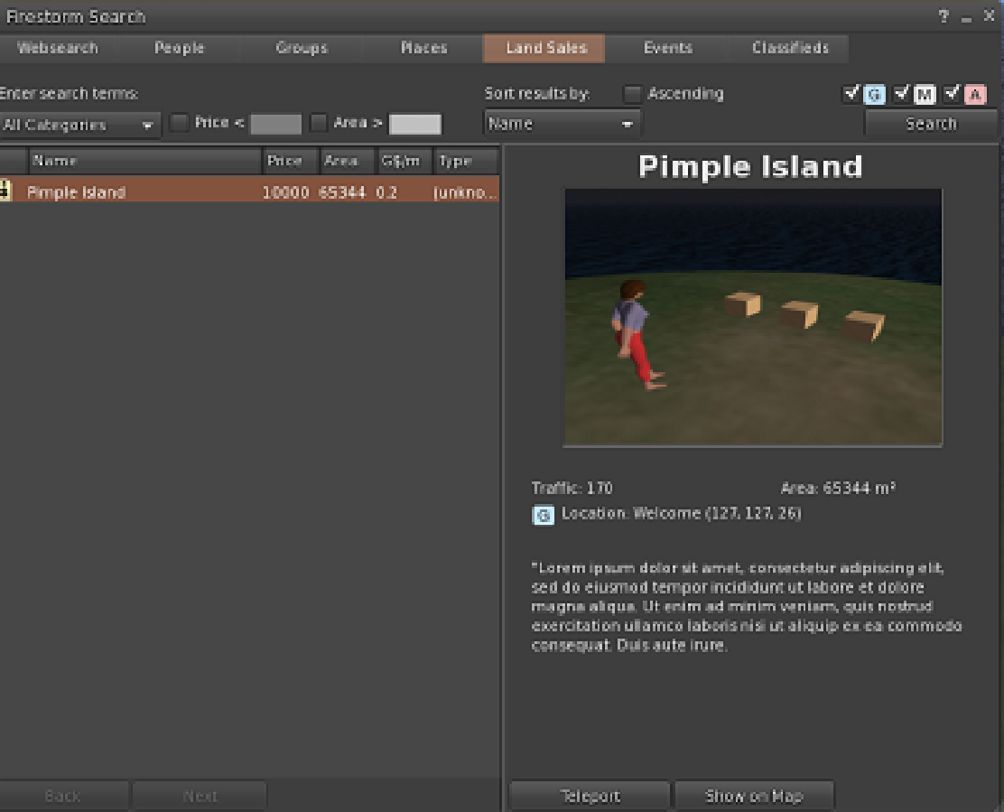

Web Control Panel

The Management Web page can be reached at <http://127.0.0.1:8002> if the checkbox is enabled and Robust is running.

For other users, it will be [http://YourDomainName:8002](http://yourdomainname:8002), where YourDomainName is your Public, Internet-facing IP or DNS name.

The features of Wifi are:

Account creation, optionally controlled by the administrator

Configurable default avatars for new accounts

Account updates by both users and administrator

Account deletion by administrator

Password recovery via email

Simple user inventory management

You can change many of the parameters of Wifi in this panel:

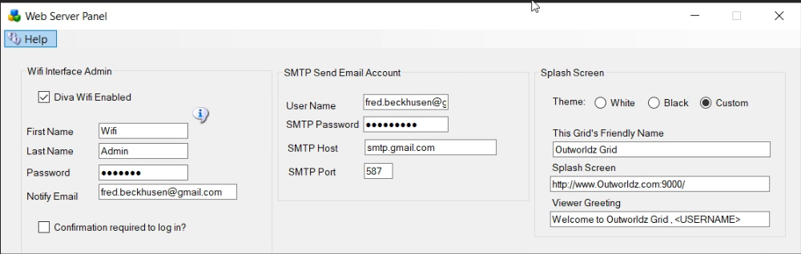

There are three sections that can be modified:

Wifi Admin account: A super-user that administers the system

Splash Screen: Things that affect the page that shows to inexperienced users

SMTP Email: Settings to send email for things like password changes

# Content Management System

A **content management system** (**CMS**) is computer software used to manage the creation and modification of digital content. CMS’s are typically used for enterprise content management (ECM) and **web** content management (WCM)

## Enable Other:

There is an Other folder in Outworldzfiles\Apache\htdocs\other. Setting this switch will redirect all home page access traffic to that folder.

See the Diva Wifi Management Web Page section in this manual.

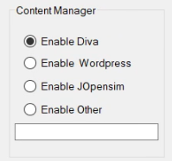

# Setting Up WordPress with DreamGrid

Download WordPress from <https://wordpress.org/download/>

Extract the zip file into wherever you installed your Grid in the Outworldzfiles\Apache\htdocs\WordPress folder. Do not put a second ‘wordpress’ flder in there. If you do, just drag and drop the contents of the wordpress folder to the htdocs\ WordPress folder. It should look like this:



1. Go to DreamGrid settings -> Apache. Set the WordPress switch on.
2. Enable the Apache Webserver on port 80 to run as a service.
3. If you have not yet done so, install the necessary Visual C++ runtimes by clicking the button. **WARNING* This may suddenly reboot your machine, so save your work.
4. If it does reboot, make your way back the Settings Apache page and , install the necessary Visual C++ runtimes by clicking the button.
5. Stop the grid, exit the app, and start it again.
6. Using a web browser, navigate to <http://localhost>. You should see a language choice screen:



After choosing your language, use these settings to set up WordPress and then Click Submit:



You should get this screen:



After this WordPress will ask for your name, password and email. Please a very strong password you have never used before! It is extremely importatnt that this be a long, strong password.

You can now navigate to <http://localhost> to view your new web site.

# Installing and Running Joomla and jOpensim

1. Make sure Apache is enabled. See the Help file for Apache on how to enable it. You must install the C++ Runtimes.
2. Leave the Apache Content Manager set at “Diva” to prevent redirects. When you finish with Joomla, you can enable JOpensim. This redirects all traffic to your web server to Joomla/jOpensim.

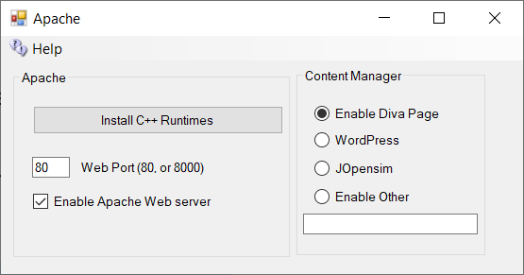



Both the MySQL and Apache icons should be Green.

1. Click Setup->Joomla/JOpensim and click the Install Button. Leave the checkbox unchecked /disabled until you are ready to go live.  
     
   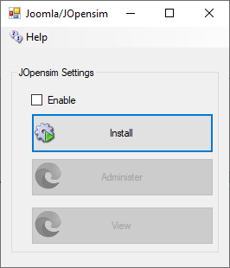

It will install the files:

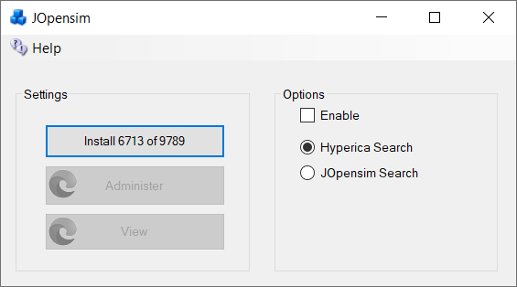

1. You should see the Joomla Setup Page. Fill in the Site Name, a short Description, and pick a Super User Account name and password. Joomla is exposed to the public Internet, so be sure that you use a long and secure password that you have never used before. Write it down as you will need it often!



1. Press Next
2. Fill in the Host name as **127.0.0.1**
3. Database name as **Joomla**
4. Username should be **robustuser**
5. Password should be **robustpassword**.



1. Press Next   
     
   Verify that there are no errors



1. Press Install  
     
   
2. Click 

## Restore data

1. In your web browser go to <http://127.0.0.1/JOpensim/kickstart.php>, or in Setup->Settings->Joomla/jOpensim, click the [Restore] button.
2. Press <esc> key to close the warning screen.
3. Select the latest backup jOpensimBackupV{X}.jpa in the pulldown.

**CAUTION: There is NO PASSWORD. If your browser adds one, please blank it out or the setup will fail.**  


1. Click Start. It will show it is extracting.   
   
2. Click Run the Installer  
   
3. Press Next at Upper Right  
     
   

Fill in the values:

* Database Host is **127.0.0.1**
* User name is **robustuser**
* Password is **robustpassword**
* Database name is **Joomla**

Leave the table prefix alone, as the name is assigned randomly for security.  
  


1. Click Next at the top right  
     
   
2. Fill in the upper part and leave the ‘Live Site URL’ blank.  
   
3. Fill in the bottom part with your Desired Super User Password. You need to remember this! The login id will be Admin with this password, not the prior one you used!  
     
   
4. Press Next at Upper right
5. Close this window to return to Kickstart. Click the **Clean Up** button to start using your restored site.



Joomla will require some edits to match your preferences.   
  
Click the Administer button to log in as “Admin” with your Super User password.

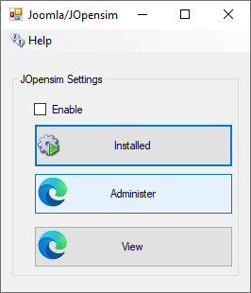



## Backup jOpensim

You can back up Joomla and JOpensim with Akeeba backup, which I built into your distribution.

Click Components->Akeeba Backup and select “Full Backup”.



To restore a backup, Click [Restore] in the Dreamrgid jOpensim menu to extract kickstart-core-7.0.2.zip and load the URL as shown in section “Restore the Data”, above.

## Update:

Press the Update button to update to the latest jOpenSim. This will take you to this screen:  
  


Click “Or Browse for file” and navigate to the Outworldzfiles\jOpensim_Files\ and select pkg_jopensim.0.3.2.0.zip. This will update you to Version 0.3.2.0.

## jOpensim Money

1. Enable jOpenSimMoney in your jOpenSim configuration, in "Settings".
2. You need to define one OpenSim account as banker in "user". To do so, mark the checkbox beside the desired user and click on "Edit user". In "Login Level" you now should be able to select "Banker" and select Save. This account will be disabled for regular login and only responsible for handling transactions with the grid (e.g. upload fees, group creation, etc...) and in demo mode it will reset all user balances (give or take the difference to the reset value) at login and when crossing any region border.
3. Now go to "Money System" in admin. It now shows a small form, where you can select the banker and set some other values important for your money system. For the first time, even if your banker is already selected, IT IS IMPORTANT to save this banker account, otherwise the module will disable.
4. The money module have 3 possible stages:

* Demo-Mode: If no or the demo license key is provided, in this mode everything works fine, but the user balance will be reset at every login and when crossing a region border to a predefined value (by default 5000).
* Default Mode: this should be the regular mode. No popups, no reset, everything (hopefully) working fine
* Disabled: if an invalid or expired license key was provided, the module will disable currency completely (e.g. due to a typo in the ini or just missed to extend license). Like this, no demo mode will screw up an already existing transaction history.

After demo mode, you might want to clean 2 tables manually in your Joomla database to reset all balances and transactions for the "real" mode: #_opensim_moneybalances #_opensim_moneytransactions You can do this e.g. by executing a query like: "TRUNCATE TABLE #_opensim_moneybalances;" and "TRUNCATE TABLE #_opensim_moneytransactions;" (of course replace #_ with the correct prefix of your joomla database)

## References:

Jopensim Wiki <http://wiki.jopensim.com/>

JOpensim Bugs <https://mantis.jopensim.com/>

## Backups:

You can back up Joomla and JOpensim with Akeeba backup, which I built into your distribution.

Click Components->Akeeba Backup and select “Full Backup”.



To restore a backup, unzip kickstart-core-7.0.2.zip and load the URL as shown in section “Restore the Data”, above.

References:

## Jopensim Wiki

http://wiki.jopensim.com/

## JOpensim Bugs

See https://mantis.jopensim.com/

# Backup Settings

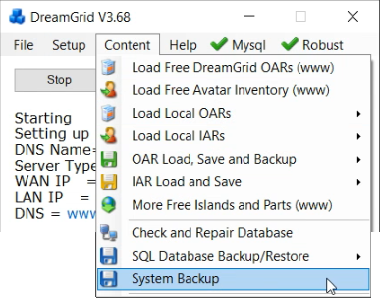

A manual backup uses a lot of disk space, but it backs up all critical files quickly and in a usable form. It will save the selected items in the AUTOBACKUP folder.   
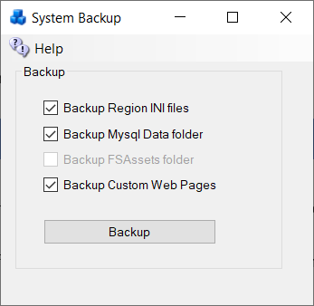  
  
Some of these boxes may be grayed out or uncheckable because the system has not installed that service.

## CheckBoxes

**Backup Region INI files** All files from Opensim\bin\Regions are copied. The useful ones are in the bin\Region\DosBoxName\Region\folder

**Backup MySQL\Data folder**: This folder holds the database. The rest of the folders in MySQL are just code or changeable settings that come in an update.

**Backup FSassets Folder**: If you are running the FSAssets system, this contains just the assets of the database. You still need to backup MySQL.

**Custom Web Pages**: This backs up two folders in bin\WifiPages-Custom and WifiPages-Custom in case you have made changes.

## Backup Strategies

There are multiple kinds of backups. Backups are at the region level, or at the grid level, which includes regions.  Also remember there are always two or more databases on a grid: the grid's robust database, and the regions Opensim database. There can be more than one Opensim database, as a grid can consists of more than one machine.

### Region Level OAR

OARs can be created on the fly - look in Content Save Oars and you can do them all with one click.  You can also set up OARS to be created on a schedule. - 24 hours is an excellent choice.

### Grid level IAR

IARS are more difficult and are more time consuming, as you need the password.   But you should make them on occasion anyway.  Just in case. They take a long time and can lag a grid when running.  If you are on OsGrid or Metro, I HIGHLY RECOMMEND you get an IAR backup often!  I have at different times lost data at both these major grids.

### Grid level SQL

SQL backup is also slow, but very thorough. It saves outfits, logins, and usernames; everything but region UUID's and settings.  With this you can fix problems in MySQL that are known to develop.   This is sort of a monthly thing to do.

### UUID:

Keep a copy of your UUID, too. This is available in your Profile. If you must start over, at least your new avatars will have the same UUID and will own everything you created.

# Backup - Autobackup

if enabled, the Autobackup module periodically saves data to a folder.



If Auto Backup is enabled, Opensim will make an OAR backup of each region after Opensim has run for **Interval** time. If there are checkboxes set in the System Backup, then those files will be backup up, too. The files will appear in the Outworldzfiles\Autobackup folder.

**Keep for Days** will delete any OAR or backup zip older than this period of time.

**Save To Folder:** You can click on “Autobackup” folder name, or the folder Icon, and set a different location.

**Backup:**



You can get Help on Backing up all Data files and how to Export SQL files in the top menu.

Links:

<http://opensimulator.org/wiki/Load_Oar_0.9.0%2B>

## SQL Backup



When you select SQL Database Backup/Restore and click Backup Database, a command window opens automatically that may look like this:

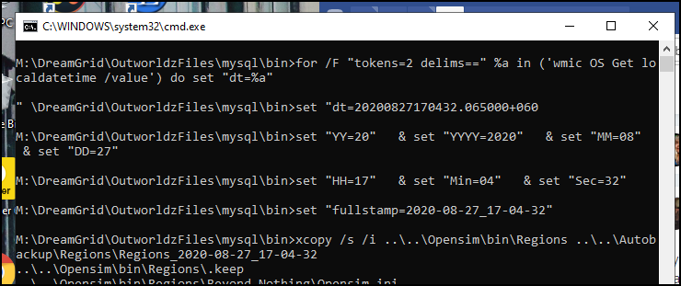

At some point the window appears to be stopped but shows this. It is very busy, so let it run.

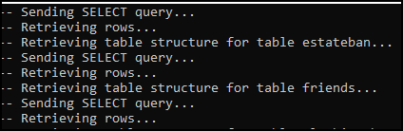

it will be complete when you see this:

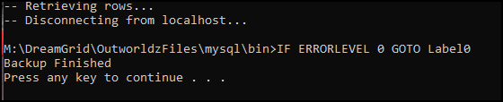

After selecting any key, the command window will close. The file will appear in the Autobackup folder in the Mysql folder.

# Ban List

Bans can be set for Grids, IP addresses, Viewers, and MAC addresses. MAC addresses are a serial number found in Ethernet cards. These bans shut off incoming traffic by using Opensim Robust capabilities, and by adding entries to the Windows Firewall. They are not a total solution but can work in many cases. This may not be effective as the login name can be changed, the Viewer Name can be tweaked, they may have another PC with a different MAC address or change it, and the IP may change by the ISP or come from a VPN. People who bypass this DRM restriction are breaking into a computer, a Federal felony, so penalties far beyond copyright laws could apply.

Settings go into effect when you save the screen after making changes. For OsGrid, Metro and region servers, only IP bans will work since no robust is running on your Region server.

Getting Ban Data:

You can get the Login Name and Grid http://name:port, IP address, and MAC address of people from the Robust log as it happens. You can also look in the menu system at Help ->View Logs->Robust to view the log in and with Baretail.

A typical Robust Log entry would be as follows:

INFO (104) - OpenSim.Services.HypergridService.GatekeeperService [GATEKEEPER SERVICE]: Login request for Jo.Blow@ **www.xyz.com**:8002 @ http://www.xyz.com:8002/ (3be47575-06dd-46b0-8637-87a8967c432c) at ab8d7770-3782-21e4-8c41-1813211c9b88 using viewer **Firestorm-Releasex64 5.2.8.58205**, channel Firestorm-Releasex64, IP **52.8.203.221**, Mac **d5af8bee7e6a265c41e729416d570f57**, Id0 dac5b5d03d9bbe2225d2c91c3238d59f, Teleport Flags: ViaLogin. From region Her Place (2c53df18-143f-4340-ae73-f2885d9694d8) @ <http://grid.nope.com:8002/>

Grid Ban:

To ban the grid that the avatar who originally logged on, add [**http://www.xyz.com**:8002](http://www.xyz.com:8002). The “http://” and “:port” number is required.

Grid Ban**:** To ban the grid that the avatar teleported from (not necessarily her home grid) , add [**http://grid.nope.com**:8002](http://grid.nope.com:8002). The “http://” and “:port” number is required.

**IP Ban:** To ban an IP, add her IP “52.8.203.221”. IPV 6 is also supported.

**MAC Address Ban:** To ban a PC by the Ethernet card MAC address, add the MAC address from the robust log: “d5af8bee7e6a265c41e729416d570f57”. The system supports upper- or lower-case formats with or without “:”.

d5:af:8b:ee:7e:6a:26:5c:41:e7:29:41:6d:57:0f:57  
d5af:8bee:7e6a:265c:41e7:2941:6d57:0f57  
d5af8bee7e6a265c41e729416d570f57

**Viewer Ban:** To ban a very-specific viewer, add “Firestorm-Releasex64 5.2.8.58205”. You can ban all version 5 Firestorms, add “Firestorm-Releasex64 5”. Only Firestorm 6 and above will work in the Firestorm viewer types.

## Copybot Viewers

To ban copybot viewers such as Darkstorm, add “Firestorm-Releasex64 5”. These old viewers are rarely in use except by copybotters.

The copybot viewer Hydrastorm is “Firestorm-HYDRASTORM”

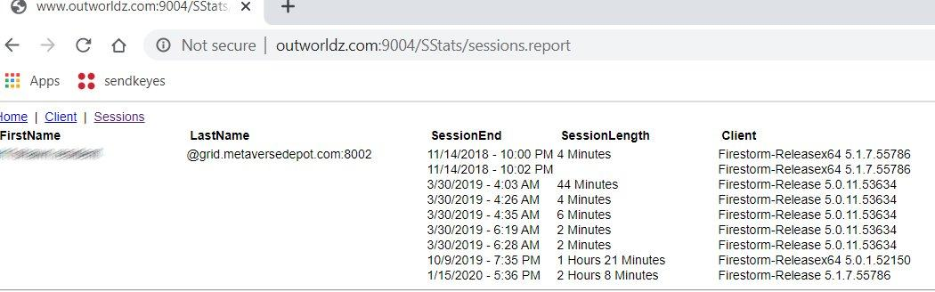

There are several ways to get data to ban by viewer. One way is to look in the Stats for your Welcome region. Another is to copy and paste it from the robust screen, or robust.log. Click your Welcome region in the Regions menu, then select the Statistics Button. This screen shows the “Sessions” tab, so you can see if someone is still using an old viewer recently. If so, they are a candidate to be a copybotter.



# Bird Module

The bird module makes flocks of birds possible.

You will need a bird. There is a button at the top of the Setup Page that will ask you for your Avatar Name and password. It will load a pair of Seagulls into your inventory.

You should login and rez "SeaGull1" on the ground in one or more of your regions.



You will need to enable the bird module in each region's control panel.

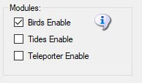

There are many settings for the Bird Module. You can use the defaults. You must also click Enable and reboot the grid. Birds must also be enabled in each Region. See each Region’s edit screen for the checkbox.

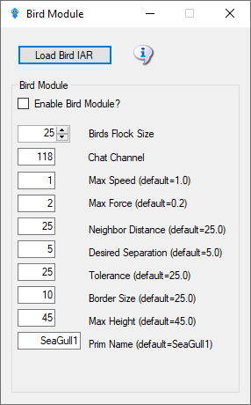

* + - Enable Bird Module: Determines whether the module does anything.
    - BirdsFlockSize = 50: The number of birds to flock
    - BirdsMaxFlockSize = 100: The maximum flock size that can be created (keeps things sane)
    - BirdsMaxSpeed = 3: How far each bird can travel per update. An update is 11 FPS
    - BirdsMaxForce = 0.25: The maximum acceleration allowed to the current velocity of the bird
    - BirdsNeighbourDistance = 25: Max distance for other birds to be considered in the same flock as others
    - BirdsTolerance = 5: How close to the edges of things can we get without being worried
    - BirdsBorderSize = 5: How close to the edge of a region can we get?
    - BirdsMaxHeight = 25: How high are we allowed to flock
    - BirdsUpdateEveryNFrames = 1: Update bird positions every N simulator frames
    - BirdsPrim = SeaGull1: By default, the module will create a flock of plain wooden spheres, however this can be overridden to the name of an existing prim that needs to already exist in the scene - i.e. be rezzed in the region.

The following commands can be issued on the Console or via in-world chat or scripted chat on the Chat Channel to control the birds at runtime:

* birds-stop or /118 stop   
  stop all birds flocking
* birds-start or /118 start   
  start all birds flocking
* birds-enable or /118 enable   
  enable the flocking simulation if disabled and rez new birds
* birds-disable or /118 disable   
  stop all birds and remove them from the scene
* birds-prim <name> or /118 prim <name> changes the name of the bird prim that it loads
* framerate <num>   
  only update the flock positions every frame, only really useful for photography and debugging bird behavior.

These commands are great for playing with the flock dynamics in real time:

* birds-size or /118 size   
  change the size of the flock
* birds-speed or /118 speed   
  change the maximum velocity each bird may achieve
* birds-force or /118 force   
  change the maximum force each bird may accelerate
* birds-distance or /118 distance   
  change the maximum distance that other birds are to be considered in the same flock as us
* birds-separation or /118 separation   
  sets how far away from other birds we would like to stay
* birds-tolerance or /118 tolerance   
  sets how close to the edges of things can we get without being worried. If distance is less than separation, then the birds will never flock. The other way around and they will always eventually form one or more flocks.

## BirdsChatChannel

Security:

By default, anyone can send commands to the module from within a script or via the in-world chat on the 'BirdsChatChannel' channel. You should use a high negative value for this channel if you want to allow script access, but not in-world chat.

Bird Prims:

Any currently rezzed in-scene-object can be used as the bird prim. However, fps is very much affected by the complexity of the entity to use. It is easier to throw a single prim (or sculpty) around the scene than it is to throw the constituent parts of a 200 linked prim dragon.

Tests show that <= 500 single prims can be flocked effectively - depending on system and network. However maybe <= 300 simple linksets can perform as well.

Network Traffic:

I tested the amount of network traffic generated by bird updates. 20 birds (each with 4 linked prims) takes up about 300kbps in network position updates. 50 of the same birds generate about 750kbps traffic. Each bird uses roughly 15kbps of network traffic. This is all measured using an update framerate of 1, i.e. birds' position is updated every simulator frame.

Statistics:

The stats command in-world or via script returns data to BirdsChatChannel. The console command returns stats to the console. All the module parameters are returned including a list of the active bird prims currently rezzed in the region, and the UUIDs of those prims' root prim. Also included is a list of any avatar UUIDs that may be sitting on those prims.

Here is an example output:

birds-started = False

birds-enabled = True

birds-prim = SeaGull1

birds-framerate = 1

birds-maxsize = 100

birds-size = 20

birds-speed = 1.5

birds-force = 0.2

birds-distance = 25

birds-separation = 10

birds-tolerance = 5

birds-border = 5

birds-prim0 = OpenSimBirds0 : 01abef79-7fb2-4c8d-831e-62ce1ce878f1 :

birds-prim1 = OpenSimBirds1 : af85996d-af4d-4dda-bc89-721c51e09d0c :

birds-prim2 = OpenSimBirds2 : ca766390-1877-4b19-a29e-4590cf40aece :

birds-prim3 = OpenSimBirds3 : 6694bfa9-8e7f-4ac5-b336-ad13e5cfced2 :

birds-prim4 = OpenSimBirds4 : 1c6b152d-dcca-4fef-8979-b7ccc8139e1e :

birds-prim5 = OpenSimBirds5 : 08bba2cc-d427-4855-a7f0-57aa55109707 :

birds-prim6 = OpenSimBirds6 : bbeb8b6d-28d8-41a9-b8ce-dab3173bd454 :

birds-prim7 = OpenSimBirds7 : 45c73475-1f0f-487f-ac9f-87d30d0315e8 :

birds-prim8 = OpenSimBirds8 : d5891cc8-c196-4b05-82ef-3c7d0f703963 :

birds-prim9 = OpenSimBirds9 : 557b61e1-5fd6-4878-980e-e93cabcc078f :

birds-prim10 = OpenSimBirds10 : 7ff2c02d-d73c-4e49-a4e9-84b652dc70a9 :

birds-prim11 = OpenSimBirds11 : c2b0820c-ba20-4318-a0e8-ec6ad521f524 :

birds-prim12 = OpenSimBirds12 : e8e87309-7a47-4983-89a1-4bb11d05a40c :

birds-prim13 = OpenSimBirds13 : a351e0e3-ae99-48b8-877d-65156f437b33 :

birds-prim14 = OpenSimBirds14 : 150f1c3b-e9d9-4cda-9e03-69fb5286e436 :

birds-prim15 = OpenSimBirds15 : ebf63de1-d419-45d0-8eee-3db14295e401 :

birds-prim16 = OpenSimBirds16 : faad97af-4ee6-425c-b221-99ef53650e93 :

birds-prim17 = OpenSimBirds17 : d75ba544-bbc2-4f5a-9d7e-00e21ed6f191 :

birds-prim18 = OpenSimBirds18 : b91e42cb-ae5b-4f03-bf6e-dc03d52858b7 : a351e0e3-ae99-48b8-877d-65156f437b33

birds-prim19 = OpenSimBirds19 : 44aa3e14-56bc-43dd-afbd-7348c5dfe3a5 :

In the above example, there is one avatar sitting on bird-prim18. For more than one avatar the UUID list will be separated by spaces.

# aches-Cache Control

## Cache Deletion

Opensimulator has many caches of data to improve performance. You may optionally clear these caches. The system will refresh them on the next startup. This will slow your system down dramatically on the next boot as it must re-fetch all assets the next time it starts.

Opensim must be stopped to clear the script and the Avatar Bakes Cache.

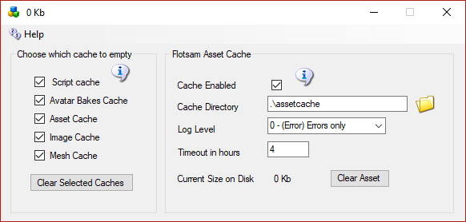

**Script cache:** Clearing the script cache is only necessary after an update to Opensim binaries. Dreamgrid will not delete the “.STATE” files so your virtual pets will not die.

Opensim must be stopped to clear script and the Xbake caches

**Avatars bakes cache:** this folder holds the various baked skin layers. Opensim must be stopped to clear script and the Xbake caches

**Asset cache:**  holds the assets (mesh, prims, textures) and is typically exceptionally large. It automatically flushes itself every 48 hours.

**Image cache:** holds the images and is typically exceptionally large.

**Mesh cache:** is typically not used

## Flotsam Cache Settings

OpenSimulator has an asset cache that stores the assets retrieved from an asset service. This reduces the load on a remote asset service and improves OpenSimulator responsiveness.



## Flotsam asset cache

Note: You do not need to run the Flotsam asset cache if you are running the FSassets file system database locally.

The Flotsam asset cache, stores assets on disk and in memory.

At the moment, the amount of memory or filesystem storage used by the cache can only be limited via manual actions (wiping all or part of cached assets from the filesystem), by console commands (e.g. "fcache clear") or by timeout settings (e.g. FileCacheTimeout = 1 to automatically remove cache files not accessed for 1 hours).

## General principles

When OpenSimulator requires an asset (e.g. in response to a viewer request for a notecard), then it first asks the cache for this data. If the data is not found in the cache, then it asks the grid asset service (or possibly a foreign asset service in the case of Hypergrid). If the asset is found, then it is both stored in the cache and returned to the user.

If an asset is uploaded to OpenSimulator (e.g. by the viewer uploading an animation), then the asset is immediately both kept in cache (if there is room and the asset is not temporary) and sent to the asset service (if the asset is not temporary).

Therefore, at any point you can wipe any temporary data stored by the asset cache (e.g. on the filesystem), since the next request for that asset will simply query the asset service as the asset will not be found in cache.



# Database Settings

Did MySQL crash? See section **Crashes**.

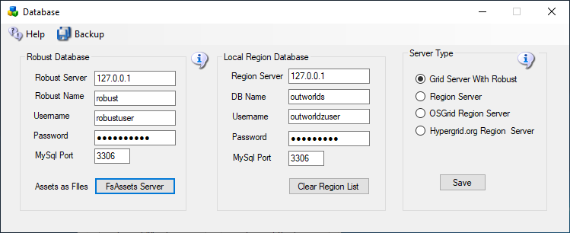

**Do not change any of these settings without knowing what you are doing!** Any change here must match complicated hand-made changes in MySQL! See the bottom of this help section for more details.

There are two databases in Dreamgrid: Robust is the login and inventory database. Each region also uses a separate Opensim database for storing what is in the region.

Database root password is blank. This is safe as it only listens on localhost, which is your server.

Robust Database:

**Robust:** should always be 127.0.0.1. This is the Server that runs Robust (itself). It can be the IP address of a different server running MySQL.  
  
Default: *127.0.0.1*

**Database name**: The name of the Robust database.   
  
Default: *robust*

**User Name:** The login name 'robustuser'@localhost'.   
  
Default: *robustuser*

**Password:** The password for Robust.

Default: robustpassword

**MySQL Port:** The TCP/IP port that both databases use.   
  
Default = 3309 to not interfere with the normal MySQL Port of 3306

## FSAssets Server

You can select the FSAssets button to set up a File System As Assets Database. This is recommended only for large grids, with hundreds of Gigabyte sized databases.

Region Database:

**DB name**: The name of the region database.   
  
default: *opensim*

**User Name:** The login name 'opensimuser'@localhost'.   
  
default: *opensimuser*

**Password:** The password for opensim region database.   
  
default = *opensimpassword*

**MySQL Port:** The TCP/IP port that both databases use.   
  
Default = 3309 to not interfere with the normal MySQL Port of 3306

If you want to alter the username and password to either database, you must use the MySQL.exe program in a DOS box.

cd Outworldzfiles\mysql\bin  
mysql -u root  
use opensim;  
create user 'anewopensimuser'@'localhost' identified by 'opensimpassword';  
grant all on opensim.* to 'anewopensimuser'@'localhost';  
use robust;  
create user 'anewrobustuser'@'localhost' identified by 'robustpassword';  
grant all on robust.* to 'anewrobustuser'@'localhost';  
quit;

## Clear Region List

Clicking this button will delete all registered regions in your database. They will be restored next time you start Opensim

## Running MySQL as a Service

Dreamgrid will detect any running MySQL using the same port. You can install MySQL as a Windows service. There is a batch file *InstallAsAService.bat* in MySQL\bin to set this up. MySQL will then start and stop safely with Windows. This batch file must be run once, as an Administrator. You type "CMD" in the search box, and then right click the Command Prompt and select "Run as Administrator".

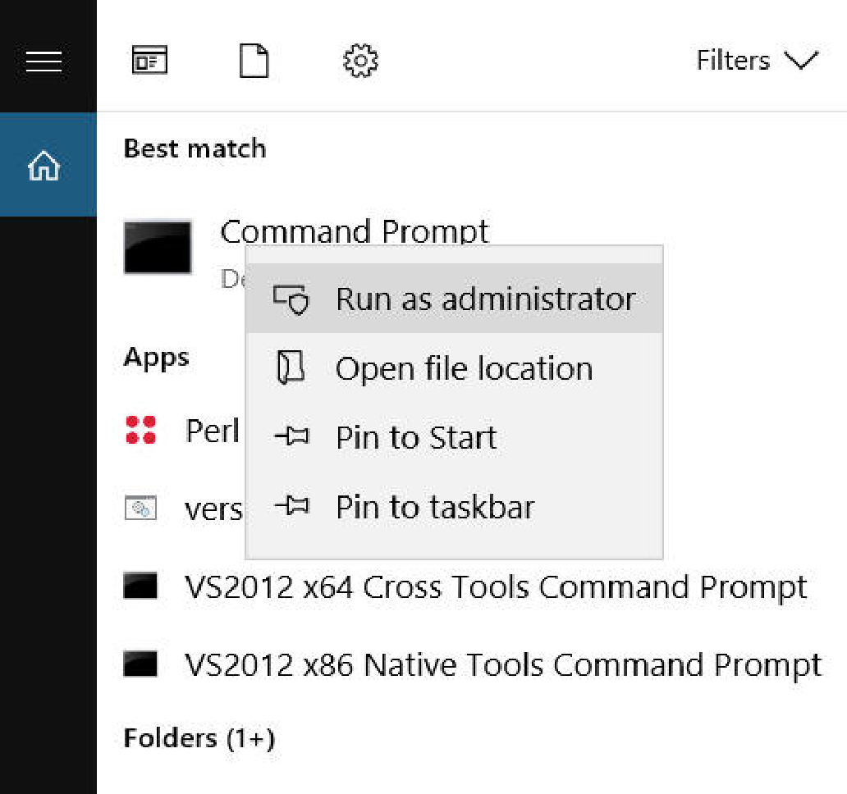

Use that DOS box to run **InstallAsAService.bat**. Then type in 'Services.msc", and use it to start MySQL, or type in ‘net start MySQL’<enter>.

You can verify MySQL is running by typing 'mysql - u root<enter>'. If you get a MySQL prompt, it is running as a service. Then type quit; with the semicolon and enter.  
  
You should also set the service to restart so MySQL restarts on any crash. Windows knows about services and will send signals to MySQL to shut itself off gracefully. The only danger is that power fails and you corrupt the database. If you are serious about running a grid, then a UPS is necessary.

MySQL Crashes:

Your MySQL database may be crashed. Here is a way to recover and start MYSQL manually.

Navigate to the **Outworldzfiles\mysql\bin** folder.

Then double-click "StartManually.bat”

Any error message it prints may be helpful. If the DOS window closes, a MySQL LOG file will be saved in OutworldzFiles\mysql\data as a *.err file. That may give you a clue as to what to do.

My database still did not start!

Try running Outworldzfiles\mysql\bin\Repair_ISAM.bat.

Then double-click "StartManually.bat”. The DOS window that appears should ‘stick’ open.

Run Task manager by typing Ctrl-Shift-ESC.

Look for *mysqld.exe.* Wait for the CPU usage to go to 0 on mysqld.exe. This may take a long time as MySQL is rebuilding the database. It could take an hour or more, depending upon the size and your disk and CPU speed.

Double click CheckandRepair.bat to run diagnostics.

If errors appear, answer any questions with a ‘Y’. This will take a long time as MySQL is repairing the database.

Once the Check and Repair is finished, type in ‘StopDatabase<enter>’

The DOS box that first appeared should now close. Your database has been recovered and it is safe to start Dreamgrid.

**If you still have issues**, delete the file MySQL\Data\ib_logfile0 and ib_logfile1. Do not delete ibdata1! Then repeat the above sequence.

If I had really deep issues with a database and it was unrecoverable, I would try the last copied one, then the SQL, then an OAR,  up, and the very last thing I would try is an OAR/IAR restore.    So far I have recovered at least a dozen databases for people.   One developed a bad bit which took about a week to ftp, to develop a fix for and a simple query to repair.

Also have fixed a crashed "primitems" table that has re-occurred on one grid. You log in to MySQL with the command ‘mysql -u root’ and type in:

use opensim;

repair table primitems;

quit;

## Starting Over with a Blank Database

You can wipe ALL data out. If you do this, you must re-enter all accounts and recreate your system from OAR and IAR files. This WILL LOSE ALL DATA.

I recommend you make a backup of the MySQL\Data folder first.

I have not yet ‘lost’ a database, and I have seen dozens of them crash in oddball ways. Please contact me at [fred@outworldz.com](mailto:fred@outworldz.com) if you have questions or need more help in recovering a database. The largest was 70 Gigabytes which took four days just to get a copy sent to me. It was fixed in a few hours. The problem was with a single bad character in a UUID. So please do not delete it unless you really, really want to start over!

If you MUST wipe out the database and start over, delete the folder MySQL\data. Then extract the contents of the file Blank-Mysql-Data-folder.zip to make a new MySQL\Data folder.

This will make it start over at the very beginning. The database should start up now. You must go to Robust; type create user<enter>’ and re-enter your Avatar name and password. You can then re-enter your estate information in each DOS box for Each region.

You can also restore the database if you have a .SQL backup. Or use OARs and IARs.

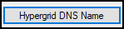

# Hypergrid and Domain Name Setup

Hypergrid requires a DNS name or a Public IP. You can register your own domain, or use your router's public IP, or use the Outworldz system’s’ free Dynamic DNS system (DYN DNS).

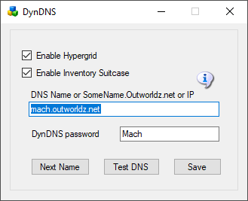

**DNS name:** For a Free Dynamic DNS name, use "somename.outworldz.net". Choose a simple name and add ".outworldz.net". For domain names, the letters, numbers a-z, digits 0-9 and a dash (-) are the only allowed characters.

Do not add anything else other than a name and .outworldz.net.

IP addresses may be used. If blank, the PC's LAN address will be used. Hypergrid will not be available, but other LAN PC's will be able to connect. This is ideal for schools and other types of private work grids.

## Running on the LAN only

When there is no network connection, such as when travelling, use localhost, or 127.0.0.1. These allow only the viewer on the server to connect.



**Enable Hypergrid**: If unchecked, the Hypergrid will not be available. The grid will be only a Private Grid, with access possible only by logging into the grid directly.

**Enable My Suitcase**: If checked, Hypergrid travel uses a viewer suitcase. The purpose of the Suitcase is to prevent a foreign "rogue" grid from stealing your inventory while you are visiting. However, any items in your suitcase are exposed to other grids. you can only rez or give items in other grids that are already in your suitcase.

The My Suitcase folder is special: it is the folder tree that receives objects you collect while you are visiting other grids. But now it is even more special: it is the **only** folder tree that is accessible to you (and therefore to the rest of the Internet) while you are traveling. Period.

If you disable the suitcase by unchecking this box, as OsGrid does, you will be able to rez and give items while on other grids from anywhere in your inventory. Items you take or are given will still end up in your suitcase.

**DynDNS Password**: This is a random number that may be used to keep your DNS Name from being used by others. It is first come, first served. Your password must be copied from one installation to another to use the same DYN DNS name. If you need help with this, or wish to delete your DNS name, please email me at [fred@outworldz.net](mailto:fred@outworldz.net).

**Next Name**: to use the free Outworldz Dynamic DNS, click "Next Name" to get a name. The Dreamgrid Dynamic DNS system will automatically register your PC's ever-changing IP address and keep your sim running.

**Test DNS**: Will register the DNS name and check that it is resolvable. The result should be the Public IP address of your router.

Troubleshooting Network:

1) Go back to running locally.  Set the DNS name or IP to 127.0.0.1 and press Save.

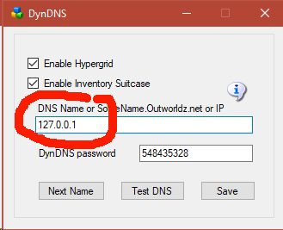

Start the grid up.

2) Now that the grid is running, use http://www.canyouseeme.org on port 8002 to verify your router has ports forwarded.  if not, work on the router/firewalls so you can see the Opensim Robust service on 8002.

3)   Try to get to that same IP address plus :8002 in a web browser from the server. My IP was 24.173.0.66, so I would try http://24.173.0.66:8002

If you get no web page, your router does not support loopback.

4)Add the Windows Device driver for loopback. Use the exact same IP address that http://www.canyouseeme.org reported.  This is what mine looks like

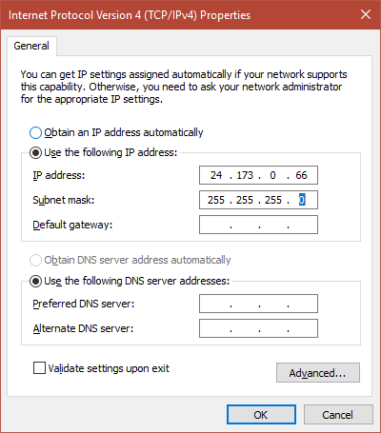

1. Click Start, then type cmd in the search box.  
2. In the command prompt, type hdwwiz.exe and press Enter.  
3. Click Next.  
4. Select Install the hardware that I manually select from a list (Advanced), then click Next.  
5. Select Network adapters, then click Next.  
6. Select Microsoft as the manufacturer, select Microsoft KM-TEST Loopback Adapter as the adapter for Windows10 , then click Next.  
7. Select Next to confirm the installation.  
9. Select Finish to complete the installation.  
  
To configure the newly created adapter:  
  
1. Click Start > Control Panel > Network Connections.  
2,. Select the newly created connection (named Local Area Connection #, where # is its order number).  
4. Right-click on the selected connection and choose Properties from the menu.  
4. Confirm that Microsoft Loopback Adapter or Microsoft Loopback Adapter # is displayed in the Connect Using: field.  
5. If it is not, return to step 2 and retry properties for another adapter.  
7. Select Internet Protocol IPV4 and click Properties to open Internet Protocol (TCP/IP) Properties.  
8. Select Use the following IP address. Fill in the IP address and Subnet mask fields.  
  
Example: 10.10.10.10, 255.255.255.0 <=====But use the IP address shown by http://www.canyouseeme.org  
  
9. Click OK to close the Internet Protocol (TCP/IP) Properties.  
10. Click OK to close the connection properties.  
11. Right click the Microsoft Driver and rename it to just "Loopback". DreamGrid will automatically update the driver if your Public IP changes.

12.   You should be able to reach your grid at the IP Address:8002 now.   If so, you can now go back to the HyperGrid Setting and choose a DNS name.

Links:

<http://www.canyouseeme.org>

## FIREWALL

The Windows firewall is automatically opened for TCP and UDP for any ports that DreamGrid needs. It closes those ports if you reduce the number of regions and increases the open port count if you add regions. This also works on Icecast and Apache.

You may want to block certain Ips from accessing your system.

You can use the Windows firewall to block specific IP addresses and ranges of Ip addresses.

Open the windows firewall and click **Advanced Settings** on the upper left side.

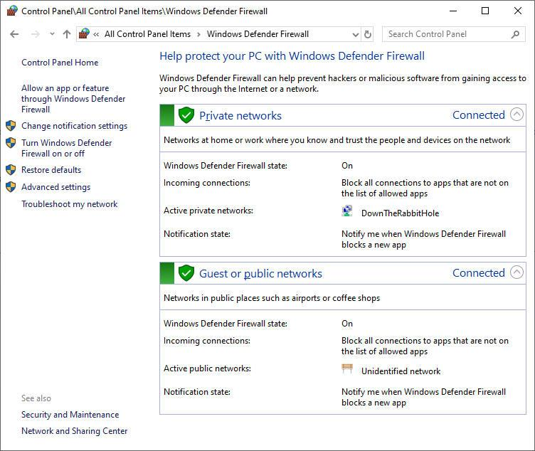

Advanced settings screen:

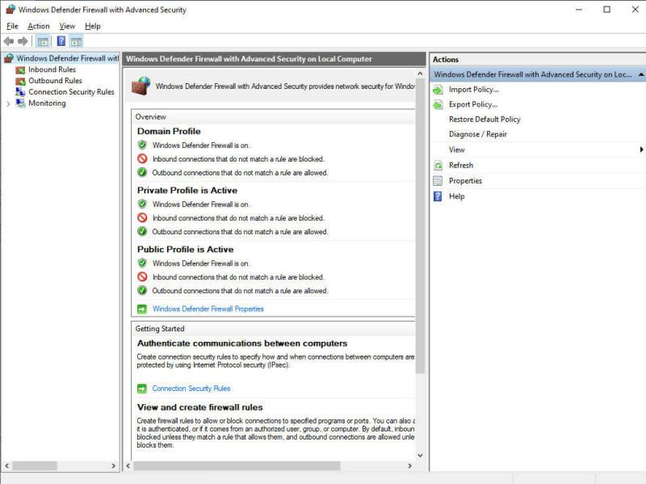

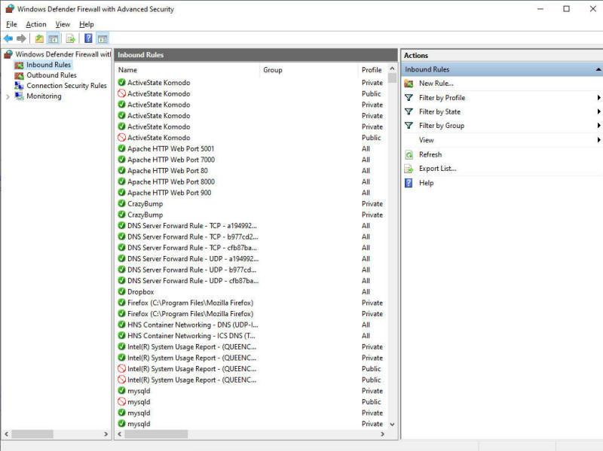

Right click **Inbound Rules** and select **New Rule:**

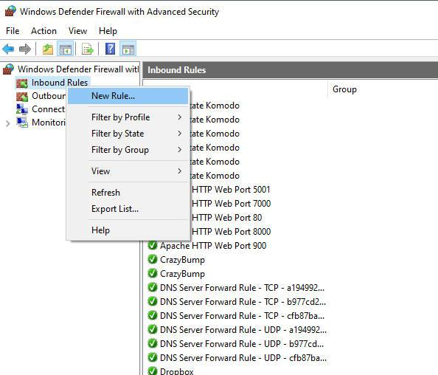

Select Custom Rule

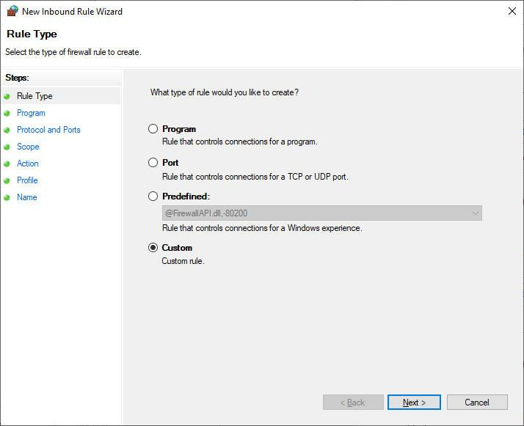

Select All programs:

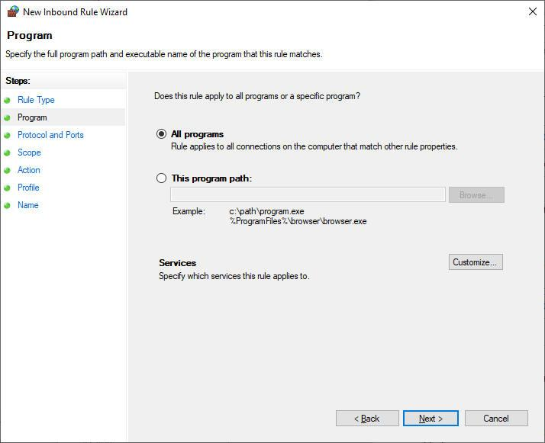

 Enter the port for your grid login. Yours is likely to be **8002**. TCP is used to log in, so we will block it.

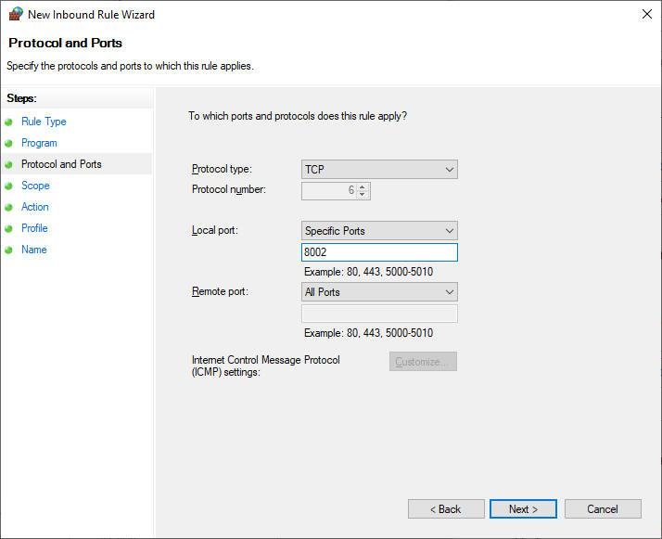

Select Which Remote IP does this rule belong to and click These IP addresses and click Add

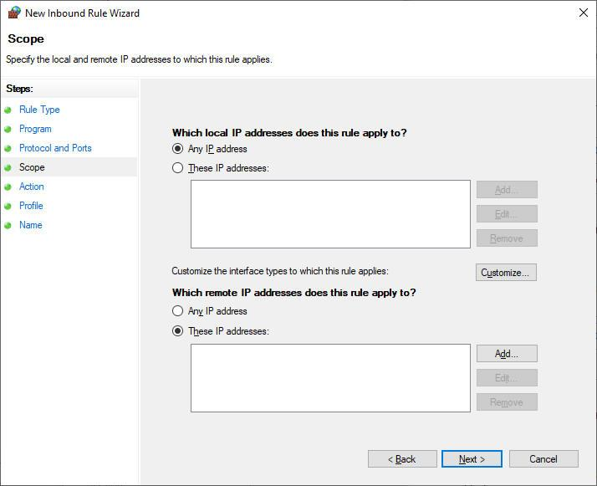

Enter the IP or range of IP's.

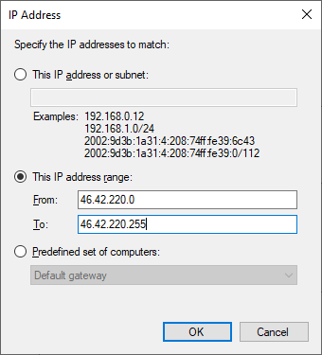

Click **OK**

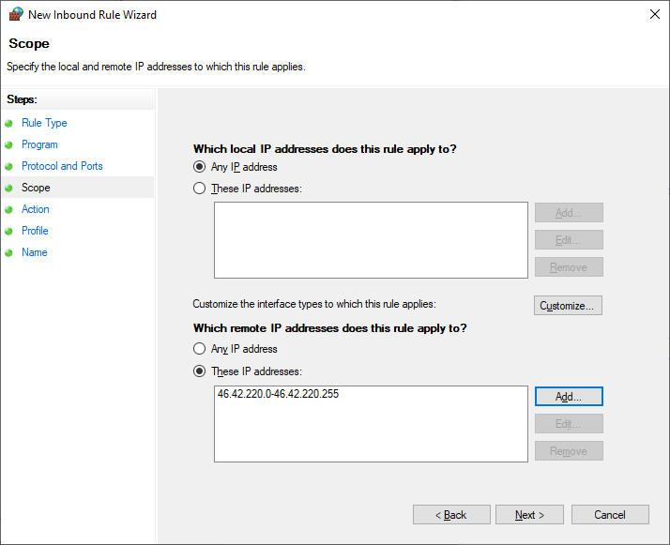

Click Next

Click "Block this connection"

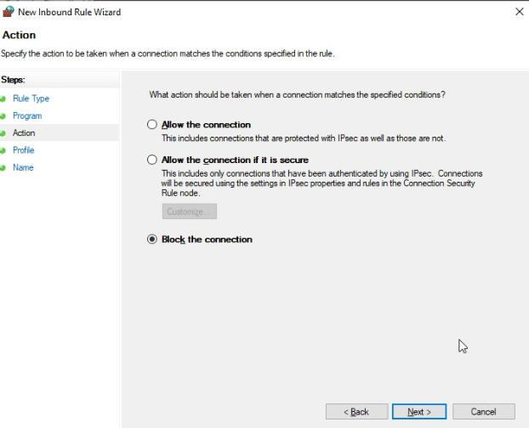

Which firewalls? Do all of them. These are for machines that may travel to public places such as a McDonalds. Your grid should be set for Private. In corporate environments, it would be Domain.

It is safer to just do them all.

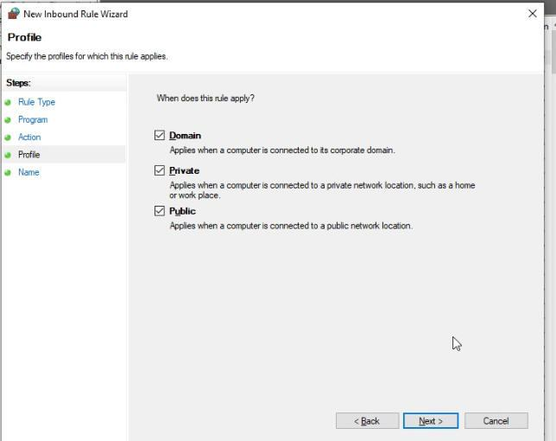

Enter a descriptive name.

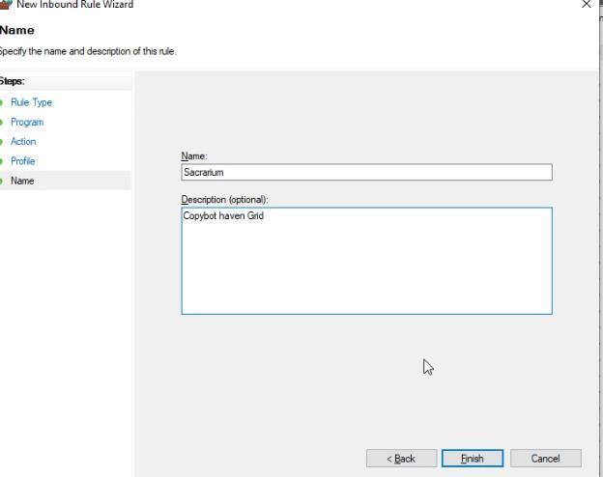

Click **Finish**.

Flotsam Cache Settings

OpenSimulator has an asset cache that stores the assets retrieved from an asset service. This reduces the load on a possibly remote asset service and improves OpenSimulator responsiveness.



Flotsam asset cache

The Flotsam asset cache, stores assets on disk and in memory.

At the moment, the amount of memory or filesystem storage used by the cache can only be limited via manual actions (wiping all or part of cached assets from the filesystem), by console commands (e.g. "fcache clear") or by timeout settings (e.g. FileCacheTimeout = 1 to automatically remove cache files not accessed for 1 hours).

General principles

When OpenSimulator requires an asset (e.g. in response to a viewer request for a notecard), then it first asks the cache for this data. If the data is not found in the cache, then it asks the grid asset service (or possibly a foreign asset service in the case of Hypergrid). If the asset is found then it is both stored in the cache and returned to the user.

If an asset is uploaded to OpenSimulator (e.g. by the viewer uploading an animation), then the asset is immediately both kept in cache (if there is room and the asset is not temporary) and sent to the asset service (if the asset is not temporary).

Therefore, at any point you can wipe any temporary data stored by the asset cache (e.g. on the filesystem), since the next request for that asset will simply query the asset service as the asset will not be found in cache.

# FSAssets Settings

FSAssets is intended for larger grids where the size of the database is expected to exceed 50GB. This option will save the assets to the file system as opposed to the default service which stores assets as blobs in the database. This option also provides deduplication abilities. Each asset is hashed when it is received for storage. If the asset already exists, the asset service will link to the existing file rather than store two copies.

**IMPORTANT:** This is a major change in database structure. If you already have a MySQL database running with a lot of assets, this will help speed it up, but it will cost a lot of disk space. If you start out with this setting, it will use the least space. **Once you switch to FSAssets, you cannot go back to just MySQL without losing data entered since the switch.**

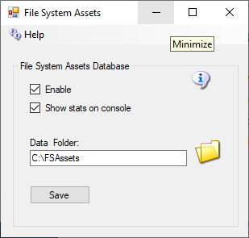

## Data Folder

This is the folder in which the asset data will be saved. Default = ./fsassets/data

## SpoolDirectory Folder

The spool directory is a folder used for temporary storage while the asset is hashed and compressed before it gets moved to the BaseDirectory. This must be on the same file system as the base directory. Default = ./fsassets/tmp

## Migration

FSAssets will use the MySQL database to collect the original data. This will not automatically convert all the old assets to the new service. To convert all assets from the default service there is a Robust console command provided:

import <conn> <table> [<start> <count>]

The import command expects a database connection string and the name of the legacy asset table to be passed as parameters. The following example shows how to start the import process for a MySQL database. Change the connection details to match your database schema, username and password, or use the DreamGrid default shown here, and copy and paste this into your Robust console:

import "Data Source=localhost;Port=3306;Database=robust;User ID=robustuser;Password=robustpassword;Old Guids=true;" assets

Depending on the size of your existing assets table, the import process will take some time to complete. The optional parameters, start and count allow you to specify the position and number of rows to convert.

A default, blank database will look like this:

R.O.B.U.S.T.# import "Data Source=localhost;Port=3306;Database=robust;User ID=robustuser;Password=robustpassword;Old Guids=true;" assets

Reading data

0 assets imported so far

100 assets imported so far

200 assets imported so far

Import done, 274 assets imported

R.O.B.U.S.T.#



# Grid Type (or server type)

Grid Type lets you choose from either a Grid Server with Robust, or from 3 Region Server choices to connect to another grid.

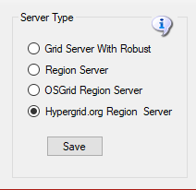

**Grid Server with Robust** is a complete DreamGrid, with your own inventory, logins, and name. This is the default. When you start your grid, a Robust Box will open to control all your users’ inventory.

This is the default with the Robust “Grid" module. One server must have a running copy of Robust. Additional PC's can connect to the Robust server to add more regions.

**Region Server** is an add-on to an existing DreamGrid. You can connect additional regions on one or more PC's to an existing Grid Server. You must have access to port 8003 on the Robust server to do this.

A region Server can connect to another Dreamgrid, provided it can reach the Dream Grid’s Port 8003. You connect to the Dreamgrid server by changing the DNS name on the Region Server to the name of the grid. For example, my grid is normally named ‘[www.outworldz.com:9000](http://www.outworldz.com:9000)’. So I change the DNS to [www.outworldz.com](http://www.outworldz.com), and change the HTTP port to 9000 and the robust port to what the grid runs on (which happens to be 9003).

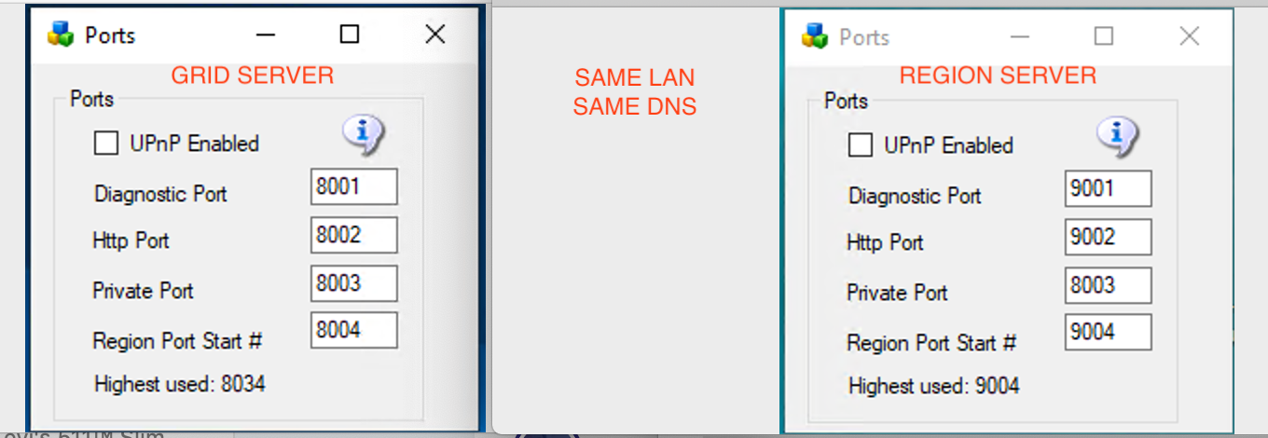

pic courtesy of Michael Bradley

The firewall must also be opened between the two machines. This is not normally an issue on a LAN. But if the region Server(s) are on the Internet, you should not allow access to the port 8003 from everyone. Set up a firewall rule to allow only the Region Servers to access your servers port 8003.

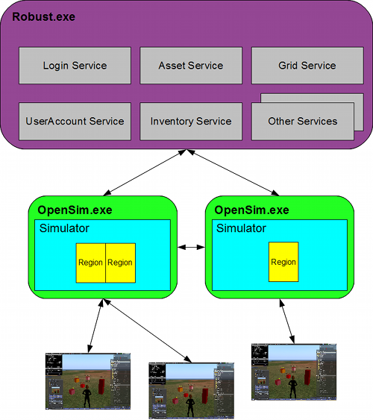

<http://opensimulator.org/wiki/Configuration>

’<https://www.osgrid.org/map.php>

**OsGrid Region Server** This choice is much like running a Region server. OsGrid Servers connect to OsGrid.org. OsGrid is already configured to accept your connections. There are some simple rules you must follow to connect to OsGrid

You will need to choose an empty spot on OsGrid's map for each region.

Your viewer login must be set to hg.osgrid.org.



[http://opensimulator.org/wiki/Configuration CC-BY-SA 2.5](http://opensimulator.org/wiki/Configuration)

**Hypergrid.org Region Server** This choice is also much like running a Region server. These servers connect to hypergrid.org, commonly called **"Metropolis Grid"**. Metropolis is already configured to accept your connections. There are some simple rules you must follow to connect to Metro in the section below.



[http://opensimulator.org/wiki/Configuration CC-BY-SA 2.5](http://opensimulator.org/wiki/Configuration)

Metro has a monthly charge to connect your region(s) to their grid, there is also a one-time one Euro charge to register/verify your avatar/account which you need to do to connect a region and login.  
  
See [https://hypergrid.org/metropolis/wiki/en/index.php?title=SIM](https://hypergrid.org/metropolis/wiki/en/index.php?title=SIM&fbclid=IwAR0EfU2ajm8jxRk6TdZLnIxtINao5_ngDwppnAiwqpCe1y54Fg1MY1nyqLc)  
  
When connecting a self-hosted region, the grid services will be charged a fee of 1.50 euros per month. This contribution is automatically collected monthly from the owner of the respective region.  
  
Any avatar registered in METROPOLIS can move freely within the grid and, if interested, visit most regions freely. Furthermore, he can also collect and use freebies.   
  
Only two functions require verification of the user:  
  
- if a self-hosted region should be connected  
- if the user wants to build on sandboxes or on the DUNE regions.  
  
Since copyright-relevant objects can also be loaded into the grid for the aforementioned functions, we are obliged to verify the respective user for legal reasons.  
  
**How can I verify?**  
  
To verify an avatar, a one-off symbolic Euro (1 Euro) will be paid to the Metropolis grid via PayPal. Upon payment, PayPal transmits an ID number of the payer. This ID tag (and only these) is stored in the METRO database. No RL names or other RL details are requested and / or stored.  
  
Subsequently, the name of the avatar name indicates the user for whom the verification is to be performed. IMPORTANT: After payment has been made via PayPal, you must return to the METRO page via the link on the PayPal confirmation page.  
  
For the verification a PayPal account is required, which can be created for free on paypal.de. The account is available within a few minutes."

<https://hypergrid.org/metropolis/wiki/en/index.php?title=SIM>



# Icecast & Shoutcast

Outworldz Shoutcast And Icecast Server

Outworldz Dreamgrid contains a free Icecast and Shoutcast server. You can use this to broadcast voice and music to any radio, web page, Opensim, Second Life, or your own grid.

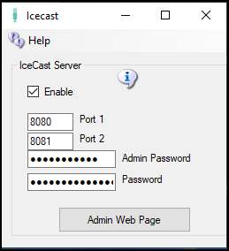

**Enable**: Starts an Icecast Server when Start is clicked.

**Port1 & Port 2**: Default is 8080 and 8081. Both ports must be Port Forwarded in your router from the Internet so users can hear the music.

**Admin Password**: Enter a strong password for control of your Shoutcast server. This Password protects a web page, so choose a good one.

**Password**: This password allows anyone to stream music to your server. You give it and the stream mount point out to applications and musicians who can stream music using your server. The stream mount point is part of the URL, in this case, it is normally /Stream:  
  
http://(Your URL).outworldz.net:8080/Stream

**Admin Web Page**: Click this button when Icecast is running to get to the control panel web page.

Troubleshooting Icecast:

The latest "default" for ports for NEW installs is 8100 and 8101.

Check in Setup->Icecast which port is set.  Check that Icecast is enabled.  There is an Icecast DOS box that appears when it is running.  You can restart it by clicking the Icon or the Menu bar at the top of Dreamgrid.

Check that you can reach the Icecast server at http://127.0.0.1:8080.   If not, check Icecast error.log and access.log.

This is normal error.log:

[2019-08-20  11:13:33] INFO main/main.c Icecast 2.4.3 server started  
[2019-08-20  11:13:33] INFO yp/yp.c YP update thread started  
[2019-08-20  11:13:33] INFO connection/connection.c No SSL capability on any configured ports

Check the port with http://CanyouSeeme.org to see that it is open.  If not, make sure both ports are port forward for TCP and UDP.

Add an exclusion for both ports to your firewall.  Keep trying this until you get it to answer to http://127.0.0.1:8100. At that point Winamp should connect.

Then check http://(Your Grid)Outworldz.net:8080

Use this URL (the mount point) to play music:

http://(Your URL).Outworldz.net:8080/Stream

This URL will Opensim or SL or in a web browser or other compatible stream reader.

How to Broadcast Music:

To stream your own radio, you need a program to play music and send it to your stream.

I use Winamp. You can also use Mixxx, or any third-party streamer. Instructions for both follow.

## WINAMP

You can use many different music or microphone players to stream music to your system. These instructions are for the popular Winamp player.

First, [download](https://www.outworldz.com/Outworldz_installer/Grid/winamp5666_full_en-us_redux.exe) and install Winamp.

Then [download](https://www.outworldz.com/Outworldz_installer/Grid/shoutcast-dsp-2-3-5-windows.exe) and install the Shoutcast DSP

Run Winamp.  You should see a screen like this:

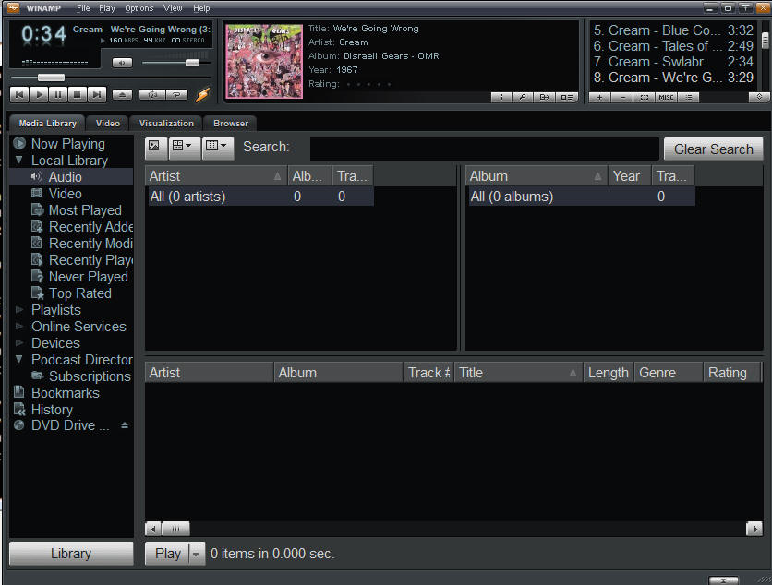

Navigate to the Options -> Preferences screen

Scroll to the DSP/Effect section on the left side:

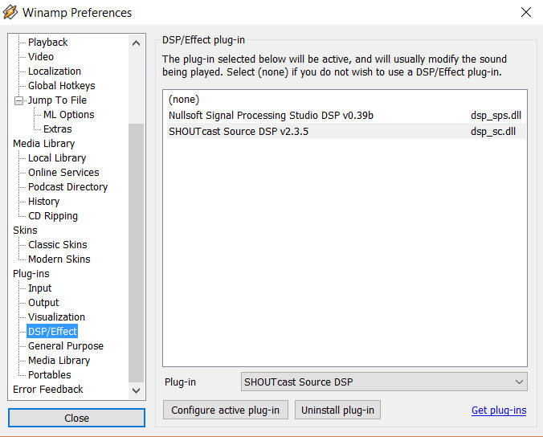

Double click the Shoutcast DSP on the right side to get the DSP setup screen.

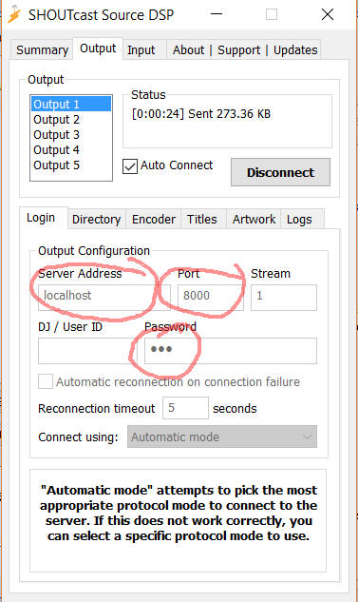

**Server Address:** Enter 'localhost' for the Server Address.  If you wish to run Winamp on a different machine, use the Server LAN address.

**Password:**Choose the same password as you used in the Dream grid’s password field (not the Admin password).

**Port:**Also enter the same port you used in the Dreamgrid setup screen.  The default is 8000.   If you want others to hear this stream from outside your network, remember to either forward the port or enable the UPNP setting and restart your server.

You can configure more of the screens, but they are not required.

Click **[Auto Connect]** and make certain you see it connect to your Shoutcast server.

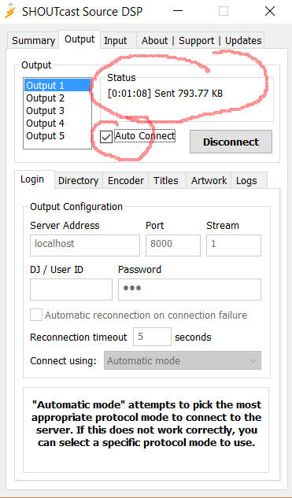

## Icecast Control Panel

Click the Icecast [Control, View and Listen] Button to view your Icecast web page.  

It should open a web page that looks like this when there is no stream playing.  
  
  
  
  
Go find some music in Winamp and press "Play".  
  
The screen should now change to show it is up  
  
**Setting up your in-world radio**

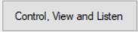

You can use any radio script to set your radio onto the land. A straightforward way is to navigate to the About Land tab and enter the URL into the Sound Tab. For more information see <http://wiki.phoenixviewer.com/land_audio_tab>  
  
  
  
Now enable the media to play in your viewers Sound & Media tab.  
  
  
  
For more details, please see <http://wiki.phoenixviewer.com/land_audio_tab>

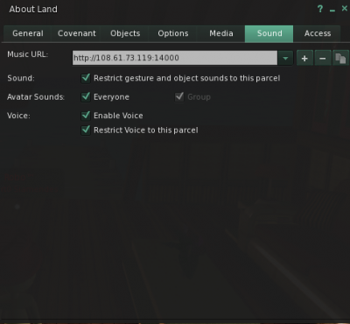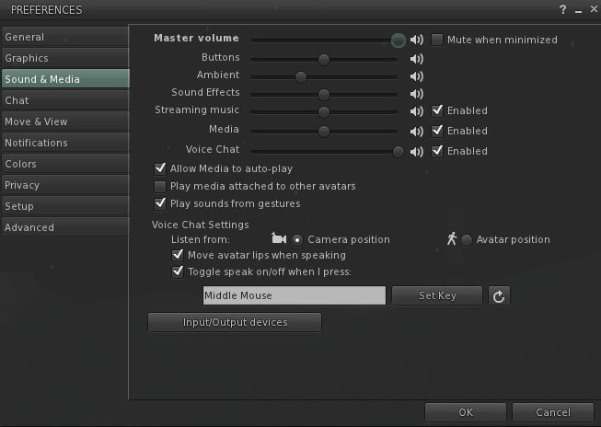

## MIXXX

Download and install [Mixxx](https://www.mixxx.org/) from https://www.mixxx.org/. This is what the screen looks like.

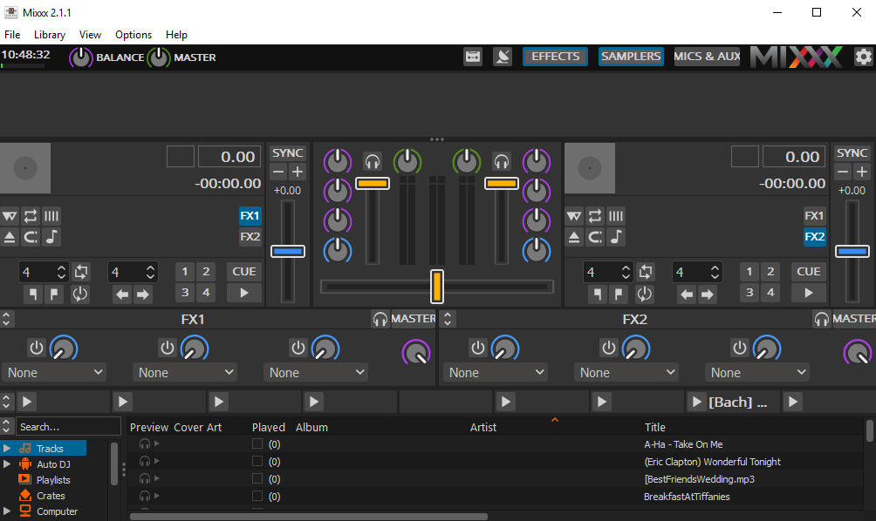

Special instructions for MP3 files:

To enable MP3 streaming on Windows, you must follow these instructions:

First, download the lame library from http://www.rarewares.org. The download page includes 32-bit and 64-bit versions. Make sure the version you download matches the version of Mixxx that you use, not the version of Windows. If you are on 64-bit Windows but are using 32bit Mixxx, you need the 32bit (“x86”) version of the library. Unpack the downloaded ZIP archive.

Copy libmp3lame.dll to the location you have installed Mixxx, probably C:\Program Files\Mixxx\.

### 

### 

### 

### 

### 

### 

### 

### 

### 

### Running Mixxx

Go to Mixxx's Preferences Screen, then select the "Live Broadcasting" tab on the left. These are the settings I used:

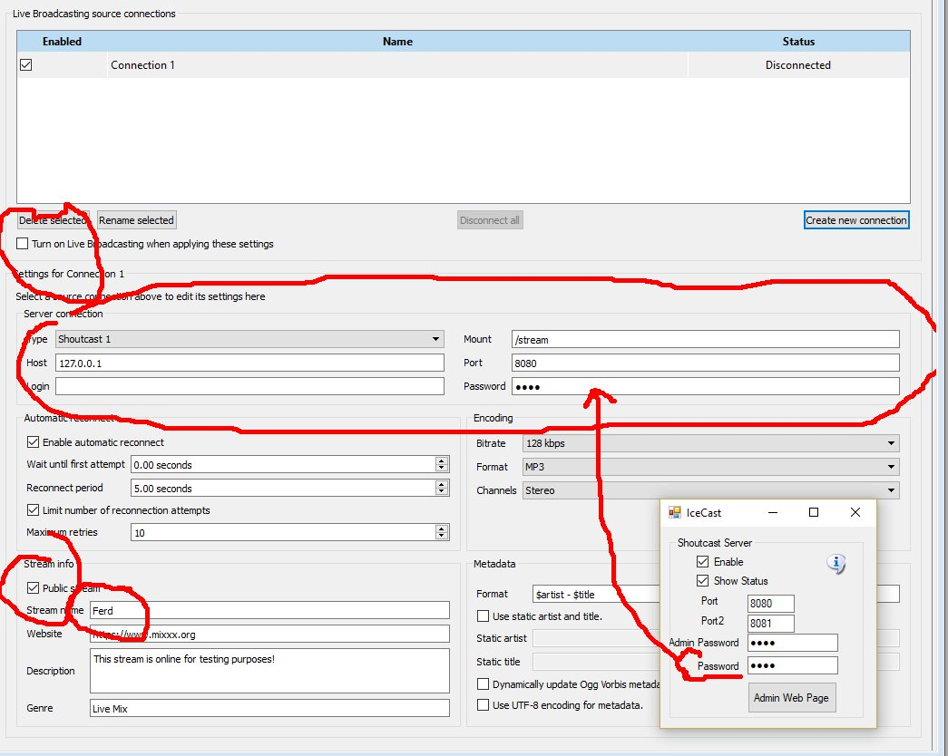

* Check Turn On Live Broadcasting
* Set type to **Shoutcast1**
* The standard mount point everyone uses is **/stream**
* Host is 127.0.0.1
* Port is **8080** from the Dreamworld setup.
* Login is **blank**
* Password is the same password from the Dreamworld setup.
* Check **Public** if you want your stream to be on the Mixxx website. Give it a name.
* Click **Okay** and the screen will gray out and should show no errors.

Icecast/Shoutcast Troubleshooting:

If it cannot connect, make sure Icecast is running in a separate DOS box.

You do not have to run the grid to stream music. It is only used to set up the files and start Icecast. For example, you can run a radio station or use it for Second Life. There is a batch file in /Icecast called 'icecast.bat' that will run the server.

Port Forwards for Icecast:

Add port 8080 and 8081 to your routers Port Forward.  You should also check they are not blocked by your firewall or antivirus. This is my setup:

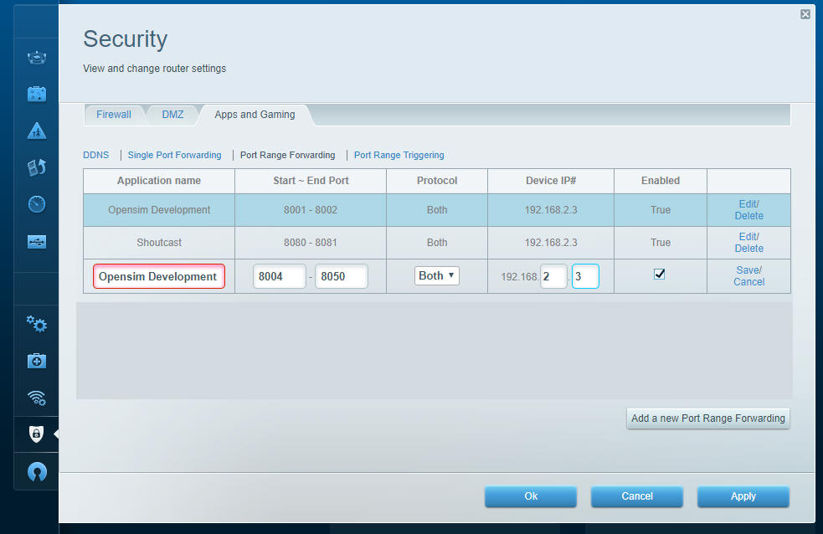

The setting shown above should be used when you are running the Icecast/Shoutcast server.

### 

### Mixx Setup

On the top of the Mixxx main screen is an **Options** menu. Click **Enable Live Broadcasting**. I have it shown in the photo. Load a track and click play. For me, that was hard to find! It is circled in the picture and shows a pause button.

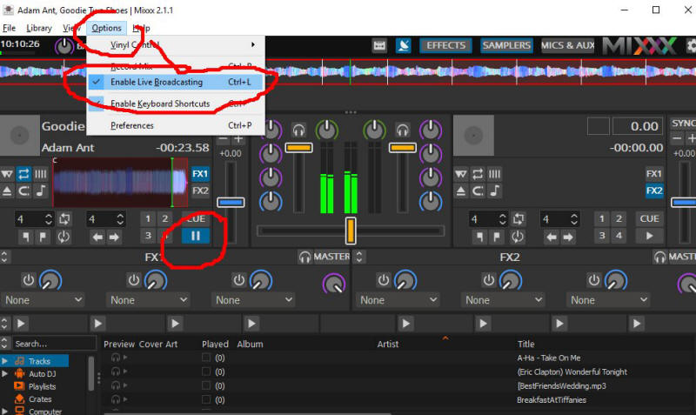

Use a web browser and navigate to http://127.0.0.1:8080/stream and click the play button. You can also click the **Admin Web Page** button. You should hear the music, delayed by maybe 15 seconds. This is normal buffering. Click Stop in Mixxx and the music will play for a bit longer due to the buffering.

The Public URL or Domain Name for your world is entered into your sim instead of 127.0.0.1, so for my simulator, the music URL becomes **http://www.outworldz.com:8080/stream**. This URL must include the 'mount point' of /stream you entered earlier.

Navigate to http://127.0.0.1:8080. You should see the standard web page for Icecast. Yours truly, can log in using your administrator password, see the status, and see the mount point.

# License Agreement:

Dreamgrid is Copyright 2011 by Outworldz, LLC under the GNU Affero General Public License (AGPL 3.0). The GNU Affero General Public License is a free, copyleft license for software and other kinds of works, specifically designed to ensure cooperation with the community in the case of network server software. All rights are irrevocable provided the stated conditions are met. This License explicitly affirms your unlimited permission to run the unmodified Program. https://www.gnu.org/licenses/agpl-3.0.txt

Source code: https://github.com/Outworldz/DreamWorld

Other open source licenses apply to Opensimulator and the libraries and other functions included herein. A list is provided in several folders:

* \Licenses_to_Content
* \Opensim\ThirdPartyLicenses
* \Opensim\NOTES

Publicity:

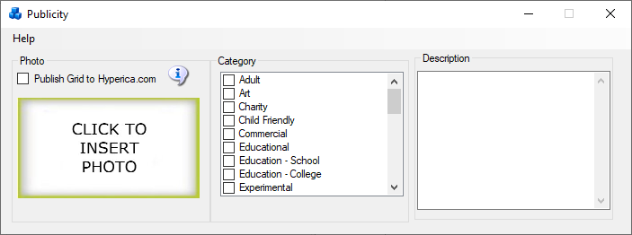

If you check the **Publish Grid to Hyperica.com** box, the system will send public information about your grid, such as the web address, to Outworldz, LLC for use in the Hyperica.com directory. This information is removed automatically if you turn your grid off or uncheck the box.

## DNS

The DYN DNS system stores public IP addresses and your domain name as is necessary to run the DNS system.

## Anonymous data

The unique random identifier of your machine is stored at Outworldz along with a small amount of anonymous data. This includes whether your software passes diagnostics, the revision level, and whether it is on the Hypergrid. This is used for quality control purposes.

The Outworldz web server may also automatically collect and store routine information in server logs. This may include details of how you used our service, such as your search queries or Internet protocol address, browser type, browser language, the date and time of your request and referral URL.

# Logging Menu

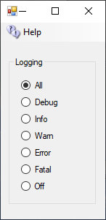

There are multiple levels of logging in Opensim:

"All" - Everything is logged. This includes every level below.

"DEBUG" - Developer level notices are sent to the log, plus the levels below.

"INFO" - Useful information, plus the levels below.

"WARN" - Warnings are logged, plus the levels below.

"ERROR" - Errors are logged, plus the levels below.

"FATAL" - Only Fatal errors are logged.

"OFF" - nothing is sent to the log files.

"Logs" are the Robust.Log located in Opensim\bin, and the Opensim logs located in Opensim\Bin\Regions in each DOS Box folder.

# Load Free DreamGrid OARs Menu

An OAR is an Object Archive - a complete region with content, terrain, and scripts. You click the Menu to load a Free OAR from the Outworldz, and a list of free OARs appears:



The name, file size, and the credits/license for the OAR appears when you hover your mouse over the photo. You can search for an OAR in the search box at top.

Clicking any photo brings up a region chooser box:  
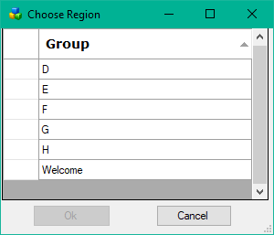

Select the Region you wish to load and click OK. you can also double-click the region.

Click a Blue section to choose which section of this Var Region to put this OAR in. Typically you will always click the lower left box. You can click others if you wish to put a 1x1 inside one of the other Blue boxes.

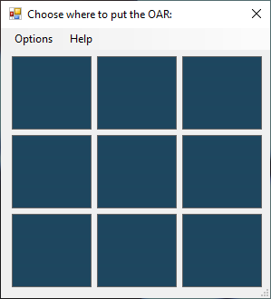

## Options:

-merge

Specify to merge the contents of the reading OAR with the existing contents in the region. Choose this if you are adding more than one OAR together. If disabled, all of the region spaces will be cleared and then your OAR will be loaded.

Clicking a different Blue box adds a displacement to all data as it is added to the destination region. The bottom left is <0,0,0>. The displacement is be specified as "<x,y,z>". So, for instance, to load an OAR from a 256x256 region into the middle of a larger 512x512 region, the parameter would be --displacement "<128,128,0>". Note that you can specify a "Z" displacement which will move the objects up or down. Thus --displacement "<0,0,1000>" will put all the OAR's objects up high for a sky box.

The displacement is also applied to the terrain if it is included. The 'z' component is added to the terrain's heights.

--force-terrain

Force terrain loading on --merge. Normally, --merge does not overwrite the existing region's terrain.

--force-parcels

Force parcel loading on --merge. Normally, --merge does not overwrite the existing region's parcel data.

--default-user "<first-name> <last-name>"

Instead of setting object ownership to the estate owner, assign it to the named user. This only applies to objects that have UUIDs that do not match any user account in the receiving grid's installation. There is currently no option that will force a change of owner for all loaded objects no matter whether they match a user in the receiving installation. One workaround to achieve this would be to save the OAR with the --publish "save oar" option to strip owner information and then reload it.

Links:

<http://opensimulator.org/wiki/Load_Oar_0.9.0%2B>

# Load Local IARs Menu



An IAR is an Inventory Archive - all inventory, or an object, image, mesh, or a folder. You click the Menu to load a Free IAR from the Outworldz, and a list of free IARs appears.

These IARs serve the following purposes:

* **Buoy for tides** floats up and down with the rising and falling water level. The script in is used to keep water plants, boats, and jet skis floating at the correct water height.
* All DreamGrid Teleport Systems are automatic updating signs that show online regions. The steampunk sign is by Garry Beaumont. Each sign holds 32 regions. You can add more signs by changing the number in the description to 1, 2 etc.
* HypeEvents.iar is a sign that contains Hypergrid-wide events.
* OpensimBirds.iar contains two sample birds for use with the bird module. You put out 1 bird, enable the birds module and they will fly around and flock.
* Outworldz visitor list is an experimental data collector that shows where visitors travel on your grid.
* Partner Control Panel is a prim that two people touch to become partners.
* The Radio is a auto updating radio system
* Server Visitor Screens counts traffic

# Load Free Avatar Inventory Menu

This WWW-based system has 72 IARs. The name, file size, and the credits/license for the IAR appears when you hover your mouse over the photo.

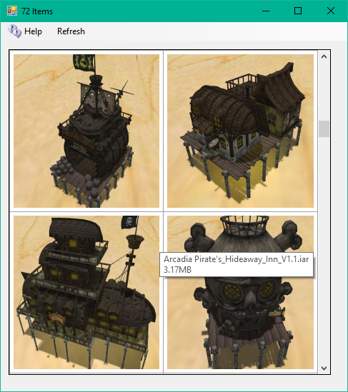

Clicking any photo brings up a folder chooser box. The default is "/Objects", but you can load your IAR to the root of your Inventory with "/", or to a specific folder, such as /Textures.

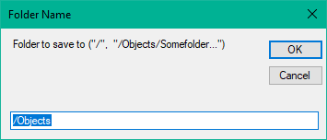

After clicking OK it will show an avatar First and Last Name box

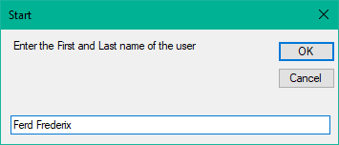

After clicking OK it will show a password box. Enter the password for that Avatar.

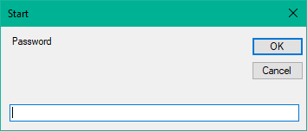

The inventory will load in one of the Dos boxes.

You may need to re-login in order to see your new inventory item.

Links:

<http://opensimulator.org/wiki/Inventory_Archives>

# **Troubleshooting Manually**

You can just run Help-Network Diagnostics and see what it says. Or troubleshoot it manually, step-by-step. The diagnostics essentially do what is described below, but sometimes you just need to know more. This is a list of things to try.

Diagnostics are run once upon installation. You can run them again (Help->Diagnostics).

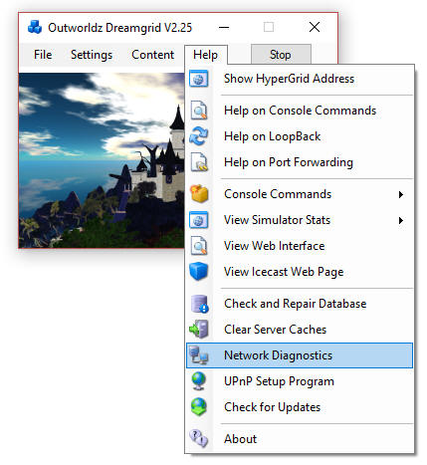

## Try This First:

Reset your router by cycling the router power.

UPnP settings are removed when the program is stopped to keep your system safe. I use Universal Plug and Play (uPnP) and several diagnostics to configure compatible routers automatically. uPnP may be disabled or fail. If your router does not support uPnP, you must manually open ports in your router and Port Forward them to your PC.

## Try This Next

Go to Settings -> Expert mode, click the DNS button at top left, and enter '127.0.0.1'. Then restart the grid and use <http://127.0.0.1:8002> as the grid in the viewers "Add Grid" menu.

You should also be able to see the Systems admin web page with a viewer by clicking the above link.

Open up your viewer. Now add the grid <http://127.0.0.1:8002> to the viewer. You should now be able to log in on the Server from the Server.

## Password Reset

You should see the Welcome region spit out a lot of text as you log in. If this fails, it is not your network, router, or loopback. You probably forgot the password. You can reset your password with the command 'reset user password' in the Robust screen.

## Troubleshooting the Network.

Any IP from outside must be able to connect to ports 8001 to 8002, and from 8004 upwards. A test at http://canyouseeme.org should work on port 8002 when Robust is running.

If not, you need to Port Forward. See the manual on Port Forwards.   
  
After that, if it does not work it highly likely to be an antivirus firewall. Windows Defender firewall may be blocking ports. You need to add exclusions to Opensim\bin\robust.exe and Opensim\bin\opensim.exe.

Try these in order:

1.  http://127.0.0.1:8002 <- gives a web page.  Verifies that robust is running on the machines Network Card loopback adapter.  
  
    If not, start Robust.

Go to the next step only when this test passes.

2. Find your LAN IP with the dos command 'ipconfig'.

Us a web browser to go to your LAN IP, such as http://192.168.0.10:8002

You should get a web Page.  If not, check your IP with the dos command 'ipconfig'.  It will be listed as an IPV4 address. While there make sure there are no other gateways enabled.  This is usually 192.168.0.1.

Go to the next step only when this test passes.

3. Use a cellphone or some other PC connected to your LAN for this next one.

Navigate using a web browser on that OTHER device to <http://192.168.0.10:8002>.

You should see the web page.   
  
If this fails, it is likely to be an antivirus program blocking a port such as the Windows Defender firewall. Turn them ALL off.  Look for Malwarebytes or other installations that can block the port.  I have troubleshot one machine that had three anti-viruses. You can turn them back on once you get it working, one at a time, and see when Opensim quits. Then add the necessary exclusions to that anti-virus program.

Go to the next step only when this test passes.

4. All the above tests are LAN-based.  So now try the router:  
  
    http://canyouseeme.org on port 8002  
  
This test must pass.   If it does not the problem is either the router is not forwarding, or another firewall is blocking you.  Usually this is when people realize they have their router plugged into another router that needs to port forward, too.   
  
Go read the manual on Port Forwards. Look up your router manual. Go to http://portforward.com and look it up, too.  
  
If this fails, it is also likely to be your anti-virus. It can also be the Windows Defender windows firewall. Turn them both off.  Look for Avast and Malwarebytes or other installations that can block the LAN port.   You have already proven it is not DreamGrid, so there is no point in re0installing the grid or restarting it.  
  
Do not go to the next step until the above is working.  There is no point until the above works.    
  
Go to the next step only when this test passes.  
  
5.  Go to the network settings and click the properties of the Microsoft Driver for the Loopback Adapter.   You should have renamed it 'Loopback".  If you did, DreamGrid will update this IP when it changes.  In the IPV4 settings, it should show the same address Canyouseeme.org shows as the address.  The gateway is 255.255.255.0   No other settings are needed.   Close those settings, and right click the adapter and enable it.   
  
6.  Navigate to http://(The Ip address reported by CanyouSeeme.org):8002   
  
You should see the web page. If not, recheck the Loopback settings.   
  
Go to the next step only when this test passes.  
  
7. Right click the Loopback Network Adapter and disable it, if you have installed it. Navigate to http://(The Ip address reported by CanyouSeeme.org):8002.   It may or may not work.  If not, you need to re-enable the adapter.  If it gives a web page, congratulations, your router supports loopback. Leave it disabled.  
  
8. Go to Dreamgrid Settings-> Hypergrid DNS name.  Add your desired name, such as in ‘somename.outworldz.net’.  The allowed characters are a-z, 0-9, and a dash '-'.  Press Save.

9. Go to a DOS prompt.  Type 'nslookup<enter>'.  Type ‘somename.outworldz.net', where name is the name you chose.  It should report the IP with the exact same number as Canyouseeme.org.

10. Add the ‘somename.outworldz.net:8002’ to the viewer’s grid selection, and log in. Both the robust and welcome region should show you logging in. If you only see Robust, then you forgot to port forward or unblock Ports 8004 upwards. You should unlock 10 to 15 ports for expansion, as any extras are harmless.

## Flaky Teleports

Multiple factors can cause flaky things, some of which may not be under your control, such as at the far-end system.

One way to prove your issue is not Opensim or your PC network card is to boot up after changing the Hypergrid DNS name to the IP of the server, or just leave it blank, so it will choose the LAN IP by default. You should be login to that IP address in your viewer, and teleports on your grid should take just moments.

Try uploading a dozen textures. Do they all load without aborting? Now ask some on the Hypergrid to do so. If there is a difference, you have issues with the router and loopback, as the traffic from you and the outside both go to the region, but the region cannot reliably reach some of the ports.

Do you have more than one Network adapter with paths to the Internet, such as both wireless and hardwired running? Opensim can listen to only one adapter, but traffic can come back on either.

Loopback is often flaky in routers. For example, the routers from FIOS and Frontier have tiny 1K buffers for UDP leaving to flaky teleports. Have you tried adding the Microsoft Loopback driver?

These are the URLS it checks to see if it is working that can be run on the server.

When the DNS name is blank, such as first boot, I need a LAN IP to broadcast to the viewer. If a LAN IP is unreachable from the Internet, I announce you cannot Hypergrid.

DG tries to always make a working system, no matter what. There are multiple ways to connect to a LAN, by the WAN IP with or without a DNS name, and as a LAN IP, and localhost. In a complex network environment, there can be multiple ways and more than one IP in use to connect to the outside. Both Wifi and Ethernet adapters, for example. Opensim can only listen to one IP, thus return traffic on the wrong IP can be lost. This is flaky, at best, and is a major cause of teleport problems.

Opensim needs to listen and broadcast only on the "proper" IP. But which is it? I do this by connecting to Googles 8.8.8.8 DNS server, then asking Windows what the Endpoint address is. Typically, this is a number in the 192.168 range, or the 10. * range, which are typical LAN IP's. But it can be anything. If I cannot reach it, I use localhost. DG will thus always come up in a working configuration on first boot.

### The URL I use to Test port forwards:

<http://outworldz.com/cgi/probetest.plx?IP=YOURNAME.Outworldz.net&Port=8002>

Answer should be **yes**

### Test Private Loopback:

<http://192.168.2.135:8001> (change this to your LAN IP of the server)

Answer should be **Test Completed**

### Test Public Loopback

<http://YOURNAME.Outworldz.net:8002>

Get back a web page

# How to Get on The Hypergrid

Accessing the Hypergrid easily requires a compatible uPnP router with loopback. If your router does not support loopback, you can still join the Hypergrid by installing a special pointer in /etc/hosts or a special Windows Device Driver. Additional information about routers is available online at the Opensimulator site at <http://opensimulator.org/wiki/NAT_Loopback_Routers>.

## UPnP Not Working?

Do you have Plug and Play (uPnP) issues? Your Help menu has a useful tool to look at uPnP in your router:

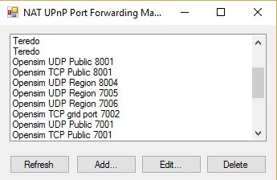

Free UPnP (Universal Plug and Play) Tool for Windows

You can add, delete, and modify the settings without a password, assuming you have uPnP enabled. This is included in Dreamworld and Dreamgrid in the Help menu.

You can still manually forward ports in your Router. Instructions for your specific router can be located at <http://www.portforward.com>

## Firewall

Windows will prompt you to allow Opensim to open ports when it first runs. If you say no, you will not be able to log in.

If you are using an Anti-virus with a firewall, such as Zone Alarm, AVG Internet Suite, or anything else, running Start.exe my trigger the 3rd party firewall popup warnings. Opensim.exe needs to be allowed internet access, and Start.exe should be allowed to make changes. This code is digitally signed by me, Fred Beckhusen of Outworldz.com, and is open source and available for inspection on <https://www.github.com/Outworldz>.

## Updater:

If it acts wonky or is missing files, look in Help->Check for Updates. It will repair any missing files.

## Help with Opensim Crashes:

Your MySQL database may be crashed. This is a way to start MYSQL manually.

Navigate to the Outworldzfiles\MySQL\bin folder. Press and hold the Shift Key and right click the BLANK area next to the files. Or navigate there, as I did below, by typing in commands. Then run "StartManually.bat"

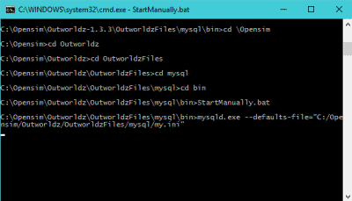

Any error message it prints may be helpful. If the above DOS window closes, a MySQL LOG file will be saved in OutworldzFiles\MySQL\data as a *.err file. That will give you a clue as to what to do.

## My database still did not start.

Try running Outworldzfiles\MySQL\bin\Repair_ISAM.bat. Start MySQL and wait until the Task manager in Windows shows that Mysqld.exe is at 0% CPU use.

Still not working? Delete the two 10 MB files, ib_logfile0, and ib_logfile1 in MySQL\Data and repeat the Repair_ISAM.bat and run "StartManually.bat" again and wait for the CPU to drop to 0%

## Starting Over with A Blank Database

You can wipe ALL data out and recreate it from OAR and IAR files. This WILL LOSE ALL DATA.

If you MUST wipe out the database and start over, there are two methods.

The easiest way is to unzip the provided blank database and replace (do not mix) the contents of MySQL\Data with it.

Method 2 is to delete the ib_logfile0, ib_logfile1 and ibdata1 file in OutworldzFiles\MySQL\data (leave the folders). Then delete just the contents of data\opensim\*. Leave the folder "MySQL\data\MySQL" alone.

Either method will make it start over at the very beginning and you need to re-enter your Avatar name and password and reload everything.

## Ports

Here is more detail about ports and the way the interact with the outside world such as <www.canyouseeme.org> and to my diagnostics tests.

### Port 8001:

8001 is a TCP/HTTP port that is used for setting icons to the state of what Opensim is doing, and some other simple functions such as automatic updating teleport signs and the Partners prim. It is unique to Dreamworld.

### Port 8002:

Opensim has a web server that web browsers understand, using the same protocol (TCP/HTTP) that tools such as <www.canyouseeme.org> support. Put simply, Robust listens to port 8002 and answers to http:// requests on 8002. Port 8002 is much like port 80, the default port for web pages. You can actually set Dreamworld's 8002 port to 80, and it will work. You can then drop the need to type :8002 at the end of your hyperlink. <http://hg.Osgrid.org> does this. There would be no need to type the :80, as literally http:// means "add a :80 to the end of it". So only 8002 works with web-based probe tools. If you do switch it to 80, then you must change the Apache port 80 to some other port. Only one program can listen to a port.

If Opensim is not running and your ports are open, it is as if you tried to connect to <www.google.com's> web server, but their web server is down. Nothing will happen, though your packets can get through the Google firewall because it is still open to traffic and is steering it to a dead server. You will get no answer. Similarly, if Opensim is not running, there is no web server to answer the request.

### Port 8003:

This port is listened to by Robust so regions can chat to the server database for login, presence, and other services so people can teleport from one region to another. In Dreamgrid, just like OsGrid or any other remotely attachable grid, the regions can run on any machine anywhere in the world.

If you opened port 8003 to anyone on the web, you expose the internal database protocol to the web. Anyone with the right knowledge could attach a region to your sim. If you run a DreamGrid and host region outside your LAN, it is recommended you use firewall rules to only allow access from known IP addresses running approved regions.

### Port 8004 and upwards:

The region ports (8004-upward) run both TCP and UDP. UDP is used for the viewer. UDP cuts the load on the server dramatically as there is no need to automatically always ACK every packet. As one example, no one cares if an audio stream gets briefly interrupted as you cannot hear it anyway, and it is too late to use it if it comes later in a retry. It just gets discarded.

## Running Manually

You can run Opensimulator without Dreamgrid. Dreamgrid sets up Opensim to run. Once it has run once, you can run Opensim without it.

When you click [Start], Dreamgrid looks for a MySQL listening on a specific Port. If it does not see one, it starts MySQL as a separate process. When you exit, it shuts MySQL down gracefully with *MySQL-admin.-u root shutdown*. Dreamgrid will detect Robust running on Port 8002 and just use it. If it does not see it, Dreamgrid starts up a Robust.

For running manually, MySQL can be used in two ways.

1) MySQL\bin\ StartManually.bat runs MySQL manually. Once the Command Prompt opens, this window can be closed manually, as MySQL will run by itself in another thread.

This is also useful for diagnostics and manual backups and running a Dreamgrid in folder A on a database in Folder B or C or D:\SomeWhereElse. But there is a significant issue: you need to shut down MySQL gracefully! This really needs to be done correctly to reboot or log out of Windows. The command is *MySQL\bin\mysqladmin.-u root shutdown*. There is a batch file in MySQL\bin named *StopMySql.bat* that will do this for you.

## Run as A Service

You can install MySQL as a Windows service. There is a batch file *InstallAsAService.bat* in MySQL\bin to set this up. MySQL will then start with Windows.

This batch file must be run once, as an Administrator. You type "CMD" in the search box, and then right click the Command Prompt and select "Run as Administrator". Use that DOS box to run *InstallAsAService.bat*. Then type in 'Services.msc” and use it to start MySQL.

You should also set the service to restart so MySQL restarts on any crash. Windows knows about services and will send signals to MySQL to shut itself off gracefully. The only danger is that power fails and you corrupt the database. I have set this MySQL to always flush data to the disk without saving it in RAM, which helps. If you are serious about running a grid, then a UPS is necessary.

You can start Robust manually, too. Outworldzfiles\RunRobust.bat assumes MySQL is running.

Go.bat starts a command prompt with an instance of Opensim in it (an instance is a set of sims). The batch file switches to the bin folder and launches Opensim with the settings it needs for the INI files and the Log file.

You can start it all with a batch file like this:

@remarkable batch file to start Dreamgrid manually.

cd MySQL\bin

start startmanually.bat

cd ..\..\opensim

call runrobust.bat

call go Welcome

call go AnotherRegion

## How to Compile DreamGrid

The vast majority of this software is just Opensimulator and MySQL with edits in the INI files to allow auto-configuration by XML and INI editing.

The source code package "How_to_Compile.txt" explains how it is compiled, and what changes are made. You need Visual Studio 2015 or higher, and preferably 2019.

# Maps

Opensim has many different map settings. Dreamgrid has multiple easy-to-use combinations. Opensimulator has several Map tile makers which vary in quality, and speed. It can take an exceedingly long time to boot when using the Better and Best maps. These maps which use the Warp3D engine must load all prims, mesh, and textures, so it takes a long time to generate new maps. Also, any bad textures may cause harmless errors from corrupted assets to appear on your console.

I recommend you run all maps at Best setting once, then set Maps to None. You can remake maps when enough changes have been made.

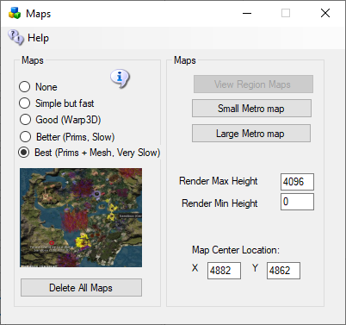

* **None**: No maps will be made. This is a good setting as the regions will boot very quickly. Any existing maps are not deleted.
* **Simple but Fast**: MapImageModule is used with just Land showing
* **Good**: Uses Warp3D module with just Land showing
* **Better**: Uses Warp3D module with Land, Prims, and land Textures showing
* **Best**: Uses Warp3D module with Land, Prims, Mesh, Sculpts, and all Textures including prims showing.
* **Delete All Maps**: If you delete a region, the map will remain. Click this to clear out all maps. You will need to regenerate all maps again by choosing a setting and restarting all regions.
* **View Map Web page:** Enabled if your system is booted. Opens a web browser to <http://localhost:8002/wifi/map.htm>.
* **Small Metro Map and Large Metro Maps** Available only if your Apache/PHP is enabled in Settings Web Pages. These maps are generated by PHP and Apache web server.
* **Render Max Height** is the maximum height that objects will appear on the map. You can use this to remove skyboxes from your map.
* **Render Min Height** is the Minimum height that objects will appear on the map. You can use this top remove water and land from your map.
* **Map Center Location** is the center of the web based map. Put the X,Y coordinate of the region that you want at the center in this spot.

## Manual regeneration

Normally, one would generate map tiles at startup. You can also manually force map tile regeneration with the console command 'generate map<enter>'.

# Permissions

Grid god mode allows certain users to take and control permissions over objects. Setting Grid God Mode on allows you to control individual users by editing their access level in the Wifi Users Panel. Any user with a level > 100 will be a grid god. You can set any estate owner or estate manager to be a grid god, too. Users can become Gods by using the Request Admin Level button in the Advanced Viewer menu.

God mode is a useful function. However, making copies of items that are no copy or no transfer and giving them to others could be illegal. Please remember that copyright laws for your country need to be respected.

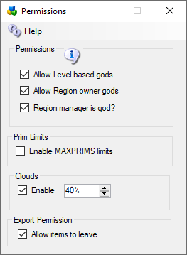

### Allow Level-based gods

God mode is available to selected people if enabled. These levels can be set for individual users in the Web control panel.

* Level = 0 is a normal user
* Level = 50 (or a level you set) is used to indicate a privileged user (e.g. who can set up new Hypergrid linked regions)
* Level = 100 is a Wifi admin account user
* Level >= 200 can become a God

### Allow Region owner gods:

If enabled, the region owner may go into God mode.

### Region Manager is God:

If enabled, any region estate manager may go into God mode.

### Prim Limits:

Opensimulator normally does not enforce limits on the number of prims for a region or a parcel. The viewer can show a maximum of 45,000 prims.

Beware: If you set this checkbox on, any prims over a count of 45,000 will be returned.

You can lower or raise any region limit in the Regions Control panel.

Default: Unchecked

### Clouds:

The original particle clouds from the early days of Second Life are still available for older viewers such as Singularity.

Default: Checked

### Export Permission:

Export Checkbox can disallow export of prims by a viewer. Default -> Allow

# Physics Engine

The Physics selection box lets you set different physics engines.

* None – You will walk through anything. No collisions. No vehicles. basic physics, where the only collidable object is a box shape.
* Ubit Open Dynamic Engine is by Ubit Umarov. It is an advanced version of ODE that is closer to Second Life compatibility with vehicles.
* Bullet Physics - Bullet is an award-winning physics engine.

Links:

<http://www.ode.org/>

<https://en.wikipedia.org/wiki/Bullet_(software)>

# Port Settings and UPnP (Region Ports/Network Ports)

Multiple TCP and UDP Ports are used in Opensim. The defaults are shown below.

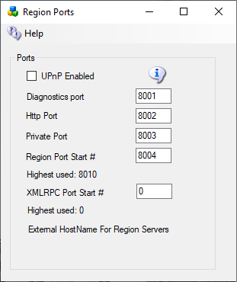

The defaults are 8001 (Diagnostic), 8002 (Public) , 8003 (Private) and 8004 (Starting Region). If you have manually added more regions, their region ports also need to be open. Each region that is used takes up one port. They start at 8004 and count up by one.

## Port Forwards

See the section on **Troubleshooting Ports** on how to manually enable the ports.

## UPnP Enabled

The Outworldz program uses Universal Plug and Play (UPnP) to automatically allow data to come from the Internet to your computer. This is called "Port Forwarding". UPnP capability may be disabled in your router, or it may not support it.

You may need to stop the SSDP Service to prevent this service from intercepting these messages.

If UPnP is enabled and your router supports it, Dreamgrid will automatically open the correct ports. This can be slow and time-consuming, so you may prefer to disable UPnP and set your ports manually

Do you have Plug and Play (UPnP) issues? The Dreamgrid help menu has a useful tool to look at uPnP in your router:

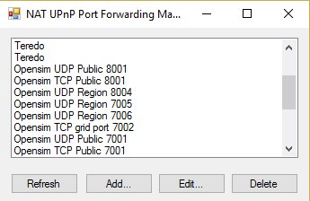  
 UPnp (Universal Plug and Play) Tool for Windows

You can add, delete, and modify the settings without a password, assuming you have UPnP enabled. This tool is available in DreamGrid in the Help menu.

## Troubleshooting Ports

A list of routers and instructions is at <http://www.portforward.com> which can help you identify your router type.

Step 1) Get your PC LAN IP address by going to a DOS prompt and typing 'ipconfig'.



In the above photo, my IP was 192.168.1.3.   Yours is likely to be in the range 192.160.*.* but it could also be a 10.0.*.* number.

For my Linksys, it looks like this:



### IceCast/Shoutcast

Ports 8080 and 8081 must be added when you are running the Icecast/Shoutcast server.

**Which ports?** You need to Port-Forward 8001, 8002, and 8004-8010 (or higher, I usually open up to 8050) to have room for expansion. You can also add 8080 and 8081 for Shoutcast/Icecast.  Do not do 8003 for security reasons. These can usually be done in ranges, like 8001-8002 and 8004-8010. The latter ones are for regions - you need one port per region, so this would let you have 7 regions. Add more if you want - nothing wrong with opening up to 8020 or 8030 or so.  In the above photo, I have opened ports 8004 through 8005.

They need to be open for both TCP and UDP. Your router will have a button or a pulldown to select UDP, TCP, or both.  If you do not have a Both or All option, you have to add them twice, once for UDP and once for TCP.

**How do I know this worked?** You can tell if it worked by starting Opensimulator, and then use a web browser to go to [http://www.canyouseeme.org](http://www.canyouseeme.org/), and enter 8002 while Opensimulator is running. Then click the Test Button at CanYouSeeMe. If that works, the ports are fine. If this does not work, try disabling your PC firewall. If this works, you must add exclusions to the firewall and then turn the firewall back on.

See **Firewall Issues (below)** for help with the PC firewall.

Keep working with the router, firewall, antivirus exclusions and IP address until this test passes.

### Loopback:

The second part that must work is loopback - either your router supports it, or not. You can immediately tell if your loopback works after running the above CanYouSeeMe.org tests. You use your web browser to navigate to http://(YOUR PUBLIC IP):8002. Mine was <http://24.173.0.66:8002>. Of course, your IP address will be different than shown here, so use whatever CanYouSeeme.org shows you. If the system is working, you get a web page.

If not, you must add a loopback adapter. Go to <https://www.outworldz.com/Outworldz_installer/Loopback.htm> and follow the instructions.

Then go to Hypergrid/DNS Name page and enter your desired Hypergrid name.

### Firewall Issues:

Windows will prompt you to allow Opensim to open ports when it first runs. If you say no, you will not be able to log in. I also set all the ports to be open in firewalls when you first click start.

If you are using an Anti-virus with a firewall, such as Zone Alarm, AVG Internet Suite, or anything else, running Start.exe may trigger the 3rd party firewall popup warnings. Opensim.exe needs to be allowed internet access, and Start.exe must be allowed to make changes to the firewall. If not, it will not work, and you will have to take manual action to fix it.

This code is safe and is digitally signed by me, Fred Beckhusen of Outworldz.com, and is open source and available for inspection at  <https://www.github.com/Outworldz>.

You may have to manually add firewall rules to allow incoming traffic on the ports.

1. On the client operating system, go to Start>Run and type firewall.cpl. The Windows Firewall window opens.  
2. Click on the “Advanced Settings” link on the left pane. The Windows Firewall with Advanced security window opens.  
3. Click on the “Inbound Rules” option.  
4. On the left pane, click on “New rule”.  
5. Under “Rule Type” select the option “Port” and click next.  
6. Select “TCP” and “specific local ports” options.  
7. Key in the port number, the port is 8001-8010 (or higher for more regions)  
8. Click Next.  
9. Select the option “Allow the connection”.  
10. Click Next, do not change any option here and click Next again.  
11. Specify a name for this rule.  
12. Click Finish.  
14. Repeat the above but using UDP from step 6

### More information about Opensim Ports

Here is more detail about ports and the way they interact with the outside world such as [www.canyouseeme.org](http://www.canyouiseeme.org/) and my diagnostics tests.

Put simply, only port 8001 and 8002 can report back to those tools as to being open and can do so only when Opensim is running.

## Diagnostics port 8001:

8001 is a TCP/HTTP port that is open for help->Network diagnostics. It is unique to Dreamworld and not to Opensim. It is used for a "port forward" test, just like Canyouseeme.org does, and for a loopback test. It collects data on sim's going up and down to change the icons and collects Partner information if two people click the partner prim.

## 

## HTTP Port 8002:

Opensim has a web server that web browsers understand, using the same protocol (TCP/HTTP) that tools like www.canyouseeme.org support. Put simply, Opensim is the only thing that listens to port 8002 and answers to http:// GET and POST requests on 8002. Port 8002 is like port 80, the default port for web pages. You can actually set Dreamworld's 8002 port to 80, and it will still work. You can then drop the need to type :8002 at the end of your hyperlink. [http://hg.Osgrid.org](http://hg.osgrid.org) does this. There would be no need to type the :80, as literally http:// means "add a :80 to the end of it".

8002 works with web based ‘GET’ probe tools. If you do switch it to 80, then you forfeit using an additional web server on your home machine as only one program can listen to a port.

If Opensim is not running and your ports are open, it is as if you tried to connect to www.google.com's web server, but their web server is down. Nothing will happen, though your packets can get through the Google firewall because it is still open to traffic and is steering it to a dead server. You will get no answer. Similarly, if Opensim is not running, there is no web server to answer the request.

## Private Port 8003:

This port is used by Opensim to listen to region traffic. Regions chat to the server database for login, presence, and other services use it to talk to the region so people can teleport from one region to another. In Dream World, regions must be on the same machine. In DreamGrid, just like OsGrid or any other remotely attachable grid, the regions can run on any machine anywhere in the world.

If you opened port 8003 to anyone on the web, you expose the internal database protocol to the web. Anyone with the right knowledge could attach a region to your sim. If you run a DreamGrid and host regions outside your LAN, it is recommended you use firewall rules to only allow access from known IP addresses running approved regions.

## Region Port Start # (Port 8004 and upwards):

The region ports (8004-upward) run both TCP and UDP.   UDP is used for the viewer. UDP cuts the load on the server dramatically as there is no need to automatically always ACK every packet. As one example, no one cares if an audio stream gets briefly interrupted as you cannot hear it anyway, and it is too late to use it if it comes later in a retry. It just gets discarded.

For multiple regions in a single DOS box, all regions listen for TCP traffic on the last port used in that DOS box. As one example, if one region is in a DOS box by itself, and it is the first region, then it listens on both TCP and UDP on 8004.

If you had two regions in one DOS box, and they start at 8004, then the regions listen to UDP on 8004 and 8005, and both regions listen to 8005 for TCP traffic. You can check that the region is reachable on the Hypergrid only by using port 8005. 8004 will not respond, as it only listens to 8004 on UDP.

## Highest used:

This displays the highest port count. You need to open or UPNP ports at least to this number.

## XMLRPC Port Start #

This port is used for custom applications

## External HostName For Region Servers

If your region server is on a different network than the Region server, put the Public IP address of the Region Server here.

## Links:

### Port Testing: [Open Port Check Tool -- Verify Port Forwarding on Your Router](http://www.canyouseeme.org)

### Loopback: <https://www.outworldz.com/Outworldz_installer/Loopback.htm>

# Publish Grid

Publish Grid shows your grid in the list at [Hyperica.com](http://hyperica.com/).

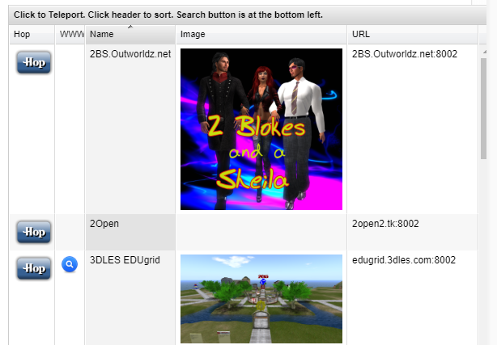

## Photos

Click the Green box to load a PNG image. It will appear in your listing.

## Publish Items Marked for Search

Setting this switch will store any prims or regions you set for "Show in Search" into a database at Outworldz that shows the data in any Outworldz grid in your viewer in Search.

## How it works

Just before a region boots, it will show this:

18:01:19 - [DATASNAPSHOT]: Set up snapshot service

18:01:20 - [DATASNAPSHOT]: data service <http://www.hyperica.com/Search/register.php> notified. Secret: 63d6b2fb-e286-4be7-b756-bb16657b4612

This is for global search. It tells Hyperica to come to your sim and get the data. This URL may be pointing to your grid's Apache server. If so, the above URL should tell the database on your grid to fetch the data.

It takes time for the region to create the XML. You must have prims marked as Show in Search, or land for sale.

# Region Add or Edit Panel

This is where you can add/edit/change a region



Selecting the above will bring up this dialog:

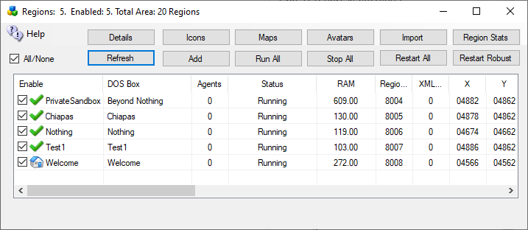

Left click on the region name you wish to work with, and it brings up this:

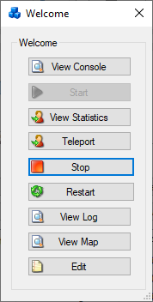

Select Edit, at the bottom of the dialog. You will get this dialog:

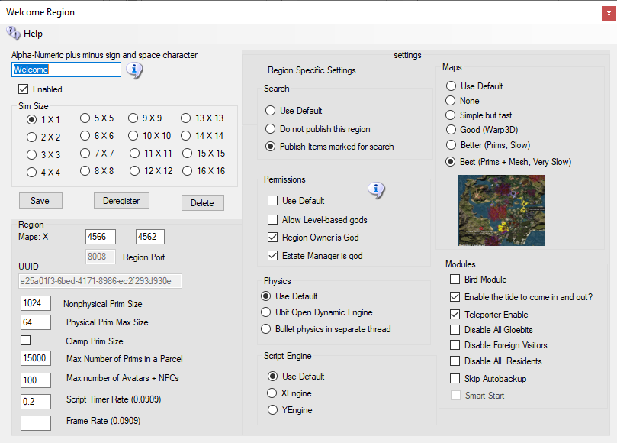

This section is a breakdown the above dialog into sections:

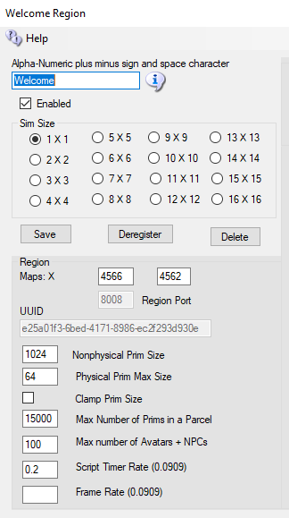

You must give a new region a name and then click [Save]. You can immediately start it up by clicking the name in the Regions panel.

If you click Delete, the region INI file will still be there, but the file name will change to .bak from .ini.

Regions are stored in OutworldzFiles\opensim\bin\Regions in folders by each DOS box name. The DOS box folder has a Region folder in it that holds the Region.ini file. See Rules for INI files at the bottom of this section for more details.



## Rules:

* Each region size can be anything from 256 X 256 to 1024 X 1024, or higher. Huge region sizes such as 4096 X 4096 can be used for flying or car racing. If you go over 8192 X 8192, you can expect it to be slow and laggy as the land size gets exceptionally large as it grows exponentially.
* You can replace 4 single regions with a single 2X2 region and there will be no lag when crossing the (nonexistent) border. Vehicles can move smoothly anywhere. Also, NPCs can move about freely. Look in any region settings panel and you will see a "size" box. Check the 2X2 box, save it, and restart the region. It will grow North and East and will be 4 times larger, overall. You will also need to move it in X and/or Y or delete the other regions as regions cannot overlap. You can shrink them, too, but objects that fall off the right and top edge will be lost.

## Options

The next section has optional items you may choose to change.

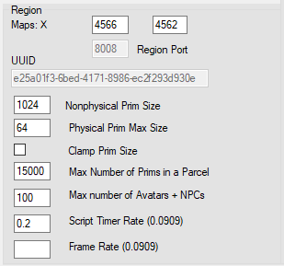

Region Maps: X (coordinates)

The (x, y) location of the region on the grid. You can set regions next to each other by changing the X and Y coordinates and restarting the region. The X and Y is the lower left point on the global map.

If you get messages saying that regions overlap, change the coordinates to some substantial number and retry the region boot. If your region still will not start due to it overlapping, type this into the Robust console:

deregister region id <UUID Goes Here>

Copy and paste the region UUID where it says <UUID Goes Here>. This can be done on Windows with Ctrl-V, or by right clicking the Robust title bar and selecting Edit->Paste.

UUID:

Never change the UUID unless you want to start with a blank region again. Altering the UUID will force the system to create a new, blank region the next time it is started, and you will be forced to move your region to another spot.

## Nonphysical Prim Size:

The maximum dimensions for a non-physical prim. This is a single number which applies to X, Y and Z coordinates. This will affect resizing of existing prims. Default is 256.

## Physical Prim Max Size:

The maximum dimensions of a physical prim. This is a single number which applies to X, Y and Z coordinates. This will affect resizing of existing prims. Default is 10.

## Clamp Prim Size:

If true (checked) then if a viewer attempts to create a prim which has any dimension larger than the Nonphysical Prim Size then that dimension is reduced to Physical Prim Max Size. Default is false.

## MaxAgents

The maximum number of agents that can be in the region at any given time. The default is 100.

## Max Number of Prims in a Parcel

The maximum number of prims that the region will be listed as supporting. However, this limit is not enforced by OpenSimulator unless you enable it in the region. Due to LL protocol constraints, the maximum limit that can be shown is 45000.

## Max number of Avatars + NPCs

How many people can enter a region.

## Script Timer Rate (0.0909) This is 1/11 of a second. This is the fastest rate a timer can run. You can lower this at the cost of some performance.

### Frame Rate (0.0909)

## This is 1/11 of a second. Our Frame Rate is 11 FPS. This is the fastest rate Opensim events can happen. You can lower this at the cost of some performance. Second Life runs 5X faster, or 55 FPS

## Overrides

The next section is overrides for global settings made elsewhere.



Each of these settings is specific to this ONE region. As an example, if you want maps to make Best quality for just one region, you can set it here. It will override the global maps setting for this region.

At lower right are settings to enable Bird, Tides, and Teleporter. These settings extend the Global settings to enable these modules on a per-region basis.

Disable Gloebit: You can disable Gloebit for each region, independently of the overall Gloebit setting.

Disable Foreign Visitors: This switch prevents Hypergrid visitors from entering this region.

Disable Resident: This switch sets it so only Region Owners and Estate Managers may enter this region.

Smart Start is a future Extension of Dreams Grid that is in development.

## Publish Items Marked for Search:



The default is set in Settings->Publicity. This setting overrides that setting for one region.

Setting this switch will Send data about any prims or regions you set for "Show in Search" into a database at Outworldz that shows the data in your viewer in Search. If you disable this, prims marked for Search and the regions marked for Show in Search will not be shown.

## Permissions:

The default is set in Settings->Permissions. This setting overrides that setting for one region.



## Allow Gods:

God mode is available to selected people if enabled. These levels can be set for individual users in the Web control panel.

* Level = 0 is a normal user
* Level = 50 (or a level you set) is used to indicate a privileged user (e.g. who can set up new Hypergrid linked regions)
* Level = 100 is a Wifi admin account user

# Physics Engine:

The default is set in Settings->Permissions. This setting overrides that setting for one region.

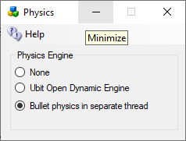

None effectively does not model physics at all, making all objects phantom.

* UBODE is closer to Second Life in vehicle performance.
* BulletSim is the default physics engine. It provides the best performance and most functionality.

# Maps:

The default is set in Settings->Maps. This setting overrides that setting for one region.



* **None**: No maps will be made. This is a good setting as the regions will boot very quickly. Any existing maps are not deleted.
* **Simple but Fast**: MapImageModule is used with just Land showing
* **Good**: Uses Warp3D module with just Land showing
* **Better**: Uses Warp3D module with Land, Prims, and land Textures showing
* **Best**: Uses Warp3D module with Land, Prims, Mesh, Sculpts, and all Textures including prims showing.

## Rules for INI files

Dream Grid has several simple rules for *.INI files that differ slightly from stock Opensim.

Example of how regions are organized is found in the file system:

Opensim\bin\Regions\**SOME DOS BOX NAME**\Region\**Fred**.ini  
Opensim\bin\Regions\**SOME DOS BOX NAME**\Region\**Jerk**.ini

These two regions **Fred** and **Jerk** will be in a single Dos box named "**SOME DOS BOX NAME**".

If you rename the folder "**SOME DOS BOX NAME**" to "**Internet**", they will be in a DOS box named "**Internet**". If you create a new folder named "**HEY**", like this:

Opensim\bin\Regions\**HEY\**

And then MOVE Region\**Jerk**.ini into it:

Opensim\bin\Regions\**HEY\Region\Jerk.ini**

You will end up with a DOS box named "**Hey**" with the Region named **"Jerk"** in it.  
The other Dos box will have just Fred in it:

Opensimulator\bin\Regions\**SOME DOS BOX NAME**\Region\**Fred**.ini

### More Rules:

* No Duplicates:  Do not leave a Region.ini in one folder and the same Region.ini in another.  All files such as Region.bak are ignored.
* The only thing you need to put in the **SOME DOSBOX NAME**\**Region**\ is one or more  Region.INI files.
* All other files, such as Opensim.ini  are automatically re-created when you start the region.
* The INI file name must match the [Region Name] inside it. This example region [Welcome] must be saved as “Welcome.ini”.
* Only one [Region Name] is allowed in an INI file.

# Modules

These settings enable features for this region and also require the feature be set in the Settings Panel. Unlike the other settings here, these must also be set here to enable them.



Bird Module: The bird module makes flocks of birds possible.

You must also enable the Bird Module in Settings->Birds.

There are many settings for the Bird Module. You can use the defaults. You must also click Enable on each region and reboot the grid. If this is checked the birds will automatically fly. If unchecked they will be available but must be started manually.

See Settings->Birds for more information.

## Enable the Tides

The tide module makes water go up and down. It has a buoy with a script to make boats and objects float with the changing water level

Individual region Tide settings must be enabled to make the water go up and down in each region.

See Settings->Tides for more information.

## Teleporter Sign Enable

If the Teleporter Enable checkbox is set, the system will add the region to the build-in Teleporter and teleporter HUD. You can load these into your inventory with the Load Local OAR option.

The below sections titled Region List and Regions

# Region List

Open the Region Panel with Ctrl-R or go to Setup>Regions.



There will be anywhere from one to many Region.INI files in your system. These show up in this panel. The default is an island called "Welcome".

Sorting: Click any column to sort. The default sort is by DOS Box.

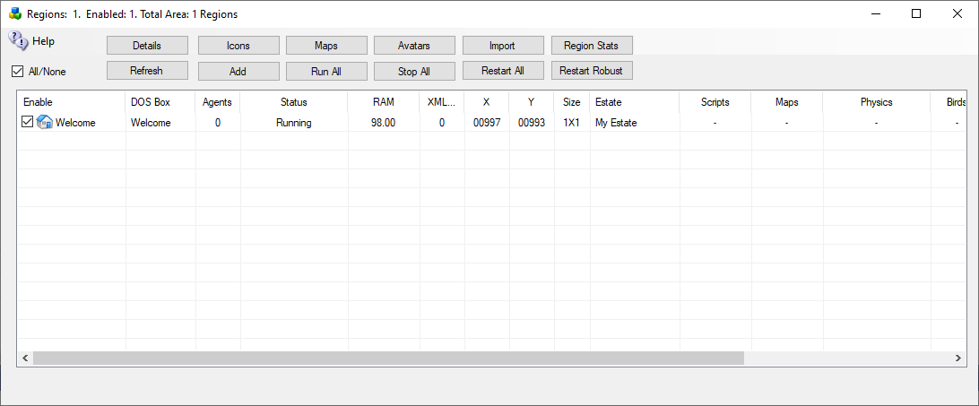

# 

## Refresh button

Click Refresh to rescan the system status and update this panel.

## Add Regions

Click the Add button to make a new region. You only need to give it a name and save it.

## Run All Button

Runs all Checked regions

## Stop All Button

Stops all Checked Regions

## Restart Button

Restarts all checked regions.

## Import Button

This button lets you find region.ini files from other systems, such as the standalone Dream World or backups, and import the file into Dreamgrid in a new or existing DOS box.

## Region Stats

The region stats are a web-based data collector. First, choose a region:

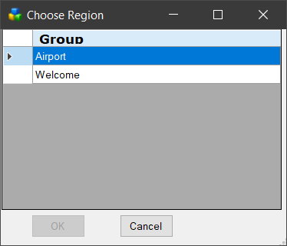

The first screen shows general statistics:

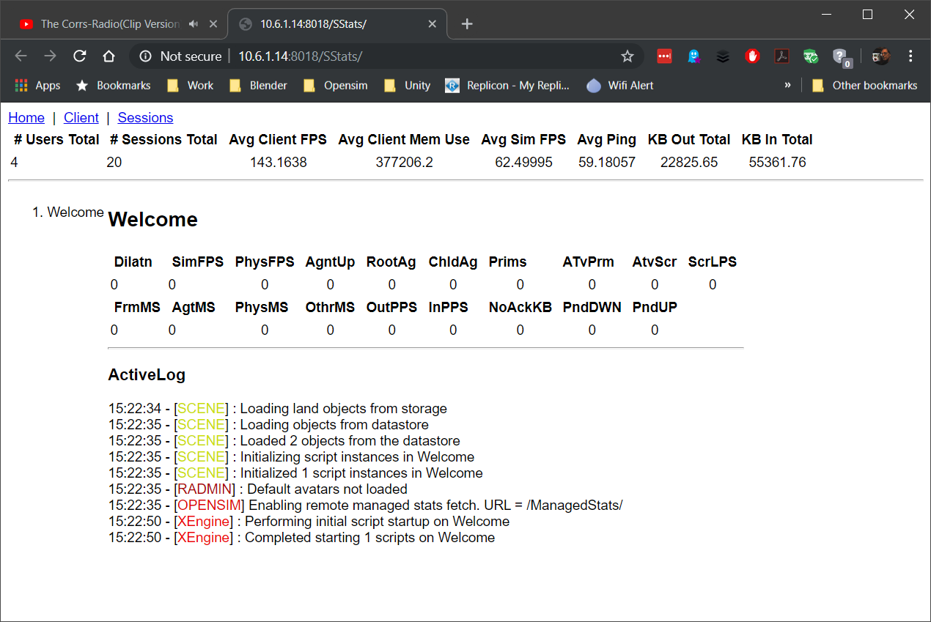

The client screen shows the types of viewers that have visited

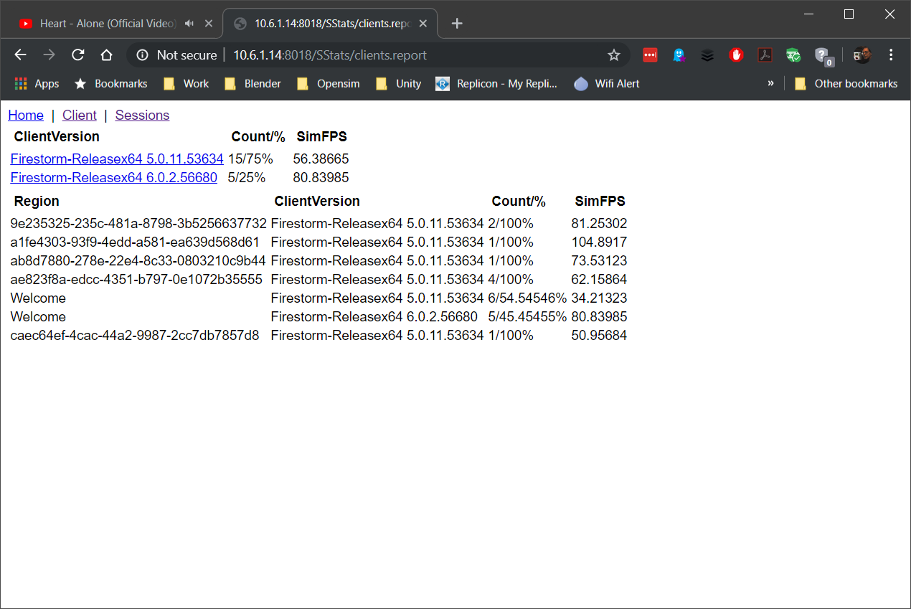

The Sessions screen shows the visitor list

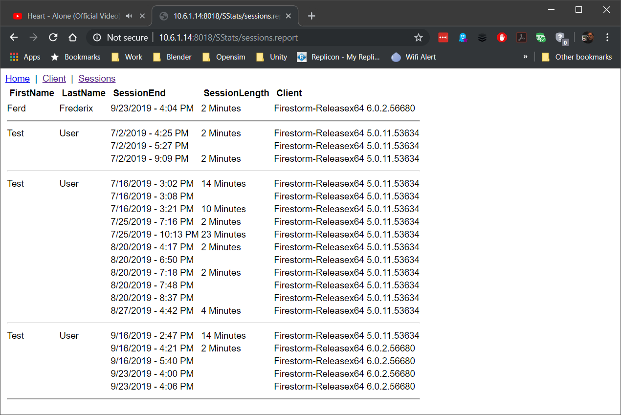

## Restart Robust

This button safely stops and restarts Robust.

## Details view:

The Detail view can be sorted by Name, Group, Agents or Status by clicking the column name.



## Icons view:

The second view is a small icon-only view for larger grids

251658240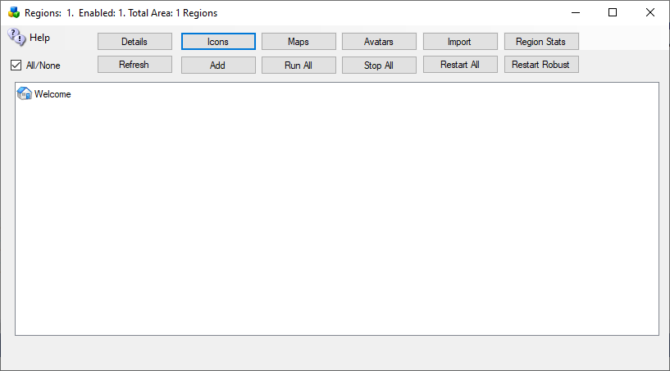

## Map view:

## The third view only appears if Maps are enabled before the stem boots. It has zoomable map images by the scroll wheel.

## Avatars view

This view shows a list of avatar names and the regions they are in.

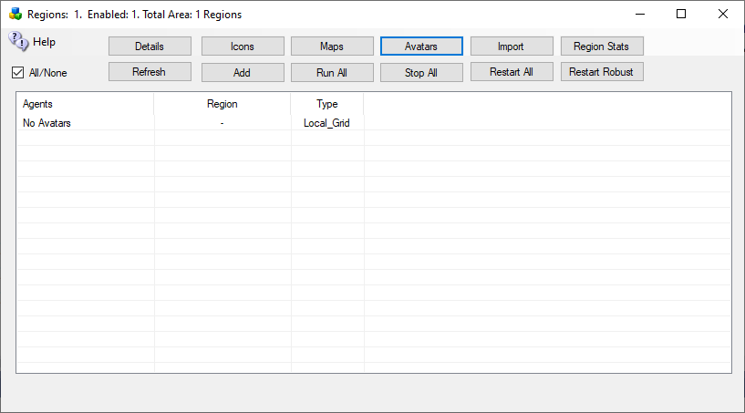

**Double-clicking** a name will start a teleport sequence to that avatar in Firestorm viewer.

## Import

The import button loads INI files from other Opensim systems.

Suggestion:

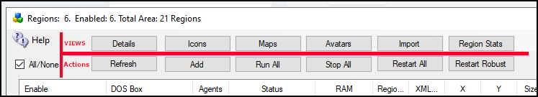

and distinguish that the top row of buttons are a Viewing function. While the bottom row is an Action item. Perhaps showing it looks like this (as a suggestion) This will assist in explaining each item in the Help file or doc, and assist in distinguishing what you are about to do is non-impacting or impacting.

Suggestion...change doc to focus on these menu items;

Regions, Consoles, Language, and Settings, falling under the primary heading of Setup.

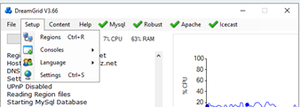

The reasoning is that the next section that follows this is the Regions section which should fall under the Settings section...which, come to think of it, might need to be pointed out earlier in this document.

# Regions

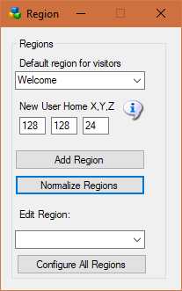

## Default region for visitors:

This is your “Welcome” region.Hypergrid visitors and people who log in for the first time get sent to this region. The region must be online.

## New User Home X, Y, Z:

Users that create accounts on the web page will land at this spot on your Welcome region. Their home is set here.

Default: 128,128,24

## Add a Region:

This will bring up a dialog form for adding a new region.

## Normalize Regions:

The web maps require that the lowerleft corner be started at 1000,1000. This will move all regions so that the chosen region is at 1000,1000. All regions maintain their relative positions.

## Edit Region:

This will bring up a dialog form to edit the selected region.

## Configure All Regions:

This will open all regions for editing.

# 

# Auto Restart and Startup Settings

Opensim uses up increased RAM as people arrive and leave. Periodic restarting of regions is necessary to clear memory. You can set up a restart timer here.

Dreamgrid will not restart a region if avatars are present. It will restart the region only after all avatars leave.

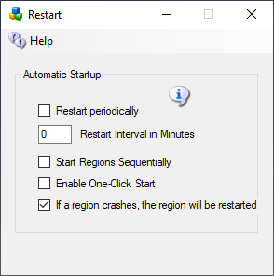

## Automatic Startup

### Restart Periodically

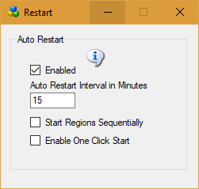

**Enable:** If enabled, the auto restart interval will be set to 1440 minutes, which is one day. If disabled, the regions will try to run forever.

### Auto Restart Interval in Minutes:

The number of minutes a region runs before it restarts.

* 0 = Off
* 720 is 1/2 day. 1440 is one day. 2880 is 2 days.
* If Autobackup is enabled, this interval will be extended beyond the Autobackup Interval by 30 minutes to allow Autobackup to complete.

### Start Regions Sequentially:

Unchecked= start a new region every few seconds. This can overwhelm the database, memory and/or CPU on some systems. Checking this box will start each region sequentially it will wait for it to boot completely before starting the next. It will extend the waiting period up to 3 minutes. per region.

### Enable One-Click Start:

If set, running Start.exe will automatically start Opensim without needing to click the second [Start] button.

### If a region crashes, the region will be restarted (automatically?)

# REVISIONS FOR DREAMGRID

This is a high-level view of major changes. Revs such as 3.3 or 3.4 are releases and will trigger the “Update Is Available” messages in the app. Anything with two digits such as 3.04 is a beta and will not trigger the Update Is Available Message.

V3.62 Post Fixes

Added Audio and Video examples on how to play region-wide audio loops and how to play videos.

Add Help files for Streaming Video .MOV and Streaming Audio .MP3 files

Update license files to exactly match names in OAR folder. Add 6 new OARS.

V3.61 Post fixes

Opensim is Dev Master for EEP testing #af9bd993bb71ed1d6 2020-08-11 09:33:41

Altered mechanism for reading OSSL section of OpenSim.ini to use config-include/osslDefaultEnable.ini which then loads config-include/osslEnable.ini overrides.

Add osReplaceAgentEnvironment, osSetParcelMusicURL to oslEnable

Add sounds used by Firestorm keyword chat alert, user younger than x days alert, etc.

Add default clouds, rainbow and Halo textures.

V3.6

Release of V3.592

V3.592 Release Candidate for V3.6

Drop Addins-db-002

V3.591 Release Candidate 7/25/2020

Oops, some missing files in 3.59.

Also fixed a missing macro in Opensim.exe.config and robust.exe.config that stopped the "Help->Issue Console Commands->Set Debug Level" from taking effect for all sessions, not just one session.

V3.59 Release Candidate 7/24/2020

Opensim updated to the same as OsGrid: Version #b598573 0.9.2.dev 2020-05-09. This includes hundreds of tweaks.

Enabled built-in Denial-of-Service protection.

Added Settable Ban lists for Grids, Viewer type, IP addresses and MAC addresses.

Saving an oar without a .oar extension now gets .oar added on end.

RegionList could be shifted one column to the right.

Create a blank WordPress database using robust credentials.

Add manual to show how to install Wordpress. tl;dr: Save WP in Outworldzfile\htdocs\WordPress and load http://localhost/Wordpress in a browser. Use Robust credentials.

FollowSymLinks added to Apache httpd.conf for easier integration of WordPress, and Directory Index is re-ordered.

Fixed Restart on Crash to ignore physics engine.

Removed Scan of Region logs to improve performance.

YEngine script is now the default for new DreamGrids.

V3.58 Post Fixes 7/14/2020

When more than one grid is run on a PC do not shut off wrong Robust.

Region Form remembers the column widths in Details mode.

OsGrid complained about 2 economy modules.

Viewers complained that items are not available even when the suitcase is off. This is a visual reminder to local users that their inventories are unavailable while they are traveling, and available when they return. Now should warn only if you enable suitcase, and off if you disable the suitcase.

OsGrid alias added to match the latest OsGrid specs.

Map button disabled except when this is a grid.

Adding a region did not add a hole in the firewall.

PHP warns in Apache log now suppressed.

Fix black on black text in White Theme when authorizing a user.

Added a pose stand patch to Opensimulator by Lotek. This adds all poses in the Firestorm floater, so the floater works in Opensimulator, making the need for 3rd party pose stands/HUDs obsolete. His alert sound patch adds the alert sound that Firestorm uses to signify radar alerts and keyword alerts.

Added XMLRPC port to each Region for third party tools to control Opensim.

http://opensimulator.org/wiki/RemoteAdmin:RemoteAdmin_Examples

Stopped a recursive timer tick from happening on slow machines which again delayed startup of Regions.

V3.57 Post Fixes 7/6/2020

Bug Fix:Console = None works again.

Performance: Skip huge folders with no Dlls in updates

Bug Fix: timer reentrant issue that shut down the icons.

Performance: Added back the DoEvents to make UI more responsive.

Coding: Added example on how to make an addin for Opensim

Bug Fix: Local Events missing a column.

V3.56 Post Fixes 6/18/2020

New Feature: Updates could destroy added on services such as WordPress or Joomla. Added a switch to

Apache to select "DreamGrid Diva", WordPress, or Joomla/JOpensim or "Other" folder as the home page,

such as http://(your grid):80, aka http://(your grid). Documentation on this is not in this update.

But to put it simply, there are three new folders in Apache/htdocs. Unzip Joomla or WordPress in the folder.

Change the Setting in Apache, click the Apache icon and select Restart. The rest is just setting up your CMS.

Improvement: Change priority of webserver to realtime to help icons stay in sync on super busy servers.

Tweak: Re-write Icecast XML on Start, not just boot.

Crash prevention: If blank "Server Admin" email, use "not@set.yet" to allow Apache to start anyway.

Performance: Don't scan logs if Restart on physics Crash is set for anything but Bullet in a separate thread, as it is useless.

V3.55 Post Fixes 6/12/2020

Added a Refresh button to the OAR loader

V3.54 Post Fixes 6/10/2020

Welcome Regions with a space in the name could not be tp'ed to over the Hypergrid. A really old bug, too.

Allow YEngine and Xengine to be selected per region.

Show map photos without lines or text.

Added a Show All Maps button to the Map page.

Pretty print Licenses with word wrap and length restriction.

OpenJPEG not CSJ2K to cut down on warnings.

Fixed graph glitch when resizing home.

V3.53 Post Fixes 6/2/2020

Tuned Apache.conf for speed, security, in effort to "Future Proof" if people add Wordpress or Joomla.

Include conf/extra/httpd-mpm.conf which has been tweaked to use a 4 core machine without too much RAM in use.

Added MIMEMagicFile module and conf/magic for peeking in file contents to determine the MIME type.

Just in case of user error, prevent .user.ini PHP settings files from being viewed by Web clients.

Added a bunch of mod_deflates for compression for various browsers.

Added a bunch of expires by type for web browsers built-in caches.

V3.52 Post Fixes 5/31/2020

'admin' password for Icecast was the same as the stream password. Extended the "new grid" random passwords to 15 characters.

V3.51 Post fixes. 5/28/2020

Tweaks at turn off DEBUG in opensim.exe.config, make a longer default password for Wifi Admin.

V3.5 Release 5/26/2020

General Release and set to trigger "Update Needed" via Auto Updater.

Made the Region Chooser resizable and remember its size per request from Ethan Breck. Nice idea!

V3.49 Release candidate for 3.5 5/22/2020

Oops, IM and receive objects via IM over HG was broken.

V3.48 Release Candidate for 3.5 5/22/2020

Map tiles in MySQL are automatically deleted when rebuilt to save disk space.

Offline message module fixes.

3-day auto backup would not work due to extra leading space

Stopping a multi-folder system would stop all Robust boxes. Now it uses the Robust Process ID.

Home page Icons relocated so app supports Large fonts.

Clicking an icon has a restart option to start or restart the service.

Icons have a Help option for each background service.

V3.47 Release Candidate for 4.5 4/26/2020

The IAR save only saved the Wifi Admin IAR. Reverted back to standard Opensimulator so you need to know or reset the users password. Doh!

V3.46 Release 4/26/2020

Opensim checks passwords for IARS now, but you only use Wifi Admin’s password. Makes it much easier to dump an IAR for a customer/user and makes it more secure. Users can load IARS in the Wifi Web Panel using their password.

V3.45 Release 4/21/2020

Change Offline IM Group port to port 8003 to stop endlessly repeating error messages in Robust.

Allow empty bin\Libraries.proto for one person who wants no library.

Simplified Try catch to catch all exceptions everywhere.

Speed up detection of stopped Robust and Icecast windows.

Lots and lots of small Search changes to make it more reliable and stop all the "Search is offline" messages

Could not disable search entirely. Now you can.

Upnp Manager crash fix.

Enabling Apache will remove and re-install the service on startup to make it easier to move to a new folder.

PHP.ini got duplicated - now it's just one. Also changed some PHP settings for Search.

V3.44 Release

Try Catch OAR load from web and other Web checks to remove dependency on Outworldz and Hyperica.

More checks on WindowsTitle as Windows is not always setting them.

V3.43 Release 4/7/2020

Missing line of code broke Gloebits if any settings were not the default.

Home page links fixed in viewer for login and Help

V3.42 Postfixes 3/27/2010

Region Restart Form could crash if you fat-fingered some settings. Now it saves on close after sanity checks.

On first boot, Welcome did not start due to not having a group port.

TOS form would save, but not stick around after an update or a change from black to white or custom.

Always set Gloebits INI as region servers will crash without it set up.

Wrong folder for cache. Oops.

Just hide the damn downloader.

V3.41 Post fixes 3/6/2020

A load OAR or Load IAR search and clicking to load it got you the wrong item. Thankxx for the tip, Scott Taylor!

V3.4 release 2/28/2080

Fixed issues in German Translation that caused a crash for Dieter Mueller. Thank you very much for the valuable feedback.

About 100 of the translations were not 'taking'.

New form for Nooblets to use to create the initial avatar. Thanks to Garry Beaumont for pushing for this.

Avatar View in Region list was not set to visible. Oops

Spell Check every manual - Office 365 Word has no grammer (sic) or other errors, and it shows readability from 6th to 9th grade so there is no excuse for not reading them.

The Publicity module crashed when nothing was entered. There was a string set to nothing. Should have been "", which is not nothing.

V3.38 Beta

Extensive refactoring and state machine changed in region restart.

Main form resizes in all screen scale font size.

Updated 15460 translations, including hand-updated German and French. Thank you very much to all the volunteers!

Should be able to change most settings and restart the region without shutting down the grid.

Sped up lots of places and much more threading during boot and shutdown.

V3.37 Beta

Updates started at 0, should be at the current version to prevent repetitive begging for updates.

Robust double start fixes.

DNS shows busy when testing.

Allow changes to Opensim.ini, Gloebits and birds to take effect without resetting the entire system, usually through changing a region settings.

Max region port function would not always return the highest port, preventing multiple DOS boxes from booting w/o restarting the system

V3.36 beta

Possible hard crash in Check for Update if going from from V3.34 to V3.35. A variable was FALSE, should have been a number

V3.35 Beta

Added Search to Load OAR and Load IAR (web)

Stopped a crash on Server 2016 if Publicity was blank.

Several Updater and Downloader changes so updates can be skipped. Updates are automatically downloaded to a zip file in the root folder. The next startup or Help->Check For Updates, it detects the fresh zip and asks if you want to update to that version. If yes, it brings up the Backup screen, then shuts down MySQL and Apache, and launches an unzipper. if you chose No, it would not prompt you again until the next version is ready.

V3.34 Beta

When region is not running, speed up region click from 15 seconds to 1 second by using an async TCPCLient to probe the port.

Reset CPU usage to 90% instead of 75% for slow machines

Crash on Server 2016 when SetMyINI value is nothing.

V.33 Beta

Can "always hide" region DOS boxes, "always show", or "hide when done" with an action.

God Mode fixes where region overrides could get stuck on or off.

Disable Residents fixes where region overrides could get stuck on or off.

Lots of tweaks to region restart.

Made it so the chooser and other important dialogs pop to the front. It was not really possible to edit two regions, before this.

Can now add multiple regions at the same time without breakage.

A Diagnostics log to show the details.

Added uncaught exception error handler & logger. See Error.log if it just quits.

Use HTTP with redirects at server in case SSL fails.

A new "Pausing" icon/state when Region Recycling is used. Restarts will be about 30 seconds now as there are two stages.

Allow_osMessageObject and Allow_osGetNotecard set true for Satyr farming by non estate managers.

Updates to Nuget repos such as Zip and MySQL

Updated Apache to latest version 2.4.41 so it can handle TLS1.3 if you want to add a SSL certificate.

Generate graphic titles to all web-downloadable IAR and OARs.

Reworked Cache on the main server to load much faster. My server's SSD needs upgrading due to all the 3D crap you peeps get for free. It's 385 GB used out of 400. Eeep!

SSL added to Hyperica.com content. What a pain. Should be "Future-proof" for both SSL and non-SSL versions of Hyperica.com and Outworldz.com by not using SSL at all except through server-side redirects.

Moved failing HDD to SSD on @Debbie Edwards Intel NUC last week, only to see it hang again and again this week. Just finished building a new AMD Threadripper 2TB SSD Gaming PC for her.

Checked every possible web access, and no, it does not break your grid if Hyperica or Outworldz.com is down. Grid-wide Search and load OAR and IAR will obviously be offline. Deal with it.

Closing the settings form now closes all the child settings forms for garbage collection.

15X15-sized region was not selectable, and the settings defaulted to max of 4 if you looked again after a save.

Tests DNS name when saved.

V3.32 Beta

Clicking the Clear cache button could cause a crash if the fsasset folder did not exist.

V3.31 Beta

A major change in internal structure should speed up the region list and boot to be significantly faster. This also improves responsiveness due to fewer blocking loops.

New grids will get a set of regions at a random starting address. This greatly reduces the problem of teleport fails when hypergridding between grids where the regions are at the same X and Y location. You can't.

Both the Metropolis map and the Google map use automagic to center the welcome region on the map.

Avatar counts now match between the region list and the main form. It used to leave the last avatar count on the main form.

If you hover on the Main form where it says N Avatars, you get a list of avatars and the region.

Clicking an avatar name in the region list brings up a teleport to the avatar. This works best if the Viewer you are using was the last viewer you installed.

Concierge announces the avatar Login/Logout in the DreamGrid console.

Double start of Robust should be gone now. It was recursion and timing related.

Opensimulator now uses UseCSJ2K for maps. This should reduce the number of warnings when making higher resolution maps.

MAXprims has been tweaked when you set an override.

The updater has been tweaked to be significantly faster. It runs in the background and leaves a zip file of the proper revision in the root folder.

Icecast did not get updated on Startup, but only when you saved the form. Moving the system to a new folder thus broke Icecast.

Maps uses UseCSJ2K for fewer warnings.

This version has a new var region preview map button. There is a button in Help where you select the region, and a button in the Pop up form when you click a region in the Region List.

Clicking a region name in the Regions form no longer brings up the DOS Box. There is a View Console button in the popup.

Changing the enable flag in Regions did not prompt "save?", if you just closed the region box.

Cache clear happens much faster. Except for scripts. Nothing more I can do there as every script has to be examined.

Selecting an OART showed the entire row selected. Now it is just the cell, Thanks AI Austin!

V3.3 - This is a general release and is in the Automatic Updater.

Opensim set to Released OpenSimulator version 0.9.1.1 Snail #7bdc408caca3. This changes some LSL constants so an automatic script cache clear will be done at first boot.

Content menu Load Free Oar and Load Free IAR pulls data at startup with images, licenses, and names of all free OARS and IARS.

Inworld restarts of a region are always buggy. Now set so any Inworld Restart shuts down the entire Instance. You must set the Auto Restart capability of DreamGrid to restart the sim.

Allow logins while scripts are loading which speeds up reboot.

UbODE: convex shape type on normal prims and sculpts enabled, and MeshFileCache enabled (UBODE only)

llCastRay set to V3 which Meshes prims for good accuracy in ray hit detection, handling basic and tortured prims, sculpts and meshes.

* Uses ellipsoid, correctly sized avatar capsules.
* Handles complex terrain, multi-prim objects and seated avatars.
* Implements throttling and the status codes RCERR_UNKNOWN and RCERR_CAST_TIME_EXCEEDED, so LSL scripts need to handle these responses and RCERR_SIM_PERF_LOW.

V3.299

New: Opensim updated to 066a6fbaa1 ("changes on lludp acks and resends", 2019-12-18) which hopefully will fix where you cannot see mesh and land when running a viewer.

Bug: MaxPort function had a bug in it that caused an occasional crash when adding a region.

Fix: Deregistering all regions was awkward to run as MySQL had not been started.

New: Region Popup now has a View Log button.

Minor: An 'alert' was missing in one load oar

Fix: Would never start a region if CPU > 75%. Was supposed to start after 1 minute wait.

Minor: Added more checks for bad region numbers.

Minor: Reduce region icon size to 20 px

Bug: No single quotes allowed in DOS box names as the Windows handler cannot grab hwnd PID with a single quote in the name. Regions can have single quotes in them.

V3.298

Restart, Error handler, and Shutdown logic changes after a DreamGrid restart where it has to find and re-attach to each region. This fixes the CPU usage = 0 and other glitches in the Region list. These occurred when DreamGrid was restarted with regions already running and it could not find the Process ID.

Global and Local Search uses V3HG links which work inside Singularity and Firestorm viewer, Media On A Prim, and in Web Links. Many thanks to AI Austin and

Robust logging set back to INFO from DEBUG.

Ports are initialized sequentially only at boot. Adding a new region puts the port onto the end. This stops Region confusion when regions are added while the system is running.

Regions > 4X4 in some cases would not load using the GUI.

Icecast port defaults changed to 8100-8102 for new users only.

Minor Start/Stopped button fixes when something goes wrong in a boot.

Icon size was off by 4 pixels in Region List which goofed up Large Screen mode

V3.297

Teleport signs could be fooled into showing offline regions if a region had crashed or been stopped without a quit command. Now they have to be both enabled and booted, too.

OAR menus refreshed every hour from Hyperica/Outworldz – no need to restart to get a new release of a Region.

Regions have an Override per region for Script Engine for X or Y Engine.

UBODE and Bullet are the remaining Script Engines

Diva Wifi updated to the latest version which repairs problems in adding Default Avatars.

Load OAR 0.9 link was busticated.

New Categories for Publicity (and fixed the ones with commas).

Ports and Script Engines now show in Region Lists.

IF Apache is a service, leave MySQL running so PHP maps work.

V3.296

Added a Log->Error Log to the menu. This log is the first place to look when it crashes. It's always been there, just not on the menu. Doh!

Changes to the way it detects the process IDs of running Opensim. Added a single class to monitor all of them. Hopefully, this will eliminate some of the odd things that have been reported that happen on occasion, such as not closing the DOS windows, but only on first boot.

MySQL now stops when you click Stop. This helps prevent MySQL corruption. If Apache is running as a Service, MySQL, PHP, and Apache are left running, even when you exit so your map and home pages will still appear. Diva Wifi Web page is part of Robust, so it will not.

Tweaks to the 4 icons, including a new Red X Error Icon.

Updated Licenses to some of the downloadable OAR files to be absolutely clear which ones are exclusive to the Outworldz.

V3.295

Opensim Release 0.9.1.1 2019-12-03 14:27 #5c5e4bd8304dbb607a mantis 8632: stop triggering Changed on just scale checks

rm extra CRLF when first starting up and creating the first user.

V3.294

Publicity module (finally) lets you add descriptive text to your Hyperica Listing. Category setting where you can click one or more sections to appear in the new Destination Guide.

Fixed a lot of Unicode problems in Events and Search.

If a region responds when it is popped up on screen after a click, make certain it also has a "running" icon.

Using Dot Net 4.6.1 (disabled legacy) features in Opensim since it is stable and the recommended setting.

Minor changes to Send keys to try to make the 'q' key more reliable on obsolete Windows 7 machines.

V3.293

Bird module DLL was missing. Could lead to a crash if you updated from an older version and enabled birds.

V3.292

Aborted release - multiple issues with German Translation due to a newline that caused it to make crash tinkly noises.

The Region List form could be opened more than once due to a missing line of code.

V3.291

German Language translations by Ralf Burger, thank you!

Search module for local grids was broken. You need to add the path to PHP7 to the beginning of Path if you want to use local search. Global is fine.

A dozen more translations and some fixes for Globalization in forms for resizing. Unicode issues broke some things and could cause crashes.

Reordered the Search Menus to make better sense - thanks, Ai Austin!

Cleaned up all warnings about programming style that appeared in Studio 2019, so I can spot anything that might be important in the future.

Region List shows dashes (-) when the setting comes from the default, instead of a region override. This was only partly implemented before.

Implemented much more checking of human-entered values in places like the Birds form.

Added a Trouble shooting Guide to Help.

V3.29

You can click the round MySQL, Robust, Apache and Icecast status buttons to stop/start them.

Avatar count was different in different displays.

Half-dozen new language Translations.

Was possible to have a Null Reference Exception when Booting a region if the Stop button was clicked at the right time.

Busy/Start/Abort button fixes. Clicking Busy will force an Abort when shutting down.

Catch as many individual errors as it can when reading region INI files. It complains with details of what to fix, and aborts the launch.

Fix check if MySQL is running so Estates and Avatars will appear in the region list.

Sequential/Timer Boot before running a next region, not after.

Precise CPU graph with a 4-second running average for Sequential/Timer - makes it bobble around 75% CPU when booting.

Added freeware program to Help 'cports.exe' Which can show all ports that are in use to help troubleshoot anti-virus and port glomming applications.

Open firewall as a separate thread for speed. Firewall has to run only if you change a region port setting, by adding or deleting, or on first start.

You cannot HG between two identical region locations. New systems change the "Welcome" region location from 1000,1000 to a random number from 1000 to 2000 to allow Hypergrid to other grids that have 1000,1000 set. Also sets the map center to the Welcome region location, whatever it is. Additional regions are added 4 to the right of the highest region as it did before.

Catch user 'blank' entries in Regions and Maps Settings.

"Allow Level Gods" was unchecked in Region Form, as it is based on the other settings being a null string, not "False".

Removed some unneeded logging that slowed down the system.

Warn if region location X,Y < 32, not possible to be that low in HG sims.

Enable Edit Button in Region Popup only if the region is stopped.

Abort Handler reworked to end a race condition that should prevent occasional extra warnings on crashed regions. Also much faster to restart and recycle.

Codemaid extension in Visual Studio settings are saved in Git for multi-system development. Codemaid is a great tool for making the source consistent, but you need the same settings on each machine.

A Warm start is when you start DreamGrid on an already running Robust and set of regions. DG located into the Robust and regions as if it had already started them. Warm Starts after a "Just Quit" did not populate region handles list. This is fixed so RAM will now show up. Should also allow us to catch a crash after a Warm start.

I spell checked this document, finally. :-)

V3.28

Region List sometimes crashed the system when a race condition occurred after adding a region.

Region List now remembers the column widths for Detail view.

V3.27

An Overall-Try-Catch in Application Events shows an error message and where the error occurred. Do not quit on an exception.

A missing or offline Welcome caused an issue - fixed

Added a Webstats button to region popup. It is enabled when the region is running

FSassets backup could cause a crash if folder did not exists

Suppressed several hundred warnings on Exceptions not being specific.

Remove compiled languages from git repo.

V3.26

Added 20 different language translations for 700+ phrases, resized many forms and prompts and tooltips to fix

Added YEngine and XEngine Switch

V3.25

Disable region Auto Backup added to region Overrides

Drop a useless old images to reduce size of exe

God mode fixes galore, reset defaults in Region INI to blanks

Added Overrides to Region List Details for carious Gods, Publicity and to skip region Auto Backup

Teleport hop link updated to hop in region list as second life link no longer works in Firestorm 6 series.

Clear script cache automagically if Opensim version or hash changes

V3.24

Updated to Released Opensim "0.9.1.1 Yeti "Server Release Notes" hash #defa235859889dbd". This is one patch past 0.9.1.0 for server release notes.

V3.23

Teleport to a region from within DreamGrid in the Region Start/Stop popup panel.

Robust, Apache, Icecast and MySQL can be set to auto restart if they crash.

Update Mysq.Data.dll

Update Visual Studio 2017 to latest FXcops and reduce footprint on unused extension in Github

Removed embedded zip compressors for smaller footprint.

Drop unused icons

V3.22

Shorten boot time by being smart about Firewall updates. On an extremely fast machine, it takes 9 seconds to get to robust start. Firewall took up 31 seconds more. Now it takes 0 unless you add a region.

Restart Robust, Apache, MySQL, and Apache if Auto restart is Enabled

V3.21

Saving a region and then immediately re-opening it did not show changes. The changes were saved to disk but not reloaded into RAM.

Rework the way ports increment from the starting number

Catch error in a crashed region that goes down while shutting down.

Strict type checking on some region variables. Integers, singles, and doubles versus strings.

Add Sean's latest Radio IAR to the free IAR collection

Y coordinate changed when X changed - was supposed to be region size.

God mode overrides fixed. They always overrode the global for Level 200 Gods to off, even if unselected.

Prevent a lower versus upper case issue if the puny human entered 'Autobackup'.

V3.2 Release Rollup

A wrong "print" caused a crash when a backup was manually run.

Always use English culture until translations are available.

V3.197

Local Search in Settings did not 'stick;

Add Visual C++ 2015 installers for PHP7

Local search was broken by PHP7 - missing explicit ossearch directive

Fix up local search PHP to use "Metromap/includes/config.php" database include

V3.196

Added Garry Beaumont's wrecked home Icon that shows when the Welcome region is disabled.

Missing PHP7 extension prevented PHP from making maps, links, or search.

Clearing asset cache when running did not work. It went to robust instead of the online regions. It worked if you were offline.

Added a Module for File/folder copy and delete to clean up warnings and catch all possible errors.

Apache Settings allowed both Local and Global search to be set. Now a toggle for one or the other.

V3.195

New updater process loads files in the background to a specific zip file. You can choose to ignore this version. It will re-prompt the next release.

Dot Net zip set back to be 1.11.0 to be compatible with older updater. This causes a crash in the DLL.

V3.194

Big speed up on registering DYN DNS

Speed up Saving regions

Move Apache to its own setting.

Metro Maps was missing an include

V3.194

Speed up Saving regions

Move Apache to its own setting.

Set Apache to only run programs in htdocs

Metro Maps was missing an include

V3.193

Unchecking Apache as a Service removes the service

Bug in Email prevented it from emailing confirmation of a new user

Bug in Settings caused Clear Cache button to crash

Cache setting added to enable viewer caches.

Iconic Zip DLL embedded in exe for updates.

V3.192

Update PHP to PHP7

Add Home Icon for the Welcome region when it is booted

Detect running Opensim and add them to PID so we can stop them

Test with Joomla/JOpensim  
Refactors for Region Type, Usings, RobustDBConnection

V3.191

Stupid Oops in Regions. Could not add a new region

V3.19

Updated manual for upcoming 3.2 release

Fixed glitch in V3.18 in Cloud Density

Disallow Foreigners switch added per-region. This lets you keep assets in your grid by disallowing assets to leave, yet allowing HG visitors to come and go.

Disallow Resident switch added per-region. This allows only Region Owners and Estate Managers in any given region.

Checked all IM vars against Opensim source and made minor changes they may help with the offline IM's getting stuck. Port 8003 should not need to be opened to allow IM's.

V3.18

Export Checkbox in Settings->permissions to disallow export of prims from viewers. Default -> Allow

If an OAR is loaded into a Var region > 4X4, allow it.

Removed lots of warnings in Visual Studio 2019.

V3.17 is a release candidate for V3.2, the official release that everybody gets a notice to update to.

There is no longer an "updater versus installer". For backwards compatibility, there are still two files on the web server, but they are identical.

If you want to start over with a blank database, you can just delete MySQL\data and it will be rebuilt as a blank system

New background updater process.

"Welcome to " & SimName() & " , <USERNAME>") set for welcome message.

Build process is much faster by using a temp folder instead of adding and deleting from a zip. Also easier to audit.

Put back support for older TLS 1.0 protocols so older systems can update.

Console Commands did not always pop open the DOS window

Load OAR in some earlier versions was borked.

GDI+ error when changing Publicity Photo is fixed

Snapshot, MinTimerInterval, Disable Gloebits fixed in region Overrides

MYSQL speedup with a small cache: query_cache_size=8M

Compile instructions updated.

Add help for ServerType, thanks to Garry Beaumont

Access of shared member through an instance; qualifying expression will not be evaluated refactored

V3.16 Beta

Search improvements for local and global search - sped up Datasnapshot interval, better HGV3 link that does not require a second click. Shows # hours each sim has been online in search, and dwell time (the Second Life visitor metric).

V3.15 Beta

Opensim Snail dev master #38dbc0328881 2019-08-31 14:36

Ctrl-R Region Form also shows the Estate name for each region

Search: Lots of new things! Search is integrated into Hyperica.com. You can look for Objects Marked for search in any Outworldz grid, or just your own. Also, locate Parcels, Grids, and regions in grids. These are only shown if the region owner chooses to enable search and the Prim Owner, region owner, or parcel owner has cheeked the "Show in Search button".

Added a new variable to Opensim Datasnapshot module to allow all grids to be searched.

Disable Search button added to Viewer Search. If on, you can set it so your residents see local only, or globally Search all Dream grids.

Datasnapshot collector starts 5 minutes after a boot to speed up collecting assets for search. Runs every hour after that locally.

Some Settings would not be placed into the Region or Opensim.ini files when changed unless you did a restart. Most changes to settings now rewrite the region so it will boot correctly.

Import Dreamworld and "regular" Opensim INI files button in the Region Panel would not work if the file name did not match the [name] of the region. Fixed.

Changed Voice Help URL to match new Vivox web page for signup.

Windows can return a null PID from Process(). It should wait until there is a PID before returning. But nooooo it does not, so I added a fix to Boot () to make sure we have a valid PID so we can minimize windows. This may explain why sometimes it does not type 'q' in certain windows.

Slow down the tests on quitting to prevent spamming the console.

Add more UPNP exception catchers to cover more brain-dead routers.

Major refactor of defaults for all region params to stop weird crashes on imported or brain-dead INI files. For example, a sim size of 0 was allowed by Opensim INI files. duh

Setting a new Publicity Photo could kill a system if the Hyperica server is offline or unreachable. Improve error handling here. There should be no dependency on any of my servers, except for optional services such as DYN DNS or search.

Updated Apache to latest security SSL/TLS 1.2 and made it refuse all obsolete ciphers like TLS 1.0 and 1.1. Tested as not being vulnerable to any common attacks such as Heart bleed.

V3.13 Beta

Repaired OsGrid and other region types that broke in prior beta version

Added a Disable Gloebits setting in region settings. This overrides the global setting if Gloebits are on.

Refactored a lot of internal settings to use native types and also set defaults for all variables in Regions.

V3.12 Beta

Sped up Opensim using Ubit's optimized Dot Net bug fix for Windows 1903 and compiled with dev master #5b39860573 2019-08-02 12:13:53

Robust logging set to INFO, as it was too noisy in DEBUG

Added auto-updating Sitemap.xml for htdocs and bin/data

Added Web Statistics button for many statistics for each region in the Region Panel

Auto firewall setup was missing the second Icecast Port

Fixed an issue where Apache could not run properly on ports other than 80

Datasnapshot was not registering in Local Search mode, which broke Local Search, and used the wrong http port if it was changed.

V3.11 Beta

Aviworlds Region Server lets you attach to Aviworlds easily.

Added Restart Robust Button

Added logic to catch UPNP errors on some machines/routers.

V3.1 Released 7/29/2019

Backup no longer blocks operation of the system

Backup FSAssets, too.

Xbakes enabled

IM Offline works without having to open port 8003.

Firewall code typo put an extra Apache Http Port 80 in the firewall every start.

V3.06

PHP Maps and Search working for any MYSQL port. Older systems used port 3309 as 3306 was used by some for Sim-On-A-Stick or OsGrid/Metro.

Use port 8003 for Offline IM to fix a problem where IM's would loop endlessly in the Console

Save IAR was non functional when all the Handles got dropped.

Save IAR needs to find a running region. If the first region was found, the region was not popped up on screen. Old bug.

osGetGridGatekeeperURI enabled for teleport HUD by anybody.

V3.05

Fixed doubled Auto teleports for Prim V2.5

V3.04

Fixed a bug where the Auto Teleporters showed regions that are unmarked for teleports.

Opening Cache form with a lot of cache caused an exceedingly long pause.

Fixed a case where Apache may not start reliably.

V3.03

Added Help for FSAssets.

Added a more visible help button to all forms.

Flotsam Cache variables can be changed to reduce disk space usage. See Settings->Caches.

System Backup has options for each type of backup to make and includes FSAssets data.

Added MinTimerInterval to each region INI file. Smallest value you should use is 1/11 of a second, as that is Opensim's internal Frame rate.

V3.02

Added Windows 1903 patches for Dot net 4.8 that caused many issues with MOAP, and changing land settings.

Checkbox to enable FsAssets - a disk based De-duplicating Asset File system. I recommend you start your regions one at a time so they will be properly de-duplicated one time.

Reworked Region/OsGrid server to allow regions to have their own IP address. Usually you do not need to do anything to run a region server except to

add the DNS name and change the setting. But this fails if the region server is on a different network. See Ports section Help for details.

Auto Teleports now support multiple region servers. Avatar counts will not work on Region servers - no access to the data unless you edit robust settings and grant access to the robust server with special MySQL commands.

Added a catch-all Error message handler for any missed exceptions to catch unexpected crashes.

Flotsam cache can be adjusted in size with a new panel.

Allow the Partners to work on region server. Also updated the Steampunk TP and set the partners prim to full mod/copy.

SupportViewerObjectsCache -= true explicitly to help with missing prims, theoretically this does nothing as true is the default. See <http://opensimulator.org/mantis/view.php?id=8516>

V3.01

ExternalHostName added to the Port section for use on non-NATed Region servers.

Added Outworldz Teleport System V2.5.iar to the Local IAR. This teleporter supports more than 32 sims. Just change the description from 0 to 1, or 2 or 3, and reset the scripts.

Create Region Name could not be typed into at the ending. Trim() fixed.

Moved KillAll scripts towards end of boot, and made it run only once.

Lowered Cache sizes to 4 hr from 48 and made it adjustable.

V3.0

Functionally the same as V2.96 with some additional Help file tweaks.

V2.96

Allow more than one LCD screen in the Auto re-positioner/resizer

Enable Xbakes

Server Visitor screens by Garry Beaumont in Local IAR

God mode for level 200+ incorrect also set Region Owner gods to on.

V2.95

Compiled with Opensim Master 6-8-2019 #38e937f91b08a2e52

Helps fix prims not being seen – if still losing them, lower your viewer bandwidth

Create inventory entries for textures uploaded with a model

MySQL could use up too many handles

Fixed %CPU to 2 digits on main screen

Databaseinfo.php and config.php are set automatically to match possible database user/password changes – used in Search, examples, and maps.

Stop printing extra '0 regions running' while it checks them all, just stop.

Add Microsoft Runtime for Visual C++ 2012 32 and 64 bit

V2.94

Fix a case issue on Partners that broke partnering prim

V2.93

Auto detect any loopback adapter named "Loopback", and set it up when the grid starts.

This set loopback adapters with the correct IP automatically.

V2.92

Correct the count of HG Avatars in Region List – was showing only the 1st one

Added a longer timeout to MySQL connections.

Drop Xbakes

“real' check if the sim is still shutting down by poking the port.

V2.91

Fixed nasty bug on Regions that caused crashes when region was renamed

Icons change in region list for 1 or more avatars

Allow oSSetDynamic texture and other settings so Aine Caoime’s (Anya Kee-vah) dance machine works for anyone.

Programmable Welcome Message on viewer screen

OsGrid and Metro support.

Comes with MSFT signed installers for Apaches' necessary DLL's.

Bug in 3X3 load oar fixed where two of the tiles have wrong coordinates.

Deletes all old DLLs that are not in the list 'dll.txt'.

Installs for Microsoft C++ 1012 32/64 bit which are needed for Apache.

A UUID could be zeroed out, leading to a crash.

V2.90

Release of V2.89 with another DLL deleted.

V2.89

Try-catch a possible crash on events load if Outworldz web site is offline. There should never be any dependencies on having an external PC running except for ns1.outworldz.net for dynamic DNS and that only applies to outworldz.net users. DreamGrid pulls a list of available OARS, IARs, and events from Outworldz.com web site periodically, and these are dependent on Outworldz.com being online.

Removed bin\addins as it is old, unused, and may have old DLLS in it leading to mysterious crashes about log4net because log4net is now Dot net 4.6.

V.28

Add Gloebit back in.

Delete 11 DLL's left over from ancient updates.

V2.87

Compiled with Opensim Dev Master 4/24/2019 #11cad57c9cac5

You should clear the script cache before starting this version as the large jump in Opensim code will likely lead to Script errors.

RegionReady set to localhost as Server2016 will run without Administrator mode.

V2.86

Patched to fix Sequential Start. If on, nothing happened to delay the next sim from starting immediately but it should have waited for the previous sim to boot first, then start the next region. If off, CPU less than 75% is needed before the next sim will start or stop.

V2.85

Link to the web page takes you to http://yourgrid:80where the large map is, or 8002, depending upon whether Opensim is running, and if you have Apache web server enabled.

Apache port is movable. If your ISP blocks :80, try :8000

Diagnostics loopback test reworked for Server 2016.

Icons fixed on Server 2016 by moving port 8001 to listen to localhost only.

V2.84

Search local or remote grids is now a global setting. Global is still being edited, as it has no grid info yet.

Paging, search, sort by columns in Search Objects.

Events re-added by a pull from Outworldz every hour and on startup

V 2.83

Apache 2.4 and PHP 5 added - may be enabled by a new switch in the Web Control panel. You can run HTML and JavaScript with it or host your own Port 80 Web pages, assuming your ISP allows port 80.

Hypergrid.org‘s “MetroMap” (large and small) added to the URL http:://(grid):80/Metromap and to the Wifi Home Screen.

You can run 3rd party programs such as PhpMyAdmin, Strawberry Perl and other CGI programs by adding the application.

Perl examples for Template::Toolkit and DBIX::Class to manipulate the database are included in the Apache\htdocs\PerlExamples folder.

PHP Examples are in the Apache\htdocs\Search folder for Classifieds, Logging, Dumping Objects, Parcels, Regions, and Hosts.

Objects and regions marked as ‘Show in Search’ are Searchable in the Viewer (Ctrl-F in Firestorm). Requires Apache and PHP Switch to be enabled in Web Pages. Classifieds do not work yet.

Load OAR defaults to all options off.

New Auto-Restart on Crash switch enabled by default.

New Auto-Restart on Bulletsim Crash.

Memory leak plugged

Sort order sorted for X,Y and RAM in Region Panel by adding leading zeros.

Faster startup started faster by skipping phase II settings unless you have edited something.

Predefined Colored logs

Enable these colored logs by selecting Save on Exit option ‘To File in Application Directory’

2.82

Disabling a region while shutting it down caused the Regions panel to not render.

Help always appeared for Load Oar 2X2

Added a Popup for 1X1 so you can set more options.

Added back the View buttons to Regionlist and made them resize and reposition the list

2.81

Add Memory used for each region to Region panel

Add RAM graph

Add Avatar, CPU and RAM to front panel

Save width for Main Form

2.8 Release

2.79E = 2.8

2.79A through E:

Avatar count shown on main form at upper right.

Prompts before shutting down if any avatars are in any region. So you can deliberately kill them all! bwuhahaha

Clear Caches was in Help, now is a Settings Button for consistency.

Baretail logging system with colorized text, live scrolling.

"View All Logs" loads all logs into Baretail as tabs. Baretail.exe in the root folder remembers them.

"View Region Log" fixed to show the DOS box log instead of the region, which only worked on the last region in a DOS box.

Scrolling text in Status panel.

Resizable main form.

CPU speed graph for last 3 minutes.

Improved PC firewall ports opened on start.

Turns off the DOS box Quickedit mode. If you clicked a DOS box, it paused which eventually crashes the sim. Works on Private or Public Networks, not Domain.

Regions panel added an Avatar view that shows a list of avatar names and the regions they are in. Double-clicking a name will start a teleport sequence to that avatar in your viewer.

Region Panel remembers the last view set, and will reappear after a restart if it was open.

Many changes to Recycling and Auto restart. More icons for recycling regions. Recycle up and recycle down are single blue arrows, Bootup and Shutdown are double Blue arrows.

2.78

The Log viewer 'baretail' is included. It lets you colorize text, is zippy fast, and auto-scrolls to the latest entry, like Unix tail does.

Caps lock no longer interferes with console typing. I hate the Cap Lock Key.

Load OAR options: 2x2, 3X3 and 4X4 clickable forms, with options for UserName & ForceMerge & ForceTerrain & ForceParcel & Displacement

Will abort Normalize regions if region locations will go negative or zero in X or Y.

Repositioned Web Maps for better fit to normalized region

Log level for robust set to INFO, instead of DEBUG, less spam, more speed.

2.77

Fix for Partners

Firewall Ports on PC are opened for you.

Robust 'create user' sent extra CRLF making it impossible to create the initial owner

2.76

Blank DNS name needs no password, becomes LAN IP.

Restart Region patch

2.75

Region Panel added some of the overrides and global region settings. These can be sorted as well.

Also, the Height and Width you last used are saved and restored.

Start/Stop/Restart All Buttons added to Region Panel

Region Chooser fixed to have New Name at top.

2.74

Teleports 2.4 fix - these do not spam the console. Does not require any settings to be set such as allow LSL scripts.

Allow LSL when checked, scripts lets you manually edit the Allowed IP Addresses in Opensim.proto

Start Regions Sequentially: Unchecked, the system starts a new region every few seconds. This can overwhelm the memory and CPU on slower systems.

UnChecked normally starts a new region if CPU is 75% or less.

Checking this box will start them one at a time and wait for it to boot completely. It will wait up to 3 minutes per region, then move on.

Changes to Icecast ports or settings did not 'stick' would not overwrite the file.

More Help on Loopback, Regions, Start/Stop

2.73

OAR file save would dump one region into all OARS. not just one

Sort Chooser screen

BaseURL was incorrect in some 2.72

2.72

Simple Google HTML Map added to <http://localhost:8002/wifi/map.html>

Allow only letters, numbers '.' and '-' in DNS names/IP Addresses

New User Home X,Y,Z: Users that create accounts on the web page will land at this spot on your Welcome region with their home set here so they can hypergrid back home.

Simplified INI constants updated from Jeff Kelly, thanks!

Suppress crash if Outworldz webserver is offline and you have Publicity checked - threaded apartment violation

2.71

Improvements to Start/Stop/Edit/Restart popup - no more double clicking effect

Try catch in case any ports were blanked out

MySQL Region port set to the same as MySQL robust port on initial startup.

Removed several duplicated licenses.

2.7

Added AGPL license popup on first start

Added Startup Help on first run

Region Database can be set to a different machine and port

Clicking a region brings in region menu it to the foreground

Tab indexes set for Common Settings

Allow multi-instances. This means you can run two different folders at the same time. You must use different ports.

2.69

"Run as Administrator" for the webserver because Icons would not change reliably. Now uses a webserver class.

Removed limit on number of regions. Was 100 to 200 before.

New "Deregister button" for region when two sims overlap.

New Rev 2.4 Teleports in the Local IARs that do not spam the console.

Log at INFO level for production use.

Many Auto Restart improvements. Recycle icon added.

Clicking a Region gives a context sensitive Start/Stop/Recycle/Edit form.

Console titles sometimes would not 'take'. Fixed for good.

Allow blank DNS name which means to use the LAN IP.

Add Vista compatibility, also 7, 8, 10.

Help-> "View All Logs" Menu.

Help-> "View Revisions" link.

Help-> "Clear Server Cache" sixes and informational messages.

Help-> "Help on Settings" Menu

2.68

V4 updater and installer

rm broken OpenSim.Addons.AutoRestart.dll

Deregister region button in RegionForm

Hide Icecast if consoles are hidden

2.67

Show robust Windows when console commands are sent.

Show Recycle Icons all the way down when auto restarting

2.66

Recycle Icons when auto restarting

Data snapshot checkbox would not save

Saving a region popped it into a new DOS box.

2.65

Icon fixes for speed

Console shows stats every 5 minutes

White Web page had bad color on edit and delete user buttons

Added help for publicity

2.64

Oops, reset MySQL Log size = 10M, not 2M, tweaks to buffers and threads

Stop trying to run if MySQL fails

2.63

White pages look more like Black, only whiter!

Added a Help Menu for all internal help files

Help for Region List and many other modules

Speed up crash recovery in MySQL

Zip builder cleanup

Blank Database changes

2.61

Console may be hidden when booted

Fix settings bug making a shortcut each boot

Do not auto restart if MySetting.AutoRestartInterval() = 0

Do not process login shutdown message in JSON - does not work and irritates the icons

Suppress possible error in Upload Image

Personality timer now running

Always upload photo if there is one

Doubled estate bug fixed in regions.

2.59

Web timer set to 1 MS for speedier response

Added Publicity Form

2.58

Help files pop up on form load, once.

Region type = Estate in viewer

Added many Help files

Autobackup went to wrong folder on Key files backup

V2.57

Setting page changed to discrete Form Buttons - no more Expert screen

Wifi pages has two themes: B&W or W&B with theme image

Add built-in Help pages

UpdaterGridV3 released with progress reporting.

V2.56

Possible crash fix.

V2.55

Faster exit of app when regions are combined

Print count of things cleared from caches

Do not stop MySQL if already running

Updates re-enable check for updates

Faster refresh of Region Form when something changes

V2.54

Suppress clutter - only one DreamGrid form of each type

Added a "backup critical files" to the Content menu - copies both Wifi folders, all Regions and MySQL\data folder plus Settings.ini to Autobackup in a new folder by Date/Time

An Update prompts to make a critical files backup first.

Add Help Links for OAS and IARS and Technical Information

Fixed Region Gods switch not being displayed in Expert menu

Cache adjusted to save disk space and use a 1-minute RAM cache

Check for Updates sets Check flag back on.

V2.53

Stop crash in Check Post, make birds be REALLY disabled when it is off by renaming the DLL

V2.52

Click Ctrl R or Settings->Region brings the regions panel to the front unless it is minimized.

Auto restart can be set to low values if Autobackup is off. Otherwise it is set to Auto Backup interval + 0.5 hour to allow time for backup

Fixed issue where Auto restart did not always restart a region by running webserver and exit handlers on a timer

Prompt at exit to leave Opensim running.

Gifs should resize on large font machines.

Birds crash prevented on some sims by renaming OpenSimBirds.Module.dll to .bak.

Recompiled and signed all files

V2.51

Forms remember their last moved-to position.

V2.50

Form Region now set to full size - no more [More] Button

V2.49

Some forms not set to Auto scale as DPI for high rez monitors.

More intuitive Click action on the Chooser form - Single click a cell selects the entire row, double click selects and OK's it.

V2.48

Startup sometimes checked the wrong region port when starting an offline region.

V2.47

You can create a New Group Name when installing a new region, or select an existing Group Name

Rename of region could throw an error on a blank name

Forms have Tab key reordered

Icons on all forms

Skip UPnP for Icecast if disabled (minor speedup of boot time)

Set INI for all regions, even if disabled, so you can start them at any time, add +1 to new regions ports

UPnP Manager try-catch on bad routers

V2.46

Could not save a region name due to a bad variable name

V2.45

More graceful test of regions running at shutdown

Region settings for Physics, once set, would not unset.

V2.44

Prim limits global setting was not being used. If Prim limits global is off, no prim limits are enforced

Set Ip to LAN IP if loopback test fails. Before it would still set WAN IP.

Set all region ports from base setting when a region is added or deleted

Deleting Caches no longer deletes script state.

V2.43

Upgrade always set region ports to 8004, or 1 on new installs- now it uses the lowest port it finds or 8004.

Birds recompiled

V2.42

If Autobackup folder does not exist, restore the defaults.

Console logging lowered to INFO from DEBUG

Cryptographically re-signed all EXE and DLL's

Login URL exposed to get_grid_info had an extra space in it

Opensim.log now appears in each Region folder in each Group

Support > 4 TB HDD in MySQL

V2.41

Tide High and Low Water levels were swapped

V2.4

Fix crash in Birds on quit

200 region capacity

Progress bar fix

Stop Memory leak in HttpServer_OpenSim.dll

V2.39

No need to enable "Allow LSL to reach the server" switch to use the teleporter

fix DNS names with :8002 and http://

V2.38

Teleport IAR makes a Grid-wide Teleporter for the first 32 regions.

V2.37

Auto Restart interval for each Region Instance

Tides module lets you have working tides and floating objects that move with the water

Includes an IAR with a floating buoy

V2.36

Regions auto-count up

V2.35

God mode was always off and could only be enabled in regions.

V2.34

Add an extra {ENTER} before typing commands

V2.33

Single threaded updater - the multi-threaded version would not start a thread on some machinery.

Gloebits Sell enabled bug fixed by setting “sell” true

Bird Startup Fix

More Region Error check

Maps shows a blank tile when off.

Maps in Region Panels match Global if set to default

No accept button for TOS needed.

Better map for Better map image

Tos does not require an acceptance

Birds have two on/off, one global and one for region

Added a blank database for restart from Zero

V2.32

"Load Local IAR" and "Load Local OAR" menu items so you can quickly find your local OARS. These links scan the Outworldzfiles\OAR and \IAR folders for files.

V2.31

Explicit casts (warnings removed)

DataSnapshotCheckBox was not showing check on form load

Clicking Accept on TOS gave an error.

Default for Auto Restart set to off (0 minutes)

Force region to foreground when typing in commands

V2.30

Made from OpenSimulator 0.9.1.dev.24df1086fa 05-24-2018 (same as OsGrid)

Suitcase or No Suitcase? A suitcase protects your inventory from rogue grids. When you are on another grid, you can only access what is in your suitcase. You can now disable the suitcase and rez objects from anywhere in your inventory while on foreign grids.

Prim limits: Opensimulator can enforce a prim limit. Property owners can enable it to enforce MAXPRIMS on each parcel. MAXPRIMS can be set in each Region panel under 'More'

Data Snapshot for any prims marked as "show in Search". This replaces the broken Diva search. It works across all Dream Grids.

- Prim Info (location, for sale, etc.) is sent to <http://hyperica.com/>. The actual search engine is under development. Enable this in Settings-Expert at bottom left corner.

- Classified ad will soon be possible across the Outworldz.

Mail Exposed more SMTP email server settings than just Gmail.

Publicity Upload an image and description to Hyperica.com's Hypergrid list.

Region Fixes You can add a region and immediately start it. Or delete a region, and nothing will break. Clicking a region prompts you to start/stop.

Backups changed into separate robust and opensim.sql region files.

Clickable Console commands

- Show lots of stats about any region.

- User Management, Add, Show info

- Log level management

- Script On/Off Management

Auto-repair of port conflicts.

DreamGrid tracks Up/Down and avatar status for p to 100 regions.

Includes Opensimulator Source code and compile commands

HTML editor for TOS for web page

Blue 3-prim box icon!

Modules:

- Web stats module for grid ops

- Server Release Notes Module by Fly Man adds these notes to Help About

- Auto Restart Module by Fly Man. You can Auto Restart regions automagically with a timer. If no avatars are in the region, it will auto-reset periodically. This clears RAM used by visitors and helps maintain stability. 240 minutes (4 hours) is the default.

- Birds Module by jonc and Jak Daniels:

There is an IAR called !OpensimBirds.iar’ in the top of the Free Avatar Parts menu. Click it to load into your master avatar, just like any other IAR. To use this, log in and rez a bird from Objects/OpensimBirds. There are two types, SeaGull1 and SeaGull2. Type this onto the region console:

birds-prim SeaGull1 <enter> (or use SeaGull2, whichever bird you have put out)

birds-start<enter>

You should see a flock of birds fly around you and gather into a flock.

To make the birds auto fly, edit Outworldzfiles\Opensim\bin\startup_commands.txt.example and add the same commands. Save the file as "startup_commands.txt" and restart the system. Your birds will start to fly immediately. This is System-Wide feature. To make it per-region, move the Birds.ini file into Opensim\bin\Regions\<Groupname>\<SomeRegionName>.

Console commands:

birds-start - Start Birds Flocking to region Welcome

birds-enable - Enable Birds Flocking to region Welcome

birds-disable - Disable Birds Flocking to region Welcome

birds-size <num> - Adjust the size of the flock to region Welcome

birds-prim <name> - Set the prim used for each bird to that passed in to region Welcome

birds-speed <num> - Set the maximum velocity each bird may achieve to region Welcome

birds-force <num> - Set the maximum force each bird may accelerate to region Welcome

birds-distance <num> - Set the maximum distance that other birds are to be considered in the same flock as us to region Welcome

birds-separation <num> - How far away from other birds we would like to stay to region Welcome

birds-tolerance <num> - How close to the edges of things can we get without being worried to region Welcome

birds-stats - Show birds stats to region Welcome

birds-framerate <num> - [debugging] only update birds every <num> frames to region Welcome

Bird Module Author: <https://github.com/jonc>

For more information, see <https://github.com/JakDaniels/OpenSimBirds>

# Save IAR

OpenSimulator Inventory Archives (IARs) are a means by which inventory folders and items can be saved offline to a single file (an IAR). This file can then be loaded into a different OpenSimulator installation.

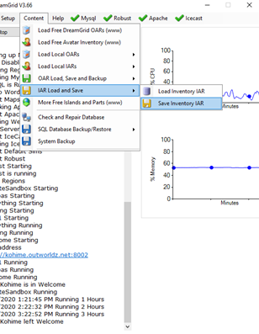  
  
Like Opensim Archives, IARs save all the necessary asset data required to fully restore the items including textures, sounds, scripts, and objects contained in the inventory of other objects.

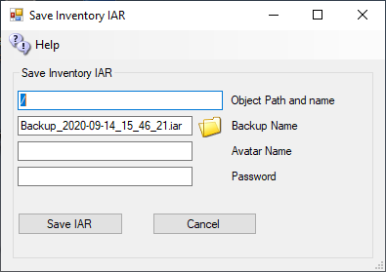

## --------------------------------

## Save IAR via Region console

The command to save an IAR on the region console is

save iar [-h|--home=<url>] [-v|--verbose] [--noassets] [--perm=<permissions>] <user-name> <path> <password> [<filename>]

where <user-name> is the name of the user to save inventory from

<path> is the path to an inventory item or folder. If the path is for a folder, that folder and all its contents (both descendant folders and items) are saved. If the path is for an item, then only that item is saved.

Components of the path are separated by a forward slash ("/"). If you need to specify a path with spaces, you can surround the whole thing with double quotation marks (e.g. "Folder A/Folder B")

You can specify that the contents of a folder should be saved rather than the folder itself using the * wildcard. For instance, "a/b/*" will save the contents of folder b but not folder b itself.

If a name or folder contains a forward slash ("/") then it can be escaped with the backslash (i.e. "\/") to stop it being seen as a path separator. Back slashes themselves need to be escaped with another backslash (i.e. "\\").

One further issue here is that it is not possible to distinguish between identically named folders or items on the path - the workaround is to rename your items/folders if you need to specify them in the path :)

<password> is the password of the user.

<filename> is an optional filename for the IAR. If none is supplied, then the filename user-inventory.iar is used in the current directory. I recommend that IARs have the .iar extension.

### Switches

If the --noassets option is specified, then the archive will be saved without assets. This can be handy if you are backing up the asset database separately and do not want the expense of including all the assets in each archive.

--home=<url> is the URL of this world's profile service. It is not required that the profile service is operational; the information will be saved, and it will be displayed wherever the archive will be loaded. NOTE: the older --profile option (the previous name of this switch) produced IARs that are not compatible with OpenSimulator 0.7.0.2 and earlier; do not use this option if you want to produce a compatible IAR.

--verbose prints out verbose saving messages

If the --perm option is specified, then items with insufficient permissions will not be saved to the IAR. This can be useful for grids that allow their customers to export their inventorys to IARs, because it ensures that exporting to IAR cannot be used to bypass content permissions.

<permissions> specifies which permissions are required. It is a string that contains one or more of these characters:

"C" = Copy  
"T" = Transfer  
"M" = Modify  
  
Examples

Here is an example. Suppose you have an inventory structure like this

My Inventory  
 |  
 +-- FolderA  
 |   
 +-- FolderB  
 | |  
 | +-- ItemX  
 |  
 +-- ItemY

If you type:

save iar John Doe FolderA PASSWORD my-items.iar

then FolderA and everything in FolderA (FolderB, ItemX and ItemY) will be saved into an IAR called my-items.iar. On the other hand, if you type

save iar John Doe FolderA/FolderB/ItemX PASSWORD my-items.iar

then only ItemX will be saved.

If there is a space in the path to the item, for example if John Doe's folder was named "Folder A" instead of "FolderA", then quotes around the path are necessary on the command line:

save iar John Doe "Folder A/FolderB/ItemX" PASSWORD my-items.iar

Saving an entire user's inventory

With save iar you can save your entire inventory as well as the contents of particular folders or individual items.

For instance, typing

save iar John Doe /* password



# Script Settings

## X Engine

Default Engine for scripts is X Engine.

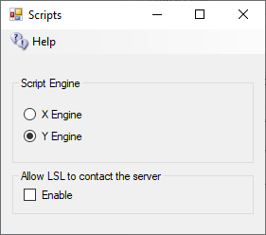

Updated UI, as there is a space between the letter X and Y for the engines on the latest UI.

Y Engine is a new engine that has better support for the llSleep() command. Y Engine offers some features that improve performance and prevent timeouts.

The problem with using llSleep function in Opensim scripts is that it may cause a script to freeze, requiring a reset. This is due to the way X Engine deals with running multiple scripts at once.

The parse in Y Engine is also like Second Life as it uses the same order when evaluating a series of expressions. X Engine parsed the order in the opposite direction from Second Life.

## Allow LSL to contact the server

By default, OpenSimulator does not allow scripts to make HTTP calls to addresses on the simulator's LAN. This stop LSL from scanning your ports inside your firewall. If you need to allow scripts to make some LAN calls, enable this checkbox. We recommend that you do not enable this unless you are very sure about what you are doing. When disabled, it will allow access to no ports on the server. You can see more in Opensim.proto - search for OutboundDisallowForUserScripts.

Default: Unchecked



# Robust and Server Type

This menu item “Server Type” lets you choose from either a Grid Server with Robust, or from different Region Server choices to connect to another grid.

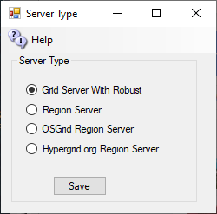

## Grid Server with Robust

A grid server is modeled after the World Wide Web, with independent domains. Content is spread across small, independent and on large domains, independently, yet interlinks.  
  
Robust is the service that lets HyperGrid users enter each world. A Grid Server can also support regions locally.

A grid server can host as many Region servers as its memory and CPU capacity allows.

## Region Server

A Region server uses a separate Dreamgrid Robust Grid Server for all assets and login services. Only regions and their content are stored locally. The grid server may be located on the same LAN, or on another WAN.   
  
A Region Server always uses the same Domain Name and port as the Hosting server.

In cases where the Grid server is on a different WAN IP address, you must also enter the Region Servers IP address or domain name in the Region Ports setting:

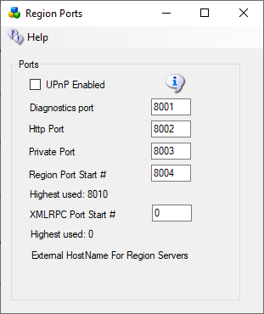

## OsGrid Region Server

The **OsGrid** region server is a preconfigured region server already set up to connect to **OsGrid**.

## Hypergrid.org Region Server

The **Hypergrid.org** region server is a preconfigured region server already set up to connect to **Hypergrid.org**.

# Streaming MP3 Sound files for Opensim

 MP3 files can be used to make region and parcel-wide background sounds.

The files are located in Outworldzfiles\Apache\htdocs\Audio.  You can add your own audio files there.

This selection of background sounds is CC-0 so can be used anywhere with no license restrictions.

You can play one sound at a time per parcel using your DreamGrid Apache web server. Apache must be enabled and running for this to work.  You can divide up your land into small parcels and play different audio sounds in each parcel

* Caves
* Oceans
* Forests
* Snow
* Rivers and Streams
* Waterfalls

How does it work?  It plays on a sim-wide on a special image.

These are the steps to play MP3 files continually on your region or parcel.

1.  In your viewer, go to the About Land Menu:

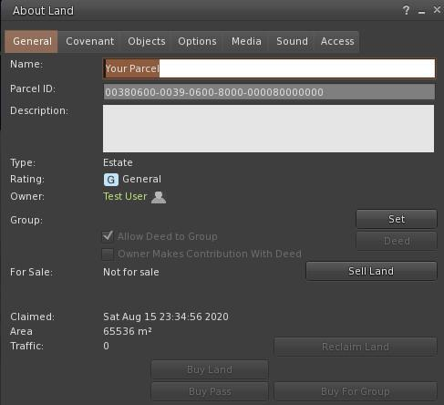  
  
2. Change to the Media Tab:  
  
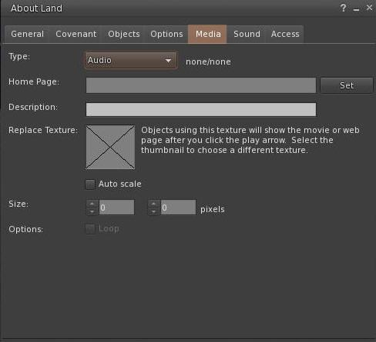  
  
3. Click the Set button and enter the URL of the desired sound.  You can click the link, and copy and paste the path.  
  
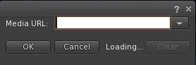  
  
4. You need a unique texture not used before. This PNG file can be used. Right click and save it, and then upload it to your viewer.  
  
  
  
  
Drag and drop the Audio.png file into the X window so it appears like this.  You need to use the web URL for your grid, typically [http://something.outworldz.net:80/Audio](http://something.outworldz.net/Audio), where ‘something’ is your chosen URL. You can get this link in the Help menu in the fist selection. Then change the port to whatever port you use for Apache, in Settings->Apache.  
  
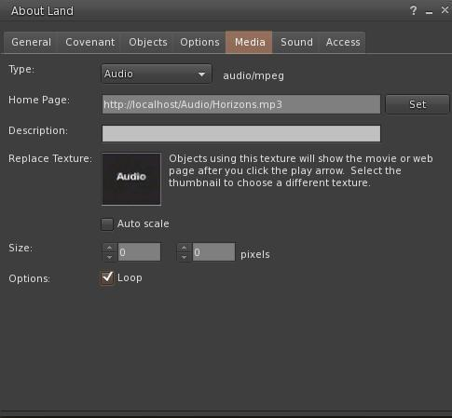  
  
Make a prim or find a hidden face on a prim. Click "Select Face". Choose one face only!  Drag and drop the image onto one face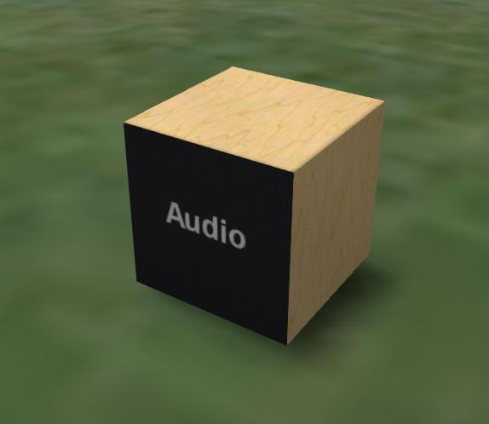  
  
Now click the movie camera at the top right of your viewer:  
  
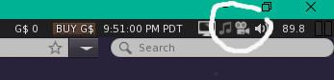  
  
  
Enjoy your new background sound!

# Streaming MOVIE files in Opensim

Apple’s MOV files can be used to make region and parcel-wide video players. The Video you see here is located in Outworldzfiles\Apache\htdocs\Video.  You can add your own Video files there.

You can play one video at a time per parcel using your DreamGrid Apache web server. Apache must be enabled and running for this to work.  You can divide up your land into small parcels and play different audio sounds in each parcel.

* Help Screens
* Movies
* About Your Region

How does it work? .MOV files can be streamed n a special image.

These are the steps to play Video files continually on your region or parcel.

1.  In your viewer, go to the About Land Menu:

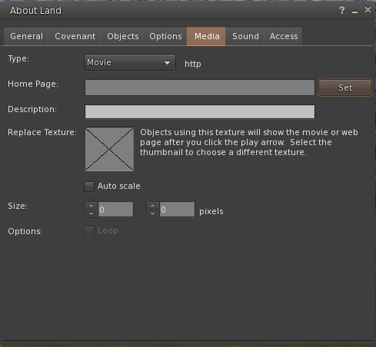  
  
2. Change to the Media Tab:  
  
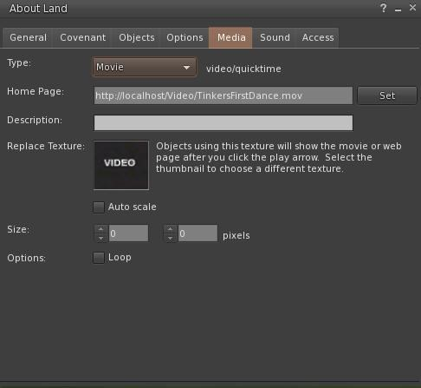  
  
3. Change to the Movie Pulldown  
  
  
  
3. Click the Set button and enter the URL of the desired video.  You can click the link to the sample, and then copy and paste the path.  
or just use http://localhost:80/Video/Tinkers First Dance.mp4  
  
  
  
4. You need a unique texture not used before. This PNG file can be used. Right click and save it, and then upload it to your viewer.  
  
  
  
  
Drag and drop the Audio.png file into the X window so it appears like this.  You need to use the web URL for your grid, typically [http://something.outworldz.net:80/](http://something.outworldz.net/Audio)Video/TinkersFirstDance.mov, where 'something' is your chosen URL. You can get this link in the Help menu in the first menu selection. Then change the port to whatever port you use for Apache, in Settings->Apache.  
  
  
  
Make a prim or find a hidden face on a prim. Click "Select Face". Then choose one face only!  Drag and drop the image onto one face only.  
  
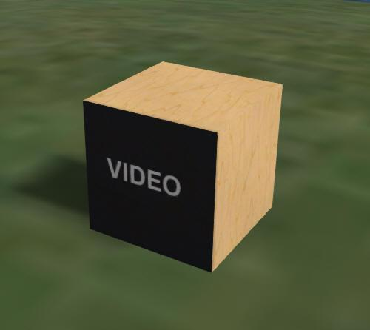  
  
Now click the movie camera at the top right of your viewer:  
  
  
  
  




# Tides Module

The tide module makes water go up and down. It has a buoy with a script to make boats and objects float with the changing water level. It must be used on a single sim surrounded by water.

Tides is by Jak Daniels from <https://github.com/JakDaniels/OpenSimTide>

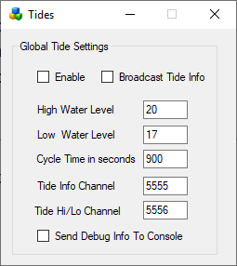

## Enable

If set, Tides are enabled globally. Individual region Tide setting must be enabled to make the water go up and down in each region.

## Broadcast Tide Info

This must be checked to send tide level info to the provided buoy. It uses channel 5555.

## High Water Level

Default is 20 meters

## Low Water Level

Default is 17 meters

Cycle Time in seconds

Default is 900 seconds = 15 minutes

## Tide Info Channel

As the tides rise and fall, a tide level command is broadcast on this channel. This must be set to 5555 for the provided script to work.

## Tide Hi/Lo Channel

An announcement will be made on this channel when the tide is at a high or low level.

## Send Debug Info to console

This will send chat to the regions console for debugging.

## Buoy

A floating buoy is provided in the Load Local IAR menu.

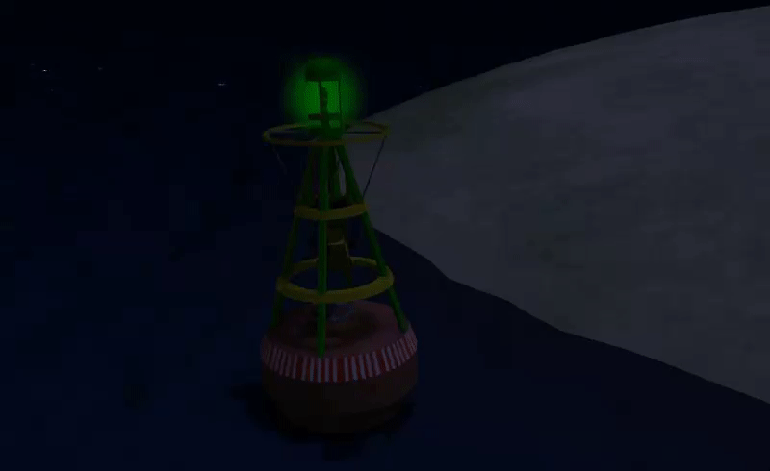

## Tide script

To make items float on water just place this script into their root prim.

integer listen_handle;  
vector myPos;  
float tideLevel = 20.0;

default {  
 on_rez(integer start_param)  
 {  
 llResetScript();  
 }

state_entry()  
 {  
 listen_handle = llListen(5556, "TIDE", NULL_KEY, "");  
 }

listen( integer channel, string name, key id, string message )  
 {  
 tideLevel=(float)message;  
 myPos = llGetPos();  
 llSetPos(<myPos.x, myPos.y, tideLevel + 0.05>);  
 }   
}

To make items float on water just place this script into their root prim.

More complex stuff can be done using the full info channel, which has data about where in the tide cycle we are. Rez a cube prim and place this script inside:

integer listen_handle;  
default  
{  
 state_entry()  
 {  
 listen_handle = llListen(5555, "TIDE", NULL_KEY, "");  
 }

listen( integer channel, string name, key id, string message )  
 {  
 llWhisper(0,channel + " " + name + " " + id + "\n" + message);  
 }  
}

The cube will whisper info about the current tide position every time the tide is updated.

Links:

<https://github.com/JakDaniels/OpenSimTide>

# TOS Service

The TOS form lets you change the HTML for your TOS. A SAMPLE TOS is included here.

Feel free to delete it or change it as you see fit.

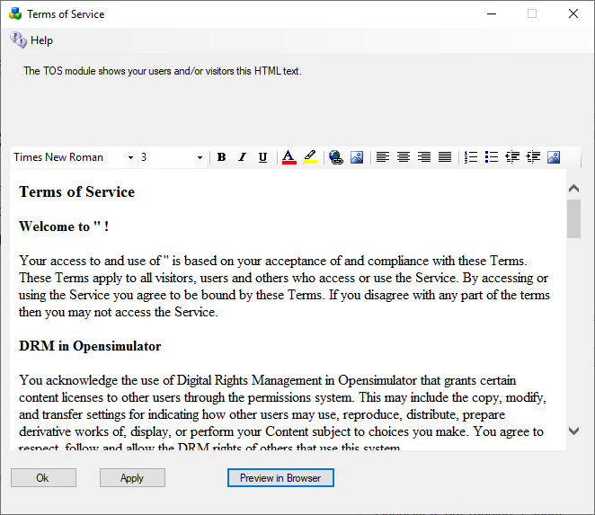

# Troubleshooting Manually

## Network Diagnostics

You can just run Help-Network Diagnostics and see what it says. Or troubleshoot it manually, step-by-step. The diagnostics essentially do what is described below, but sometimes you just need to know more. This is a list of things to try.

Diagnostics are run once upon installation. You can run them again (Help->Diagnostics).

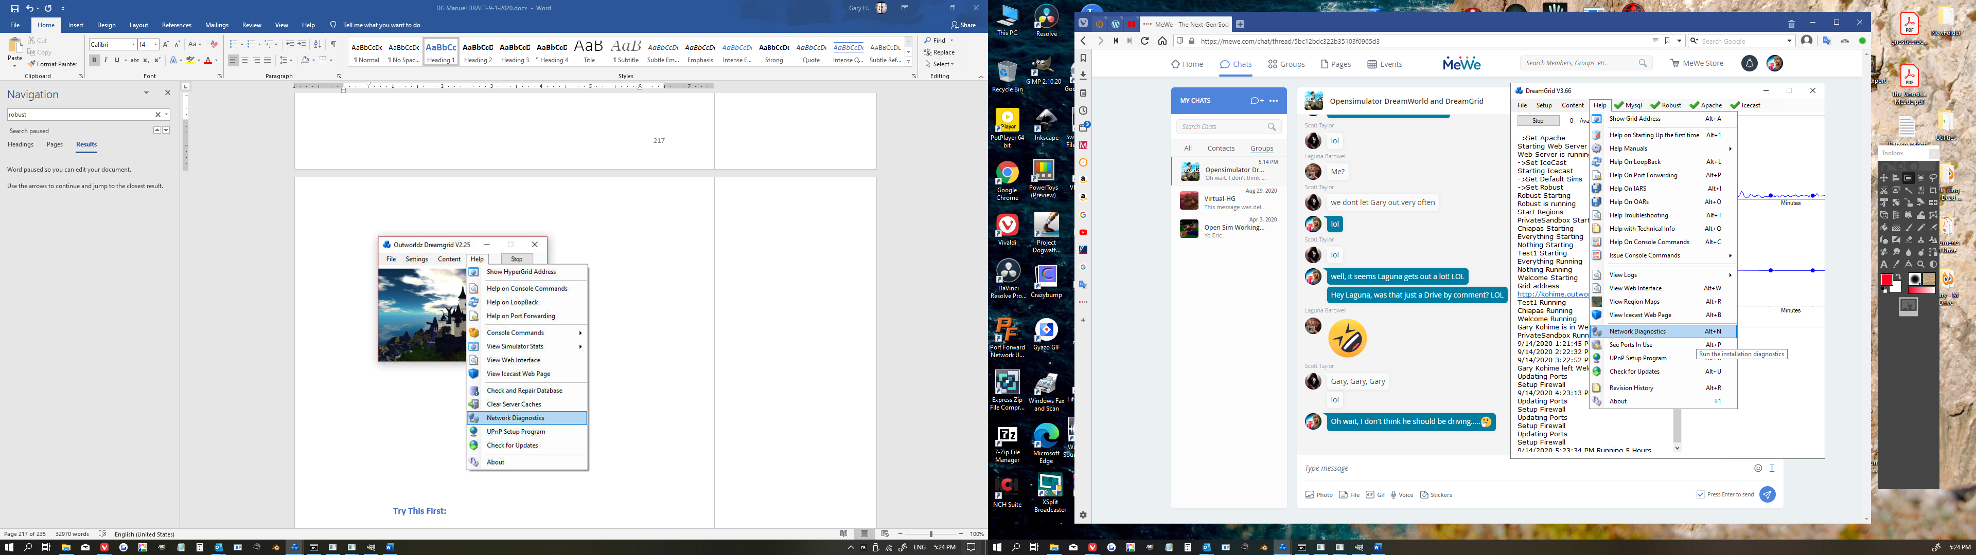

## Try This First

You may need to reset your router by cycling the router power if you change settings from the defaults.

UPnP settings are removed when the program is stopped to keep your system safe. I use Universal Plug and Play (uPnP) and several diagnostics to configure compatible routers automatically. uPnP may be disabled or fail. If your router does not support uPnP, you must manually open ports in your router and Port Forward them to your PC.

## Try This Next

Go to Settings -> Expert mode, click the DNS button at top left, and enter '127.0.0.1'. Then restart the grid and use <http://127.0.0.1:8002> as the grid in the viewers "Add Grid" menu.

You should also be able to see the Systems admin web page with a viewer by clicking the above link.

Open up your viewer. Now add the grid <http://127.0.0.1:8002> to the viewer. You should now be able to log in on the Server from the Server.

## Password Reset

You should see the Welcome region spit out a lot of text as you log in. If this fails, it is not your network, router, or loopback. You probably forgot the password. You can reset your password with the command 'reset user password' in the Robust screen.

## Troubleshooting the Network

Any IP from outside must be able to connect to ports 8001 to 8002, and from 8004 upwards. A test at http://canyouseeme.org should work on port 8002 when Robust is running.

If not, you need to Port Forward. See the manual on Port Forwards.   
  
After that, if it does not work it highly likely to be an antivirus firewall. Windows Defender firewall may be blocking ports. You need to add exclusions to Opensim\bin\robust.exe and Opensim\bin\opensim.exe.

Try these in order:

1.  http://127.0.0.1:8002 <- gives a web page.  Verifies that robust is running on the machines Network Card loopback adapter.  
  
    If not, start Robust.

Go to the next step only when this test passes.

2. Find your LAN IP with the dos command 'ipconfig'.

Us a web browser to go to your LAN IP, such as http://192.168.0.10:8002

You should get a web Page.  If not, check your IP with the dos command 'ipconfig'.  It will be listed as an IPV4 address. While there make sure there are no other gateways enabled.  This is usually 192.168.0.1.

Go to the next step only when this test passes.

3. Use a cellphone or some other PC connected to your LAN for this next one.

Navigate using a web browser on that OTHER device to <http://192.168.0.10:8002>.

You should see the web page.   
  
If this fails, it is likely to be an antivirus program blocking a port such as the Windows Defender firewall. Turn them ALL off.  Look for Malwarebytes or other installations that can block the port.  I have troubleshot one machine that had three anti-viruses. You can turn them back on once you get it working, one at a time, and see when Opensim quits. Then add the necessary exclusions to that anti-virus program.

Go to the next step only when this test passes.

4. All the above tests are LAN-based.  So now try the router:  
  
    http://canyouseeme.org on port 8002  
  
This test must pass.   If it does not the problem is either the router is not forwarding, or another firewall is blocking you.  Usually this is when people realize they have their router plugged into another router that needs to port forward, too.   
  
Go read the manual on Port Forwards. Look up your router manual. Go to http://portforward.com and look it up, too.  
  
If this fails, it is also likely to be your anti-virus. It can also be the Windows Defender windows firewall. Turn them both off.  Look for Avast and Malwarebytes or other installations that can block the LAN port.   You have already proven it is not DreamGrid, so there is no point in re0installing the grid or restarting it.  
  
Do not go to the next step until the above is working.  There is no point until the above works.    
  
Go to the next step only when this test passes.  
  
5.  Go to the network settings and click the properties of the Microsoft Driver for the Loopback Adapter.   You should have renamed it 'Loopback".  If you did, DreamGrid will update this IP when it changes.  In the IPV4 settings, it should show the same address Canyouseeme.org shows as the address.  The gateway is 255.255.255.0   No other settings are needed.   Close those settings, and right click the adapter and enable it.   
  
6.  Navigate to http://(The Ip address reported by CanyouSeeme.org):8002   
  
You should see the web page. If not, recheck the Loopback settings.   
  
Go to the next step only when this test passes.  
  
7. Right click the Loopback Network Adapter and disable it, if you have installed it. Navigate to http://(The Ip address reported by CanyouSeeme.org):8002.   It may or may not work.  If not, you need to re-enable the adapter.  If it gives a web page, congratulations, your router supports loopback. Leave it disabled.  
  
8. Go to Dreamgrid Settings-> Hypergrid DNS name.  Add your desired name, such as in ‘somename.outworldz.net’.  The allowed characters are a-z, 0-9, and a dash '-'.  Press Save.

9. Go to a DOS prompt.  Type 'nslookup<enter>'.  Type ‘somename.outworldz.net', where name is the name you chose.  It should report the IP with the exact same number as Canyouseeme.org.

10. Add the ‘somename.outworldz.net:8002’ to the viewer’s grid selection, and log in. Both the robust and welcome region should show you logging in. If you only see Robust, then you forgot to port forward or unblock Ports 8004 upwards. You should unlock 10 to 15 ports for expansion, as any extras are harmless.

## Flaky Teleports

Multiple factors can cause flaky things, some of which may not be under your control, such as at the far-end system.

One way to prove your issue is not Opensim or your PC network card is to boot up after changing the Hypergrid DNS name to the IP of the server, or just leave it blank, so it will choose the LAN IP by default. You should be login to that IP address in your viewer, and teleports on your grid should take just moments.

Try uploading a dozen textures. Do they all load without aborting? Now ask some on the Hypergrid to do so. If there is a difference, you have issues with the router and loopback, as the traffic from you and the outside both go to the region, but the region cannot reliably reach some of the ports.

Do you have more than one Network adapter with paths to the Internet, such as both wireless and hardwired running? Opensim can listen to only one adapter, but traffic can come back on either.

Loopback is often flaky in routers. For example, the routers from FIOS and Frontier have tiny 1K buffers for UDP leaving to flaky teleports. Have you tried adding the Microsoft Loopback driver?

These are the URLS it checks to see if it is working that can be run on the server.

When the DNS name is blank, such as first boot, I need a LAN IP to broadcast to the viewer. If a LAN IP is unreachable from the Internet, I announce you cannot Hypergrid.

DG tries to always make a working system, no matter what. There are multiple ways to connect to a LAN, by the WAN IP with or without a DNS name, and as a LAN IP, and localhost. In a complex network environment, there can be multiple ways and more than one IP in use to connect to the outside. Both Wifi and Ethernet adapters, for example. Opensim can only listen to one IP, thus return traffic on the wrong IP can be lost. This is flaky, at best, and is a major cause of teleport problems.

Opensim needs to listen and broadcast only on the "proper" IP. But which is it? I do this by connecting to Googles 8.8.8.8 DNS server, then asking Windows what the Endpoint address is. Typically, this is a number in the 192.168 range, or the 10. * range, which are typical LAN IP's. But it can be anything. If I cannot reach it, I use localhost. DG will thus always come up in a working configuration on first boot.

The URL I use to Test port forwards:

<http://outworldz.com/cgi/probetest.plx?IP=YOURNAME.Outworldz.net&Port=8002>

Answer should be **yes**

Test Private Loopback:

<http://192.168.2.135:8001> (change this to your LAN IP of the server)

Answer should be **Test Completed**

Test Public Loopback

[http://YOURNAME.Outworldz.net:8002](http://yourname.outworldz.net:8002)

Get back a web page

## How to Get on The Hypergrid

Accessing the Hypergrid easily requires a compatible uPnP router with loopback. If your router does not support loopback, you can still join the Hypergrid by installing a special pointer in /etc/hosts or a special Windows Device Driver. Additional information about routers is available online at the Opensimulator site at <http://opensimulator.org/wiki/NAT_Loopback_Routers>.

## **UPnP Not Working**

Do you have Plug and Play (uPnP) issues? Your Help menu has a useful tool to look at uPnP in your router:



## Free UPnP (Universal Plug and Play) Tool for Windows

You can add, delete, and modify the settings without a password, assuming you have uPnP enabled. This is included in Dreamworld and Dreamgrid in the Help menu.

You can still manually forward ports in your Router. Instructions for your specific router can be located at <http://www.portforward.com>

## Firewall

Windows will prompt you to allow Opensim to open ports when it first runs. If you say no, you will not be able to log in.

If you are using an Anti-virus with a firewall, such as Zone Alarm, AVG Internet Suite, or anything else, running Start.exe my trigger the 3rd party firewall popup warnings. Opensim.exe needs to be allowed internet access, and Start.exe should be allowed to make changes. This code is digitally signed by me, Fred Beckhusen of Outworldz.com, and is open source and available for inspection on <https://www.github.com/Outworldz>.

## Updater:

If it acts wonky or is missing files, look in Help->Check for Updates. It will repair any missing files.

## Help with Opensim Crashes:

Your MySQL database may be crashed. This is a way to start MYSQL manually.

Navigate to the Outworldzfiles\MySQL\bin folder. Press and hold the Shift Key and right click the BLANK area next to the files. Or navigate there, as I did below, by typing in commands. Then run "StartManually.bat"

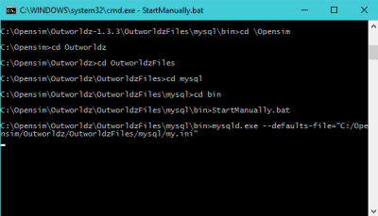

Any error message it prints may be helpful. If the above DOS window closes, a MySQL LOG file will be saved in OutworldzFiles\MySQL\data as a *.err file. That will give you a clue as to what to do.

## My database still did not start.

Try running Outworldzfiles\MySQL\bin\Repair_ISAM.bat. Start MySQL and wait until the Task manager in Windows shows that Mysqld.exe is at 0% CPU use.

Still not working? Delete the two 10 MB files, ib_logfile0, and ib_logfile1 in MySQL\Data and repeat the Repair_ISAM.bat and run "StartManually.bat" again and wait for the CPU to drop to 0%

## Starting Over with A Blank Database

You can wipe ALL data out and recreate it from OAR and IAR files. This WILL LOSE ALL DATA.

If you MUST wipe out the database and start over, there are two methods.

The easiest way is to unzip the provided blank database and replace (do not mix) the contents of MySQL\Data with it.

Method 2 is to delete the ib_logfile0, ib_logfile1 and ibdata1 file in OutworldzFiles\MySQL\data (leave the folders). Then delete just the contents of data\opensim\*. Leave the folder "MySQL\data\MySQL" alone.

Either method will make it start over at the very beginning and you need to re-enter your Avatar name and password and reload everything.

## Ports

Here is more detail about ports and the way the interact with the outside world such as www.canyouseeme.org and to my diagnostics tests.

### Port 8001

8001 is a TCP/HTTP port that is used for setting icons to the state of what Opensim is doing, and some other simple functions such as automatic updating teleport signs and the Partners prim. It is unique to Dreamworld.

### Port 8002

Opensim has a web server that web browsers understand, using the same protocol (TCP/HTTP) that tools such as www.canyouseeme.org support. Put simply, Robust listens to port 8002 and answers to http:// requests on 8002. Port 8002 is much like port 80, the default port for web pages. You can actually set Dreamworld's 8002 port to 80, and it will work. You can then drop the need to type :8002 at the end of your hyperlink. [http://hg.Osgrid.org](http://hg.osgrid.org) does this. There would be no need to type the :80, as literally http:// means "add a :80 to the end of it". So only 8002 works with web-based probe tools. If you do switch it to 80, then you must change the Apache port 80 to some other port. Only one program can listen to a port.

If Opensim is not running and your ports are open, it is as if you tried to connect to www.google.com's web server, but their web server is down. Nothing will happen, though your packets can get through the Google firewall because it is still open to traffic and is steering it to a dead server. You will get no answer. Similarly, if Opensim is not running, there is no web server to answer the request.

### Port 8003

This port is listened to by Robust so regions can chat to the server database for login, presence, and other services so people can teleport from one region to another. In Dreamgrid, just like OsGrid or any other remotely attachable grid, the regions can run on any machine anywhere in the world.

If you opened port 8003 to anyone on the web, you expose the internal database protocol to the web. Anyone with the right knowledge could attach a region to your sim. If you run a DreamGrid and host region outside your LAN, it is recommended you use firewall rules to only allow access from known IP addresses running approved regions.

### Port 8004 and upwards

The region ports (8004-upward) run both TCP and UDP. UDP is used for the viewer. UDP cuts the load on the server dramatically as there is no need to automatically always ACK every packet. As one example, no one cares if an audio stream gets briefly interrupted as you cannot hear it anyway, and it is too late to use it if it comes later in a retry. It just gets discarded.

# Running Manually

You can run Opensimulator without Dreamgrid. Dreamgrid sets up Opensim to run. Once it has run once, you can run Opensim without it.

When you click [Start], Dreamgrid looks for a MySQL listening on a specific Port. If it does not see one, it starts MySQL as a separate process. When you exit, it shuts MySQL down gracefully with *MySQL-admin.-u root shutdown*. Dreamgrid will detect Robust running on Port 8002 and just use it. If it does not see it, Dreamgrid starts up a Robust.

For running manually, MySQL can be used in two ways.

1) MySQL\bin\ StartManually.bat runs MySQL manually. Once the Command Prompt opens, this window can be closed manually, as MySQL will run by itself in another thread.

This is also useful for diagnostics and manual backups and running a Dreamgrid in folder A on a database in Folder B or C or D:\SomeWhereElse. But there is a significant issue: you need to shut down MySQL gracefully! This really needs to be done correctly to reboot or log out of Windows. The command is *MySQL\bin\mysqladmin.-u root shutdown*. There is a batch file in MySQL\bin named *StopMySql.bat* that will do this for you.

# Run as A Service

You can install MySQL as a Windows service. There is a batch file *InstallAsAService.bat* in MySQL\bin to set this up. MySQL will then start with Windows.

This batch file must be run once, as an Administrator. You type "CMD" in the search box, and then right click the Command Prompt and select "Run as Administrator". Use that DOS box to run *InstallAsAService.bat*. Then type in 'Services.msc” and use it to start MySQL.

You should also set the service to restart so MySQL restarts on any crash. Windows knows about services and will send signals to MySQL to shut itself off gracefully. The only danger is that power fails and you corrupt the database. I have set this MySQL to always flush data to the disk without saving it in RAM, which helps. If you are serious about running a grid, then a UPS is necessary.

You can start Robust manually, too. Outworldzfiles\RunRobust.bat assumes MySQL is running.

Go.bat starts a command prompt with an instance of Opensim in it (an instance is a set of sims). The batch file switches to the bin folder and launches Opensim with the settings it needs for the INI files and the Log file.

You can start it all with a batch file like this:

@remarkable batch file to start Dreamgrid manually.

cd MySQL\bin

start startmanually.bat

cd ..\..\opensim

call runrobust.bat

call go Welcome

call go AnotherRegion

# How to Compile DreamGrid

The vast majority of this software is just Opensimulator and MySQL with edits in the INI files to allow auto-configuration by XML and INI editing.

The source code package "How_to_Compile.txt" explains how it is compiled, and what changes are made. You need Visual Studio 2015 or higher, and preferably 2019.

# Vivox Voice Settings

Vivox powers voice for millions of players in many of the world's best games.

You must first ask for a free Opensim Vivox account by clicking the link. These accounts are free for non-commercial use. It can take a week to get a response, so please be patient and polite.

When you get the email, add your User ID and Password to this form and enable it. Restart the system and voice should work.

Links:

https://support.vivox

http://www.hypergridbusiness.com/2011/12/free-vivox-for-all

# Setting Up WordPress with DreamGrid

Download WordPress from <https://wordpress.org/download/>

Extract the zip file into wherever you installed your Grid in the Outworldzfiles\Apache\htdocs\WordPress folder. Do not put a second ‘wordpress’ flder in there. If you do, just drag and drop the contents of the wordpress folder to the htdocs\ WordPress folder. It should look like this:

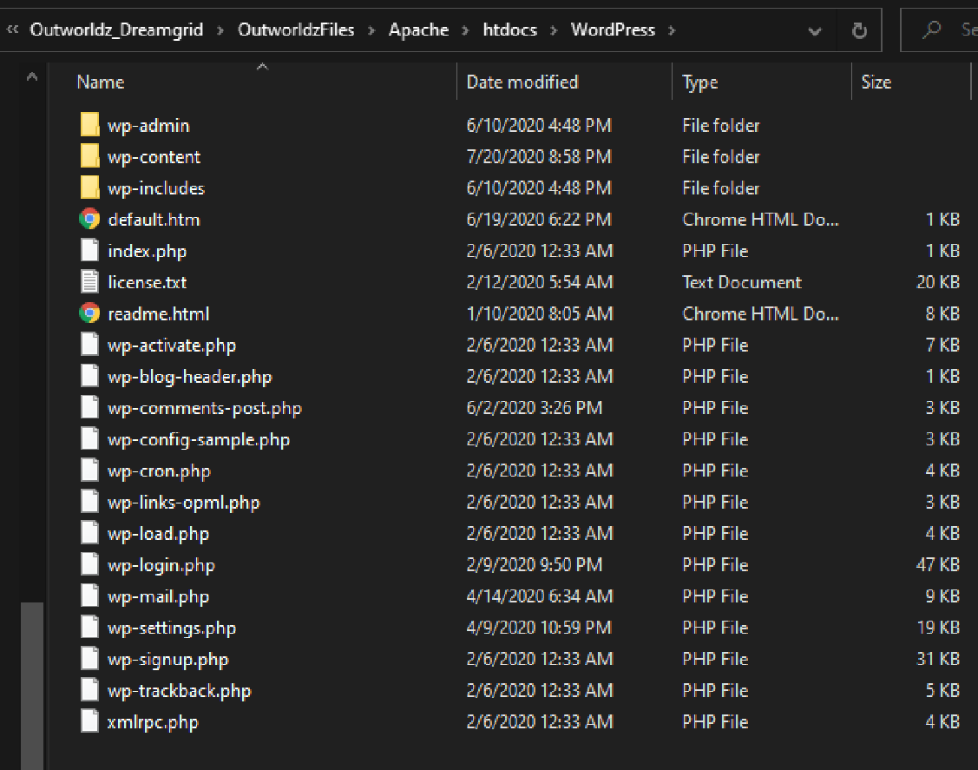

Go to DreamGrid settings -> Apache. Set the WordPress switch on.

Enable the Apache Webserver on port 80 to run as a service.

If you have not yet done so, install the necessary Visual C++ runtimes by clicking the button. **WARNING* This may suddenly reboot your machine, so save your work.

If it does reboot, make your way back the Settings Apache page and , install the necessary Visual C++ runtimes by clicking the button.

Stop the grid, exit the app, and start it again.

Using a web browser, navigate to <http://localhost>. You should see a language choice screen:

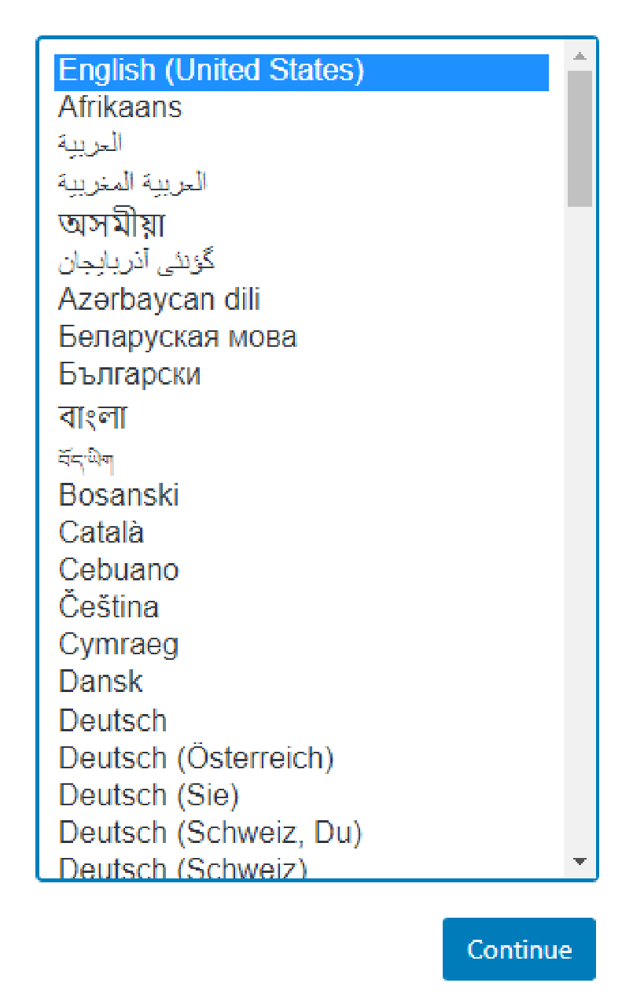

After choosing your language, use these settings to set up WordPress and then Click Submit:

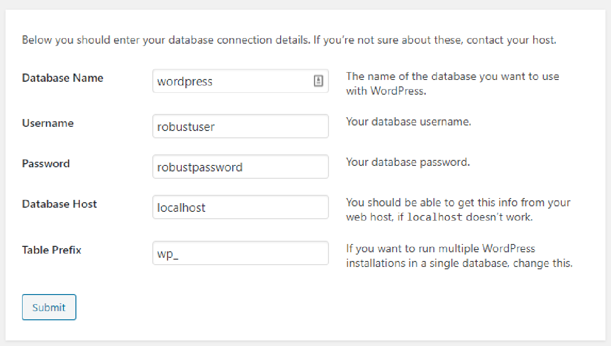

You should get this screen:

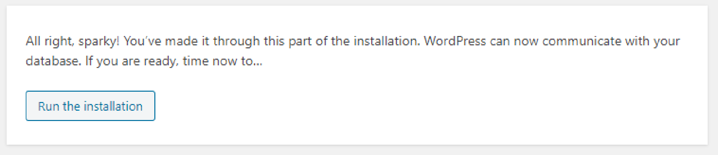

After this WordPress will ask for your name, password and email. Please a very strong password you have never used before! It is extremely importatnt that this be a long, strong password.

You can now navigate to <http://localhost> to view your new web site.